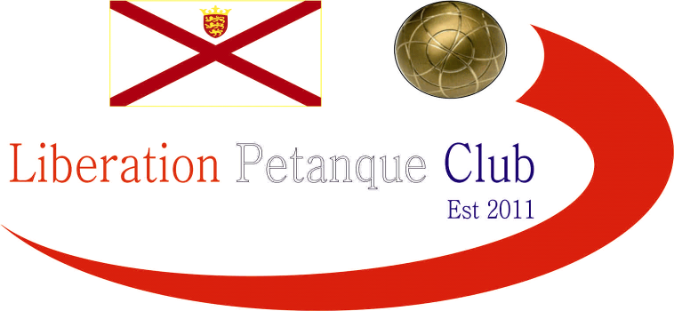

2015
Liberation Doubles Open
15th August 2015

The 4th Annual Liberation Doubles Open was held on Saturday 15th August. Despite being there being just 20 teams the calibre of teams was the very best the Island had to offer.
The biggest wins were for current Island doubles champions Toby Northern & Matt Pinel who overcame Carrefour players Christine Eccles & Paul Waters winning 10 straight points to seal a 13 – 5 win. This was also the score for Joey Le Clech and Alan Oliveira who beat fellow Liberation players Stefan Riccio & Brendan Jones.
Two close matches saw Colin Myers & Steve Simpkin come back from 12 – 8 down to beat previous finalists Neil Selby & Michel Morel and current JPC Doubles Open winners Callum Stewart & Andrew Bellamy-Burt won 13 – 12 over Guernsey pair Lee Holberry (one of last year’s winners) and Keith Priaulx.
Round 2 though saw Callum & Andrew beaten by Keith & Sue Pinel 13 – 10, Matt Ryan & David Ibitson (2014 runners up) topped the rankings with another win despite Toby & Matt beating Alan & Joey 13 – 3.
Round 3 saw current Liberation Premier League Doubles champions Ross & Antony beat Island doubles runners up and ranked 2 team in the competition Chris & Jake Romeril 13 – 0 to top the table with their 3rd straight win along with Matt & David were the only ones with 3 wins from 3 after Callum & Andrew beat Matt & Toby. With Colin & Steve getting their second win Liberation players occupied the top 6 places.
Round 4 saw another fanny as and Toby and Matt beat Lee & Keith from Guernsey 13 – 0. Matt & David lost for the first time.
Chris & Jake Romeril recovered to win their 3rd match and despite losing Colin & Steve remaining in the top 8.
The final round saw only Ross & Antony already guaranteed a top 8 finish with 4 wins and maybe this played on their minds as they suffered a heavy loss to Alan & Joey 13 – 1 which gave them a quarter final spot. But 13 other teams still had a chance of making the top 8.
Chris & Jake Romeril beat Toby & Matt to get revenge for the 13 – 0 loss they suffered in the Island Doubles final with Jake Romeril twice firing out the coche to save the match. Despite losing Neil Selby & Michel Morel finished 7th and Seb & Delphine from Guernsey finished 8th with a win in the final round.
Although they finished 2nd in the Rankings Joey & Alan finished with 4 wins + 26 and this with a 13 – 3 loss to Toby & Matt in round 2, this meant their average score was 13 - 4 in the 4 wins.
Quarter Finals were as follows:

Ranked 1st Ranked 8th
Ross Payne & Antony Di Santo v Seb Renaud & Delphine De La Mare

Ranked 2nd Ranked 7th
Alan Oliveira & Joey Le Clech v Neil Selby & Michel Morel

Ranked 3rd Ranked 6th
Matt Ryan & David Ibitson v Toby Northern & Matt Pinel

Ranked 4th Ranked 5th
Andrew Bellamy-Burt v Jake & Chris Romeril
& Callum Stewart

Ross & Antony for the second competition running went out in the quarter finals after topping the rankings but just 13 – 12 to Seb & Delphine in a very close match which could have been won by both teams.
Alan & Joey continued in fine form beating 2013 Runners up Neil & Michel 13 – 2 in the only apparently easy result in the quarter final stage.
Toby & Matt Pinel beat Matt Ryan & David 13 – 9 with the latter unlucky with two firings hitting the target boule but also the coche which on both occasions moved together to give Toby & Matt the win.
What can only be described as incredible was the comeback of all comebacks as from 12 – 0 down (that’s right 12 – 0) Callum & Andrew beat Chris & Jake 13 – 12 to seal a Semi-final spot against Seb & Delphine whom they beat 13 – 2 in the qualifying rounds.
Toby & Matt were they only team to beat Joey & Alan in the qualifying rounds with a 13 - 3 win and with excellent placing combined with a below par performance saw Toby & Matt repeat that score line to reach yet another final.
Callum & Andrew had now learnt how to ride their luck and again this time 12 – 8 down came back to win 13 – 12 against an unlucky Seb & Delphine.
So the final saw Island Doubles champions and Liberation Doubles cup champions play JPC doubles Open champions.
Callum & Andrew would have been confident having already beaten Toby & Matt in round 3 and quickly went ahead 6 – 0 but Matt accidently fired the coche out two ends later which actual gave himself & Toby 4 points to tie at 6 – 6 and then 7 each but with some excellent placing from Andrew and Callum in particular combined with a number of uncharacteristic missed fires gave Callum & Andrew their second major title of the year with a 13 – 7 win.
Joey & Alan took 3rd place with a 13 – 10 win over Seb & Delphine from an impressive performance from the pair.
Winners below
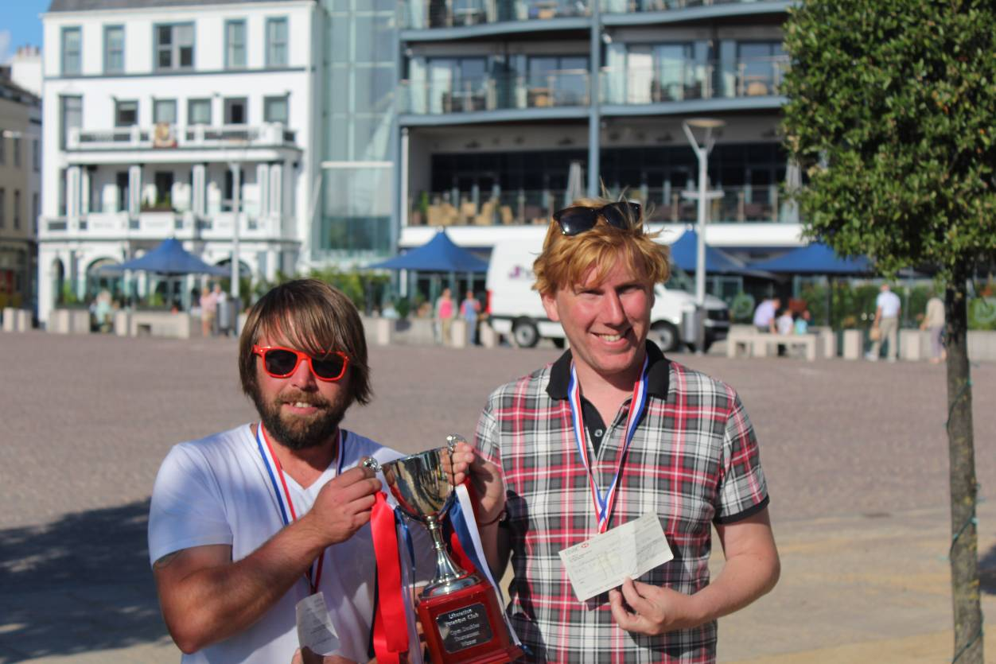

Kind Regards
Toby Northern
Chairman
Liberation Petanque Club

