The Weekly Coach Don Jacobs Radio Show
Each week during the Scottsboro High School football season, 1050 WWIC will feature a 30-minute preview show with head coach Don Jacobs. The show will be presented LIVE from KC’s BBQ at County Park in Scottsboro Thursday nights from 6:00-6:30pm. Sponsorship includes (2) ads in each program and (8) ads throughout the week, Monday-Friday, 6am-6pm through the season.

Call for pricing information.

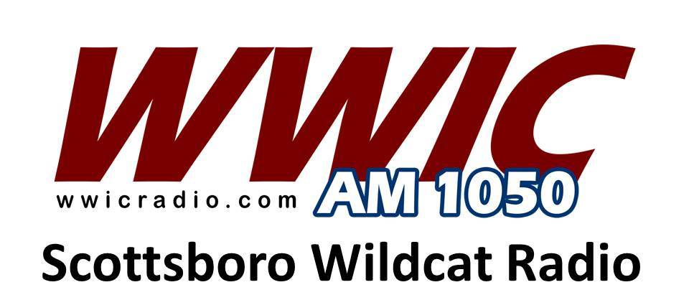

Scottsboro Wildcat Football
(Game Broadcasts)
This sponsorship includes (10) ads per week for the 2020 season schedule and possible playoff games. Four of the ads will be aired within the game broadcast each Friday night and the remaining six ads will be aired throughout the week, Monday through Friday during the same period.

Call for pricing information.

Scottsboro Wildcat Football 2020
This sponsorship of Scottsboro Wildcat football on 1050 WWIC and WWIC-Radio-Dot-Com includes the following on Friday nights:
1 – ad in each Coaches Show Program
1 – ad in each Pre-Game Show before game
1 – ad in each Post-Game Show after game
2 – ads in High School Scoreboard Show
Ads in ESPN Radio College Game Day programming on Saturday’s during CFB season.

Call for pricing information.

2020 Scottsboro Wildcat Football Schedule
8/21/20 – Jamboree at St. Clair County
8/28/20 – Madison Academy Mustangs
9/4/20 – at Oxford Yellowjackets (Region)
9/11/20 – Arab Knights (Region)
9/18/20 – at Springville Tigers (Region)
9/25/20 – at North Jackson Chiefs
10/2/20 – Fort Payne Wildcats (Region)
10/9/20 – Oneonta Redskins (Homecoming)
10/16/20 – Southside Panthers (Region)
10/23/20 – at Pell City Panthers (Region)
10/30/20 – Fyffe Red Devils

Greg Bell – WWIC Radio (256-599-2433)
Angie Bell – WWIC Radio (256-599-5599)

