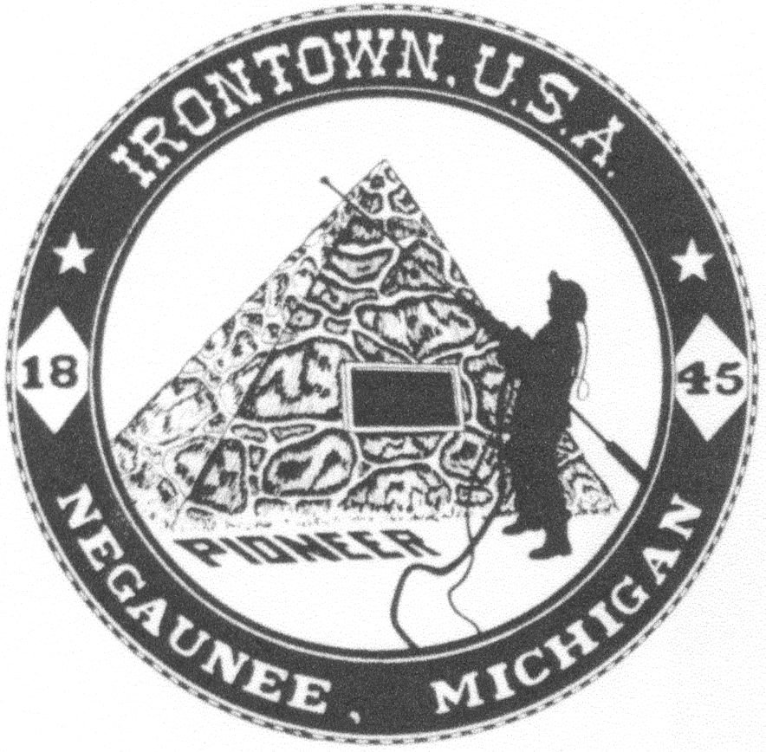 **Negaunee Irontown Association**





# P.O. Box 128 Negaunee, MI 49866 Phone: 906-486-8084

**www.negauneeirontown.com info@negauneeirontown.com**

### 2019 Pioneer Days Brochure Listing Request Form

Please fill in pertinent information as you would like it to appear in our 2019 Pioneer Days brochure. Pioneer Days will be Friday, July 5th through Saturday, July 13th this year. Please list only one event per sheet; make a copy of this form for each additional event.

***Information in this section is for brochure use:***

EVENT NAME_______________________________________________________________

DATE_______________________DAY__________________TIME______________________

LOCATION_________________________________________________COST_____________

DESCRIPTION________________________________________________________________

CONTACT PHONE & NAME____________________________________________________

***Information below is for Irontown use only:***

CONTACT PERSON____________________________________________________________

ADDRESS____________________________________________________________________

CITY, STATE, ZIP______________________________________________________________

NOTES NOT FOR PUBLISHING__________________________________________________

______________________________________________________________________________

Deadline: Friday, May 31st

Please mail or email this form to the contact information above.

No listings will be taken over the phone.

No late submissions can be included due to press deadlines.