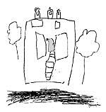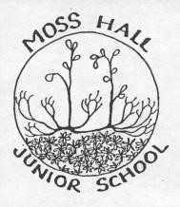

Moss Hall Nursery Moss Hall Infant School Moss Hall Junior School

Term dates 2019 / 2020
 |  |  | AUTUMN TERM 2019
Term |  |  | Dates
 |  |  | Monday 2nd September 2019 - Friday 18th October 2019
Half term Holiday |  |  | Monday 21st October 2019 - Friday 25th October 2019
 |  |  | Monday 28th October 2019 - Thursday 19th December 2019
 |  |  | SPRING TERM 2020
Term |  |  | Dates
 |  |  | Monday 6th January 2020 - Thursday 13th February 2020
Half term Holiday |  |  | Monday 17th February 2020 - Friday 21st February 2020
 |  |  | Monday 24th February 2020 - Friday 3rd April 2020
 |  |  | SUMMER TERM 2020
Term |  |  | Dates
 |  | Monday 20th April 2020 - Friday 22nd May 2020
 |  | (May Day bank holiday Monday 4th May 2020)
 | Half term Holiday | Monday 25th May 2020 - Friday 29th May 2020
 |  | (Spring bank holiday Monday 25th May 2020)
 |  | Monday 1st June 2020 - Tuesday 21st July 2020
INSET Days
Monday 2nd September 2019
Tuesday 3rd September 2019
Monday 6th January 2020
Friday 14th February 2020
Friday 22nd May 2020

