"Integrity, Competence, Service"
A Look Back At The Markets Over The Last Three Years (2017 thru 2019)
While it’s always a good thought to look at the past year in review, I thought it might be more opportunistic to look back three years. The reason is that this period coincides with the current administration, and the more data we have will allow us to build on those market moving events we have seen in the past. So let’s take a look at the attached charts and their different pieces. The first chart is the “Bollinger Band vs S&P 500 (2017 thru 2019). On the right axis, you have the daily S&P 500 “prices” displayed on the blue line. On the left axis, you have the Bollinger Band Index (BBI), which is a measure of volatility. Although I’m only giving you the final BBI, the second Bollinger Band Index chart provides more detail. The BBI is calculated by first measuring the distance between an upper and lower line which captures 95% of S&P 500 price movement over the last 20 days. The distance between these lines creates a band which expands with strong price fluctuations and contracts during consolidations. The index then takes that distance and divides it by the midpoint, giving us the Bollinger Band Index (BBI), which is the lighter colored brown line on chart 1. The higher the BBI, the greater the volatility, in either up or down markets.
So let’s start at the beginning of 2017 (far left), and put into words some of the highlights.
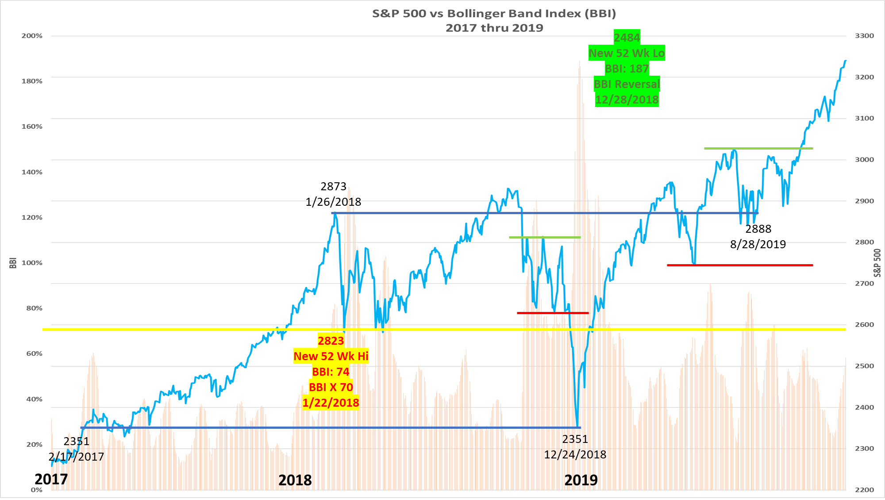
In 2017, the markets started out with an upward trend, but I do want to make a note that on 17 February the S&P 500 closed at 2371 which was a new record high, as we’ll be coming back here later. The markets continued to make new highs through the end of the 2017, but the upward trend was consistent in that there was only 8 days when the S&P 500 had daily moves of over one percent, either up or down. Now this is where the Bollinger Band Index (BBI) starts to become relevant with regard to volatility. Looking back at historical data, when the BBI stays below 70, it is a neutral position. When it crosses above that 70 level (yellow horizontal line), it is an initial warning signal of a possible impending reversal to the downside. So, as we close out 2017, the BBI is still in a neutral position with a BBI of less than 70.
However, as we enter 2018 you’ll notice an increase in slope of the S&P 500 prices, all making new record highs. Then, on 22 January, the BBI crosses above that 70 yellow line level with the S&P 500 at 2823 while also setting new 52 week/record high. This continues until 26 January with the S&P 500 at another record high of 2873, as we’ll be coming back to that again, also.
Less than two weeks after that, our TSP TIPS 2 February 2018 weekly update states, “After starting out the year with new records being hit almost daily, the markets suffered their worst week in two years with the S&P 500 closing at 2762. One market pundit had it right when he stated the obvious that ‘Yes, earnings are strong and the economy is doing well, but markets just don't go straight up.’ A rise in interest rate didn’t help either. In technical terms, the equity markets moved higher this year due to strong buyer demand resulting in an ‘overbought’ condition. Like a stretched rubber band, it finally snapped back.”
Unlike 2017 when we had only 8 days when the S&P 500 had daily moves of over one percent, this was the precursor to the new 2018 volatility where we would see 64 daily moves one percent or more. Staying with the BBI, we saw it again cross above that 70 yellow level on 23 March, but the S&P 500 was not making a new 52 week high. Therefore, it was considered irrelevant since both criteria of the BBI crossing above that 70 yellow line level with the S&P 500 and setting a new 52 week/record highs were not met.
We then continued upward and were making new record highs going into September 2018, but then trade tariff tweets kicked in causing market uncertainly and choppiness in the markets, annotated by the green and red “breakout channel”.
On 10 December 2018, the S&P 500 had a “Death Cross”. This is when its 50 day Moving Average (MA) crosses below its 200 day MA and is considered a bearish signal. This also completes its most recent bullish “Cross” cycle, which started 25 April 2015, with a gain of 26.1%.”
We then had a bearish breakout to the downside and our 14 December 2018 TSP TIPS update read, “Fear has been a theme with the markets selling off lately due to interest rate hike fears, China trade fears, and U.S. economy fears. This week then ended with global economic growth fears, starting with Asian markets and continuing with Europe until the U.S. markets felt the fear with the S&P 500 closing Friday at 2599.95.
That said, the S&P 500 continued down and hit a new 52 week low of 2351 with a BBI of 184 on Christmas Eve 2018. For the S&P 500, it also brought us back to the same point we were at 22 months ago, on 17 February 2017 (I told you we’d come back to it).
But before we leave 2018, let’s look at the last week of December’s BBI in more detail. When markets are volatile, the BBI increases. Because of this volatility, the BBI shot up to a high of 189 on 27 December. The next day on 28 December, BBI reversed itself and decreased to 186. A BBI reversal with the S&P 500 making new 52 week lows is a signal that this oversold rubber band has stretched enough and that the bearish environment may be lessening.
Since 24 December 2018 was a S&P 500 new 52 week low, we pretty much started 2019 at that mark. As mentioned in our 4 January 2019 TSP TIPS update, “So where do we go in 2019? … Bottom line is that the markets dislike ‘uncertainty’ and we have plenty of that now with trade wars, interest rate worries, border security and last but not least, the government shutdown.”
Well, that government shutdown didn’t last all that long and I’m sure a lot of our TSP subscribers were happy about that. Then, coming off that Bear BBI reversal, the S&P 500 had a nice, steady bullish run and on 2 April, we had the opposite of the aforementioned “Death Cross” and instead had the bullish “Golden Cross”, where the S&P 500’s 50 day Moving Average (MA) crosses above its 200 day MA. I’ve included a table in the Chart File which shows the performance of the Golden/Death cross going back to the beginning of 1970 which you might find interesting (Not a bad indicator for 529 college savings plans where you have two annual exchanges). Moving into May thru October, trade tariff talks/tweets and interest rate uncertainty were still in the news and the market was stuck in another of those “breakout channels”. On 28 August, the S&P 500 closed at 2888, finally recouping all the losses of 2018 and returning it above where it was 19 months ago, on 26 January 2018. This was significant in that the S&P 500 has now remained above that 2888 level. We then had a Bull breakout to the upside, crossing above that green resistance line on 28 October 2019.
As we close out 2019, the S&P 500 is once again hitting new 52 week/record highs while the BBI stands at a neutral 58, below that 70 warning level. Remember, a cautionary flag is only raised when the BBI crosses above that 70 yellow line level AND the S&P 500 is setting a new 52 week/record highs. However, I am watching things in that this recent bullish run is looking eerily familiar to the S&P 500 price movement in the two months leading up to 26 January 2018.
So going back to the “data” discussed in the first paragraph, we now have a better perspective of market movements, and the key to that is uncertainty, which breeds volatility. So here are two takeaways based on the volatility analysis over the last three years.
1) Bollinger Band Index (BBI): When the BBI crosses above a 70 reading with the S&P making new highs, this should be considered a warning signal that the markets are getting “overbought” and that we should “take some money off the table”. Conversely, after the S&P 500 makes a new 52 week low, this “oversold” condition shows the initial stages of a bullishness when the BBI reverses its direction. We’ve had two of these signals, both in 2018.
2) Breakout Channels: Market moving news has evolved over the last three years. The days of daily White House press briefings are over, and there is more of a direct connection using impromptu news conferences prior to boarding the helicopter or after White House meetings with other country leaders. As such, take more of a cautionary, middle of the road perspective until we see a breakout.
While our current strategy has had success in the past, we will be incorporating these above enhancements as we move into 2020.

2018 Year in Review

The first topic that I’d like to address are the chaotic markets in 2018. Overall, the markets had their worst year since 2008 and if there was one word to sum it up it would be “Volatility”. In over forty years of investing I’ve never seen markets like this and the following evidence supports this perception.
- In 2017 the S&P 500 had daily moves of 1 percent or more eight times.
- In 2018, the S&P 500 had daily moves of 1 percent or more 64 times, increasing “eight fold”.
- In 2017, these moves occurred less than once a month while in 2018 it was more than once a week.
- December 2018 alone had nine of these 1 percent moves, more than all of 2017.

Next let’s look at intraday volatility, or the range the market moves between its open at 0930 and close at 1600. For this we’ll look at the point difference between the market’s high and low and divide it by the opening price.
- In 2017 there were ten intraday market moves of 1 percent or more.
- In 2018, we crossed the century mark and finished the year with 109 intraday market moves of 1 percent or more, or ten times the rate of 2017.
That said, 2018’s volatility was similar to bookends in that the majority of the volatility clustered in the first and last quarters. If you look at the chart of the S&P 500 (blue line), you can see the nice run up in January followed by a swift sell-off in February and then choppiness into March. For the next six months, April though the end of September, we saw a nice upward “trending” market and all was good as the market was making new highs. Then October rolled in and we got the right side “bookend” volatility. Through the end of November, the S&P 500 could not make up its mind as to which direction it wanted to go (circles 1 thru 7). Then in December, the floor fell out and the market sank to new yearly lows.
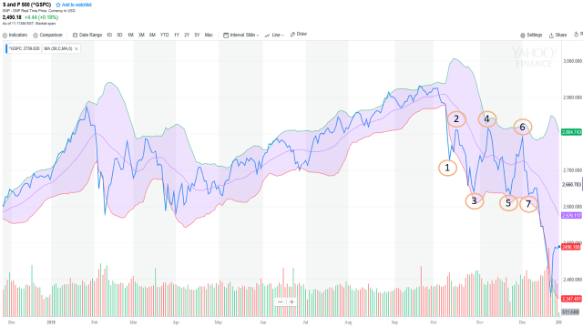

What is also telling on the chart is that purple channel surrounding that blue price line. Its official name is the Bollinger Band and it is a measure of volatility. Specifically, an upper (green) line and lower (red) line are drawn on the price chart which captures 95% of price movement over the last 20 days. The distance between these lines creates a band which expands with strong price fluctuations and contracts during consolidations. You can see that expansion in the volatile first and last bookend quarters, and that channel currently stands at its widest level as we finish out 2018.
Which then brings me to the second chart. Instead of using an eyeball assessment of the channel width, we wanted to quantify it. The chart below shows the S&P 500 price in blue, but also shows the actual daily channel width indexed by the vertical orange lines. Again notice the correlation between those first and last quarters and the height of the orange bars. We then overlaid a red line which is a 250 day moving average of the orange channels.
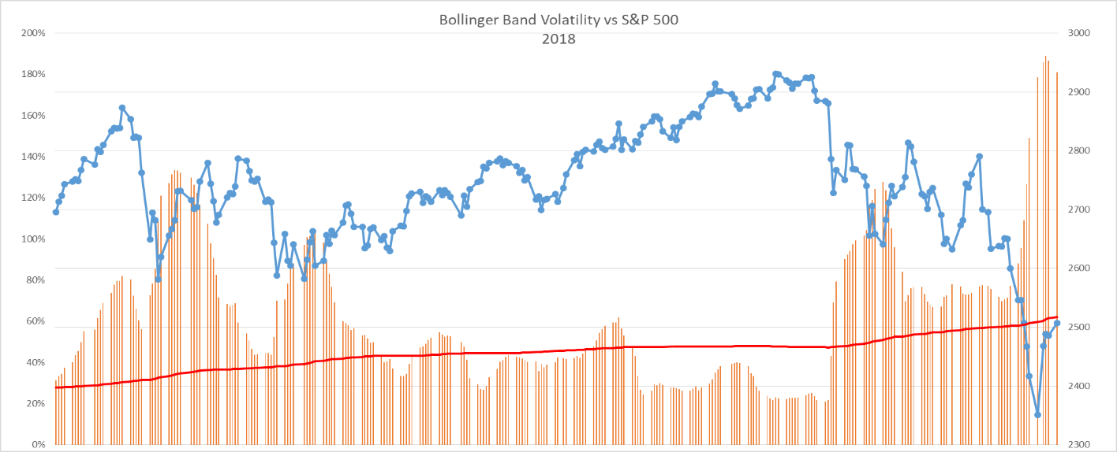

So how can we put this to good use? You know that over the years I’ve been a big proponent of “Price” moving averages to determine trending market direction. But what about those times like the first and last quarter when you have those volatile, non-trending times. This is when we would shift gears and additionally utilize the Bollinger Bar Chart. If the orange daily bandwidth line is above the red line, we’d take a more conservative approach and be hesitant on taking any “new” position, while maintaining old positions. As such there would be a corresponding increase in cash allocation. Should the orange line cross below the red line, then we would revert to the strategy we’ve successfully used in the past for trending markets. Hopefully incorporation of the Bollinger Band will provide improved results with less volatility as verified during the back testing that was completed.

2017 Year in Review
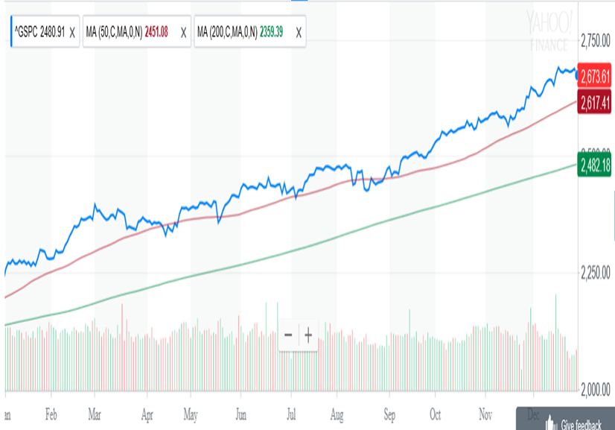
2017 was characterized by “Synchronized Global Economic Expansion”. Here in the U.S., record earnings, low interest rates and low inflation pushed the markets higher throughout the year, while expectations of tax reform drove it higher over the last half. Volatility was also low with the S&P 500 (refer to chart) having a more than one percent daily move on only eight occasions this year, while it had 48 in 2016 and 71 in 2015. This led to the S&P 500 having 62 record closes on the year and finishing out December with its first 9 month win streak since 1983. So that begs the question “What should we look forward to in 2018?” While no one can predict the future, I’d let the trend continue to be our friend. The economy will be the driving factor as we see the implications of tax reform kick in along with proposed infrastructure spending. With the S&P 500 closing the year at 2673, we’re just a little over 12 percent from that 3,000 threshold, which is not an unrealistic goal given this year’s returns.

****************************************************************************************************
2016 Year in Review
2016 started out on a horrible note with the S&P 500 suffering sharp losses through the middle of February. We then rebounded back to the 2043 level on the S&P 500, exactly where we opened the year. From a technical perspective, April brought us a major bullish “Golden Cross signal. That’s when the S&P’s 50 day moving average (red line) crosses above its 200 day moving average (green line). We continued to bounce around that 2043 level until the end of June, when we had the Brexit sell off. What was also particularly unusual was that between November 2014 and June 2016, the S&P 500 crossed the 2043 level 33 times. Talk about flat markets and trying to push a rope. We basically remained at that post Brexit level all the way thru the Friday before the November election. Since then, the markets have had a nice bullish run with all major indices making new record highs.
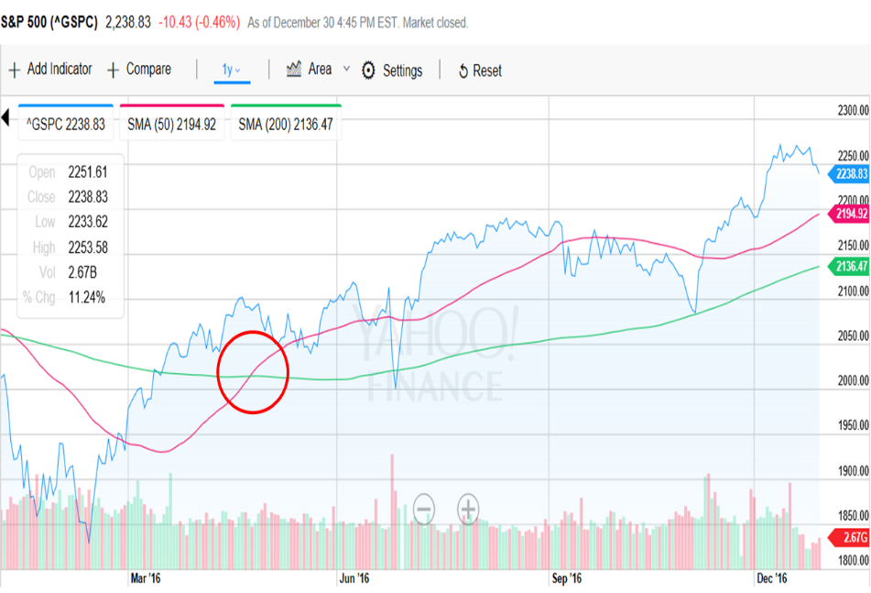
****************************************************************************************************
2015 Year in Review
Note the similarity between the 2015 and 2011 charts
As we look back at 2015, it was a frustrating year of starts and stops, with the S&P500 finishing out basically flat. In between, there was volatility especially in the August to October timeframe. As such, our strategy is optimized for trending markets in either direction. When the market was bearish in 2008, we had an annual return of over 30 percent. When the market was bullish in 2013, we also had an annual return of over 30 percent. In order to improve performance during flat years like 2015, where you have the tendency to get whipsawed, we’ve incorporated a slight adjustment in entry criteria. In the past, we would hold off on entry until the fund price was above its 50 day Moving Average (MA), which had to be above its 200 day MA. At that point we would purchase approximately 10 percent of the portfolio. After back testing, it appears it will be more beneficial to enter prior to the above criteria, but at a lower percentage. If the fund continues upward, we’ll stair step an increase in allocation up to 10 percent. If it turns downward, the allocation will be reduced. All other criteria remain the same. So what can we expect in 2016? While no one can predict the future, I’ll make a comparison to 2011 when the S&P 500 also finished flat. From 2012 thru 2014, the S&P 500 had gains of 13.4%, 29.6% and 10.7% in each of those years. It sure would be nice to see this pattern repeat and we get a trending breakout to the upside above 2100.
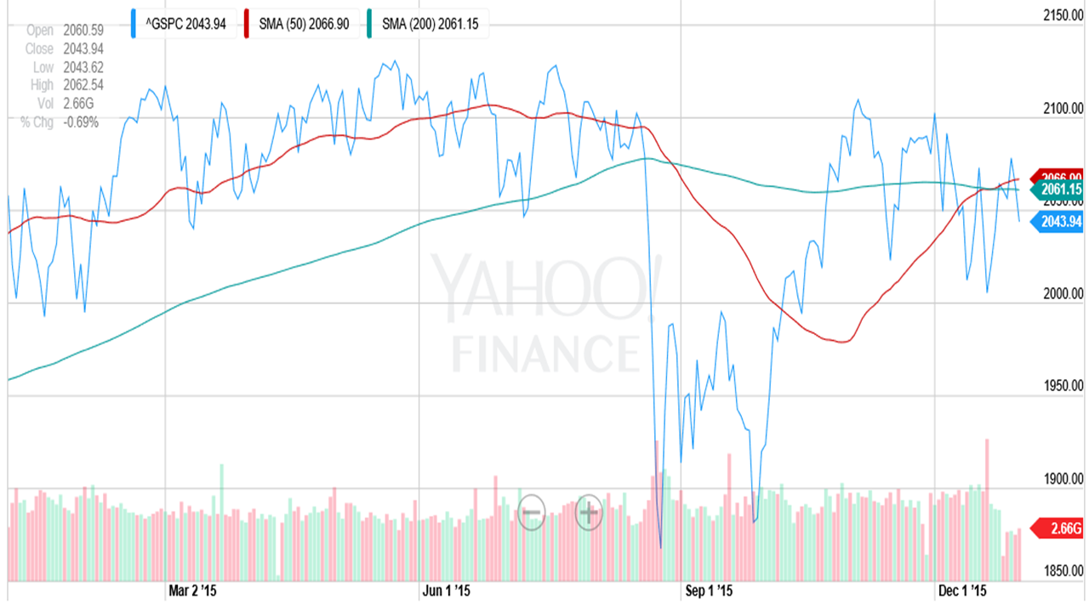
**********************************************************************************************
2014 Year in Review
On the investment side, 2014 was a good year. While overall the S&P 500 (see below chart) went up throughout the year, there were quite a few "V" shaped spikes accompanied by large and quick market moves. This happened in February, August, October (Big "V"), and mid-December. As we close out 2014 and start 2015, we’re seeing more of the same with triple digit losses and gains on the Dow. These moves can cause some concern as you are not sure if this will be a temporary down turn, or the start of something worse like the bear market of 2008. Since our investment strategy lends itself to a more cautious approach, we would decrease our exposure to stocks only to miss out on some of the gains on the upside. However, it was a positive year with ProFunds overall returns just behind the S&P 500. So what do we see looking forward to 2015? While no one can predict the future, the U.S. markets should most probably continue to lead global markets as International funds look weaker. Bonds have been a pleasant surprise, but if interest rates should increase, that will put them under pressure.
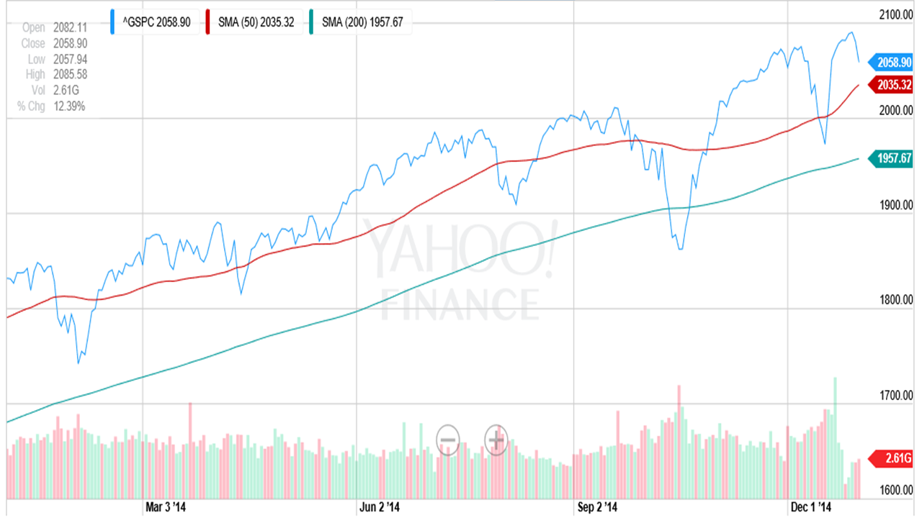
**********************************************************************************************
2013 Year in Review
Looking back, I’ll remember 2013 as the year driven again by domestic politics. Although I’ve worked in the Department of Defense for the last 41 years, I’ve never experienced a government shutdown that directly affected me. Sequestration now had new meaning, but it appears as if the recent budget deal might negate most of this in the future. Also, let’s not forget the uncertainty Edward Snowden and Obamacare threw into the situation. However, the one bright spot that we did have, which contributed to the markets performance was the Fed and their easy money “taper” policy. The impacts of this could be seen directly in the markets, the most recent being a 270 point gain in the Dow during Fed Chairman Ben Bernanke’s last press conference. This translated into positive stock market gains, with the Dow and S&P 500 hitting historic highs as we closed out the year. On the investment side, you can see how the S&P 500 performed in the last two years.
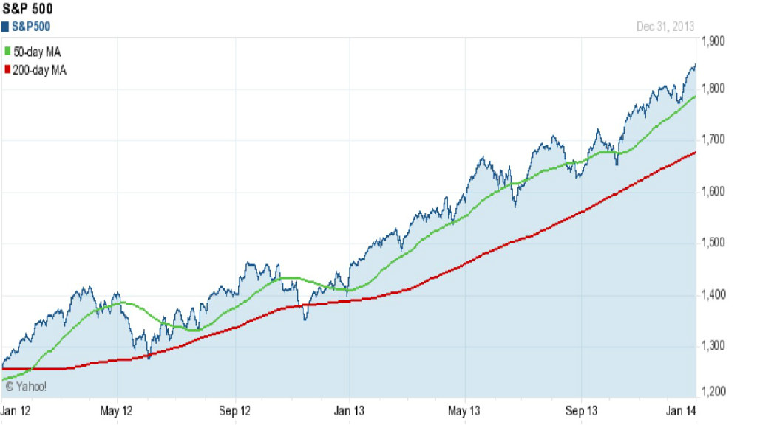
One of the best technical indicators I utilize is the 50 day Moving Average (green line) and its relationship to the 200 day Moving Average (red line). A bullish signal is when the 50MA crosses above the 200 MA, which it did at the beginning of 2012. As you can also see, that indicator continued to be bullish in 2013, which resulted in gains of over 32% in ProFunds accounts. It should also be noted that since 31 December 2007, ProFunds accounts have increased 90% as compared to 25% for the S&P 500. So what can we expect for the future? The trend is your friend. As long as this indicator remains strong, regardless of the headlines, we will continue to have to majority of funds in the stock market.
**********************************************************************************************
2012 Year in Review
Looking back, I’ll remember 2012 as the year of foreign and domestic politics. We had Greece, Arab Spring, the primaries, the election, and finished it off with the fiscal cliff. I don’t know about you, but I’ve hit the saturation point. Although now we have the debt ceiling and sequestration debates to look forward to in this first quarter. On the investment side, you can see how the S&P 500 performed in 2012 by looking at the inserted chart. Although it dipped in May and the time around the election, it was relatively bullish for the majority of the year. From a technical perspective, this was confirmed as its 50 day Moving Average (red line) remains above its 200 day Moving Average (green line).
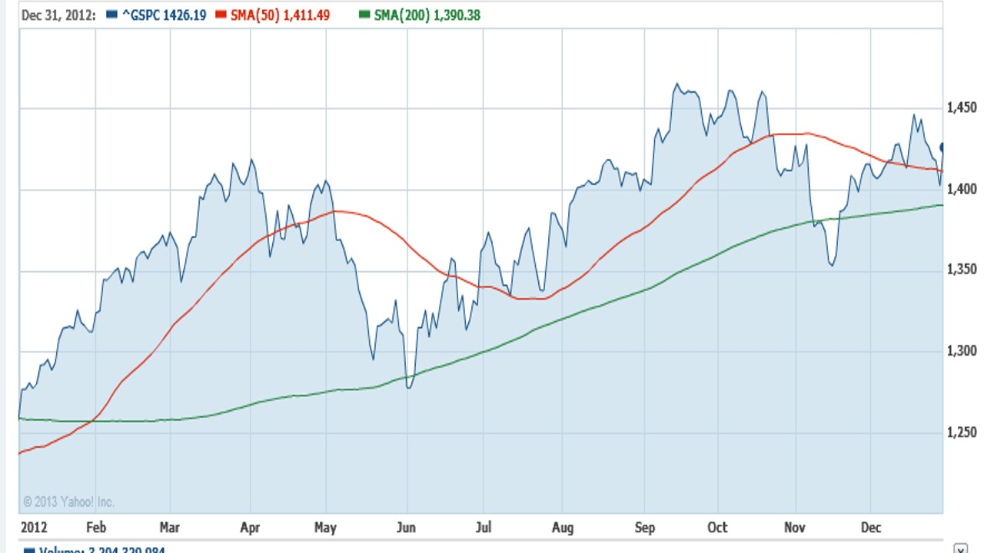
However, one number I would like you to remember is 1468, which is where the S&P 500 closed at on 31 December 2007. Then came the financial crisis and the bear market of 2008. As I’m typing this on 12 January 2013, the S&P 500 just closed at 1472. For the first time in the last five plus years, it has finally recouped what it had lost. Over that same period of time, money invested in ProFunds would have had an increase of just over 50 percent. So what can we expect for the future? As Casey Stengel once said, "Never make predictions, especially about the future". However, I will venture to say that I’ll remain cautiously optimistic as long as that 50 day moving average remains above the 200 day moving average. Also remember that the S&P 500’s historical high was 1565 on 9 October 2007. We’re only about 100 points shy of that, and I wouldn’t be surprised if we break above that level in 2013.
**********************************************************************************************
2011 Year in Review
On the investment side, I must say that 2011 was a very interesting and unique year. Although the first six months mostly followed a typical trending pattern, the last six months were challenging and frustrating. It was like being on a seesaw, going up and down but remaining in basically the same place. The 2011 chart of the S&P 500 illustrates this. Around August you can see the big drop off. Notice that the 50 day moving average (MA) green line crosses below the 200 day moving average red line, signaling a bearish market. Also notice that at the end of September, the S&P 500 makes a new yearly low of around 1100, which usually signifies a continued bearish trend. However, the S&P 500 turns around and posts one of its best months in October, drops in November, then up again in December.
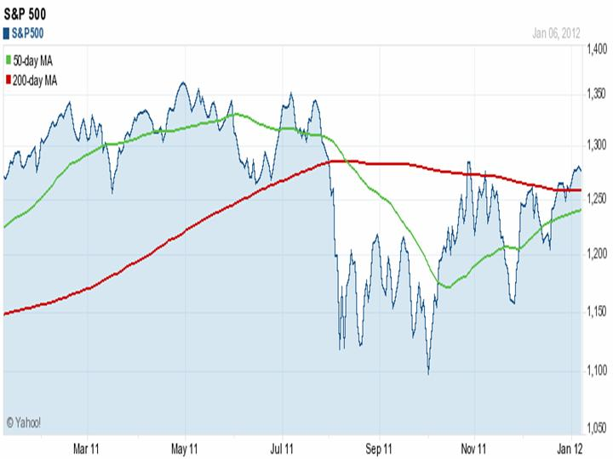
This was reminiscent of December 2007 when over a four week period the S&P 500 started at 1463, jumped to 1516, dropped 70 points to 1446, gained some back to 1498, and then dropped 108 points to 1390, which started the big bear market of 2008. There are a couple of big differences though. In December of 2007 the 50 day MA was crossing below the 200 day MA, while in 2011 it crossed about six months ago as noted above. Another is that from December 2007 to present, the S&P 500 is down about 15 percent, while a lump sum investment in ProFunds is up approximately 39 percent. No one can predict the future, but I do think 2012 will be a good year and gains will be made as the 50 day MA next crosses above the 200 day MA, probably in January.
*********************************************************************************************
2010 Year in Review
In mid-2010, I stated that “Over the last two years we have made major gains in the second half of the year, and I’m hoping that this pattern will repeat”. Well, the stars did align themselves and we had consecutive gains for the last five months of 2010. For the year, our ProFunds clients were up just over 13 percent. That makes three years in a row with double digit returns and since 31 December 2007, client's accounts are up over 70 percent. During that same three year period, the S&P 500 is down just under 15 percent, still reeling from the effects of the 2008 Bear market. As I’ve said before in these letters, one of the primary criteria I utilize to define a bull or bear market is “Crossover”. If the 50 day moving average (blue) is above the 200 day moving average (red), it is a bullish sign. If the 50 is below the 200, it is bearish.
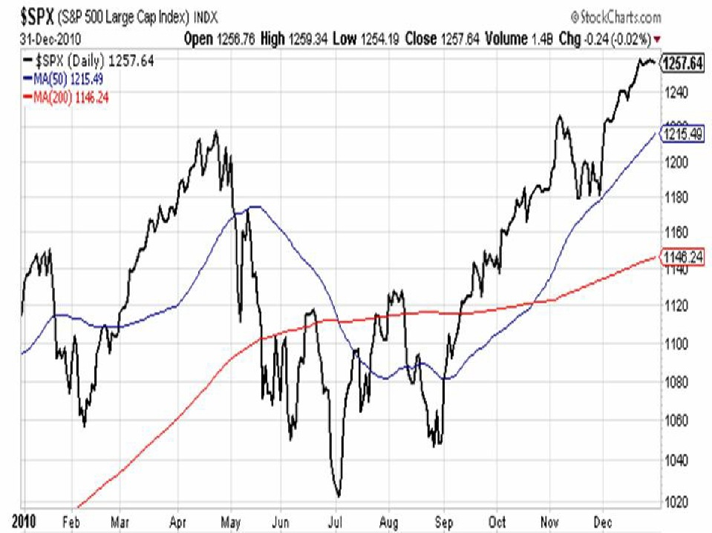
You can see on the chart of the S&P 500 that this index struggled during the first half of the year and even turned bearish during the summer given the fact the 50 (blue line) dipped below the 200 (red line). Thankfully this market rebounded and like I said earlier, our ProFunds clients saw gains in each of the last five months of 2010. The other nice thing I like about this scenario is that the end of 2010, S&P500 is trading around 1250 (refer to chart). The S&P 500’s historical high was approximately 1550 in July 2007. That 300 point delta divided by the current level of 1250 equates to a gain of approximately 25 percent. Bottom line is that I’m continuing to see a lot of potential in this market, and I think we have the opportunity for four straight years of double digit gains.
********************************************************************************************
2009 Year in Review
As we start off a new decade, we are coming off two of the most tumultuous years in financial history. Although the S&P 500 did well in 2009 and finished at 1125, it is still down 22% from the 1468 mark of 31 December 2007. However, there is good news!! Over that same two year period, our clients had double digit gains for both years and those invested in ProFunds gained just over 52%, while those in Rydex made about 37%. All told, the two year percentage difference between the S&P 500 and ProFunds/Rydex was approximately 74% and 59% respectively.

While the gains in 2008 came from investments in bearish inverse funds, the gains in 2009 came from bullish funds. Looking back to December 2007, the S&P 500’s 50 day moving average crossed BELOW its 200 day moving average signaling a BEAR market. This bearish mood persisted throughout 2008 and the first few months of 2009. In June 2009, the S&P 500’s 50 day moving average crossed ABOVE its 200 day moving average signaling a BULL market. Since that time, we’ve seen the S&P 500 increase from approximately 900 to 1125 along with the majority of portfolio gains.
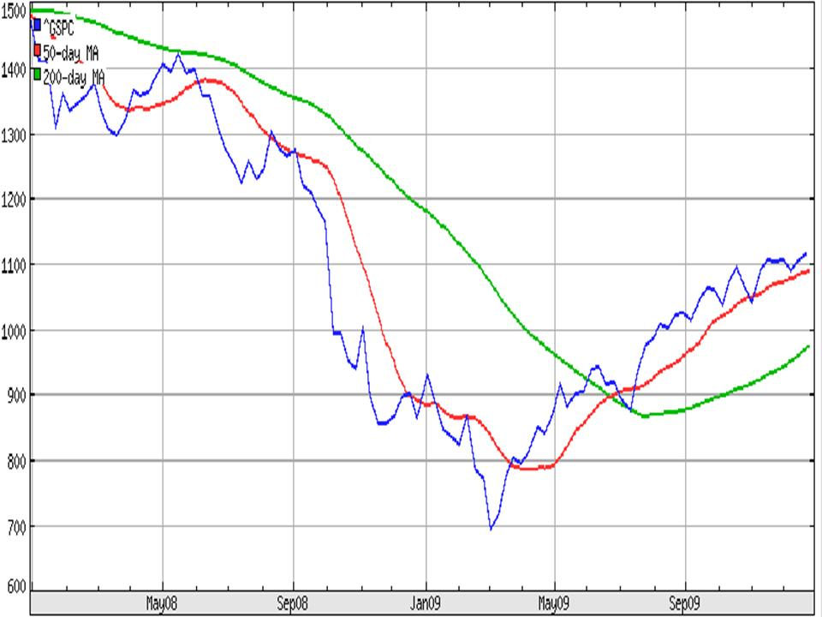
So what should we expect for 2010? One of my notable quotes is, “No one can predict the future”, and so I won’t. However, I will say that just like the S&P 500 was in a 19 month bearish phase from December 2007 until June 2009, I would expect the same to hold true for a 19 month bullish run, bringing us through the end of 2010. We should also remember that the S&P 500’s historical high was 1553 in July 2007. If we are able to return to those levels (and historically we have), that would be about a 38% gain from year end 2009.
*********************************************************************************************
2008 Year in Review
This will be hard to believe, but 2008 was a banner year for our clients. While the S&P 500 was down 38.5% for the year, those clients invested in ProFunds made just over 30% and those in Rydex made approximately 24.5%. The majority of those gains came during the month of October, when the market was falling like a disintegrating satellite. But before we get too far ahead, let's go back to October 2007.
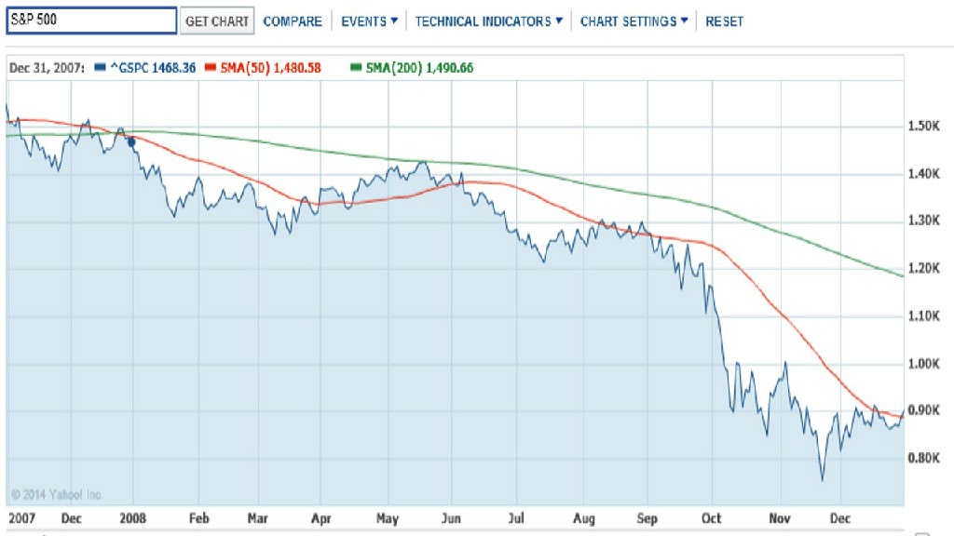
At that time, the S&P 500 had just made a new high of 1565.15. After being bullish since September 2006, the S&P 500's 50 day moving average crossed below it's 200 day moving average, signalling a bearish outlook. The S&P 500 started 2008 at 1468.35, and throughout the first six months of 2008, it meandered back and forth within about a 150 point range and was starting to look more positive at the end of May. However, the summer saw continued lower movement and the fall brought an acceleration of the downward spiral. There was also a sector rotation as evidenced by the fund's Performance Ratings. By the end of September, the majority of portfolio holdings were in Inverse funds which go up when the market goes down. The last quarter of the year was what I like to call "Taking Money Off the Table", and we finished out the year with approximately 90% of our holdings in cash. For the year, the S&P 500 is down about 38.5%, while this strategy has resulted in significant gains for my clients. If this peaks your interest, please click on the WIT (Weisert Investment Tripod) tab on the menu for more information.

