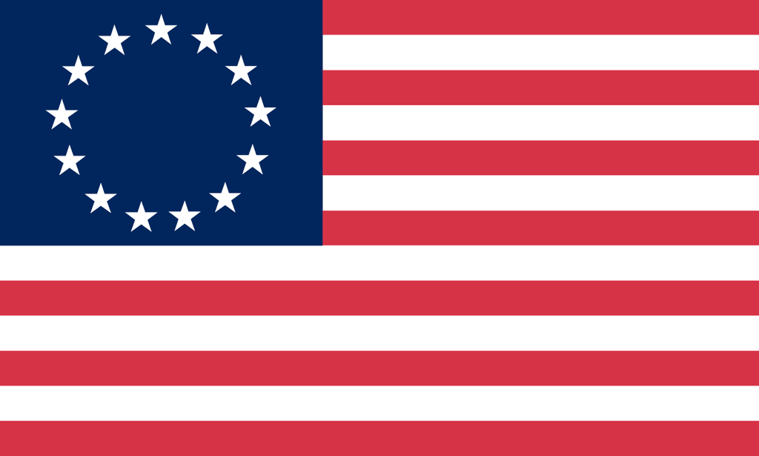U.S. History with Mr. Brown Name _______________________________ Period _____
Declaration of Independence
Lost in Translation
Directions: What did he just say? What does that even mean? Translate the portion of the Declaration of Independence on the left into your own words in the box on the right.

Preamble
When in the course of human events, it becomes necessary for one people to dissolve the political bands which have connected them with another,

That to secure these rights, governments are instituted among men, deriving their just powers from the consent of the governed.

a decent respect to the opinions of mankind requires that they should declare the causes which impel them to the separation

Rights of Man
We hold these truths to be self-evident, that all men are created equal, that they are endowed by their Creator with certain inalienable rights,

that among these are life, liberty and the pursuit of happiness.

That to secure these rights, governments are instituted among men, deriving their just powers from the consent of the governed.

That whenever any form of government becomes destructive of these ends, it is the right of the people to alter or abolish it,

and to institute new government, laying its foundation on such principles and organizing its powers in such form, as to them shall seem most likely to affect their safety and happiness.

Grievances
He has dissolved Representative Houses repeatedly, for opposing with manly firmness his invasions on the rights of the people.

He has kept among us, in times of peace, Standing Armies without the Consent of our legislatures.

For Quartering large bodies of armed troops among us:

For cutting off our Trade with all parts of the world:

He has plundered our seas, ravaged our Coasts, burnt our towns, and destroyed the lives of our people.

Colonial Responses
In every stage of these Oppressions We have Petitioned for Redress in the most humble terms:

Our repeated Petitions have been answered only by repeated injury.

A Prince whose character is thus marked by every act which may define a Tyrant, is unfit to be the ruler of a free people

Declaring Independence
We, therefore, the Representatives of the united States of America, in General Congress, Assembled,

appealing to the Supreme Judge of the world for the rectitude of our intentions,

do, in the Name, and by Authority of the good People of these Colonies, solemnly publish and declare,

That these United Colonies are, and of Right ought to be Free and Independent States;

that they are Absolved from all Allegiance to the British Crown, and that all political connection between them and the State of Great Britain, is and ought to be totally dissolved;

