Washington State Holstein Association
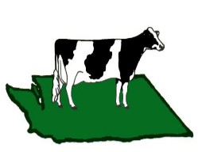
2025 Membership Application or Renewal

Name | Type of Membership  Adult or Junior | Email/Phone

National Member? Yes/ No National Holstein Account Name: ____________________________________________________

Farm Name: ____________________________________________________________________________________________________________

Mailing Address: _______________________________________________________________________________________________________
Street Address City Zip

Name of Area Club (if known): _______________________________________

Which state committee would you prefer to work on: _________________________________________________

Number of milking registered animals
(Includes animals 87% RHA and higher) ___________ @ $1.00 = ______________
(Maximum = $300.00)

Adult Memberships ___________ @ $30.00 = ______________

Junior memberships ___________ @ $5.00 = ______________

Scholarship Donation ______________
Donations to the Junior Fund help defray costs of attending National Holstein Dairy Quiz Bowl and other national contests. They also help pay costs of the Junior State Show.
Donation to the Junior Fund ______________

Grand Total $ ______________

PAYMENT OPTIONS
If using PayPal, use this QR code to submit payment then email or mail this form back, with this section circled.
Pay by Check:
Make Check Payable to:
WA State Holstein Assoc.
Include check with this form and mail to: Washington State Holstein Association
c/o Duane Davidson
2005 W 24th Ave
Kennewick, WA 99337
Pay with PayPal:

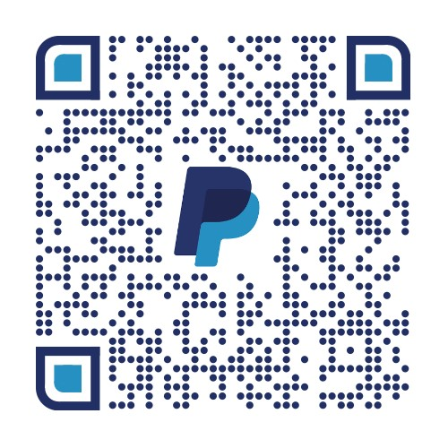

OR
wastateholstein@gmail.com

