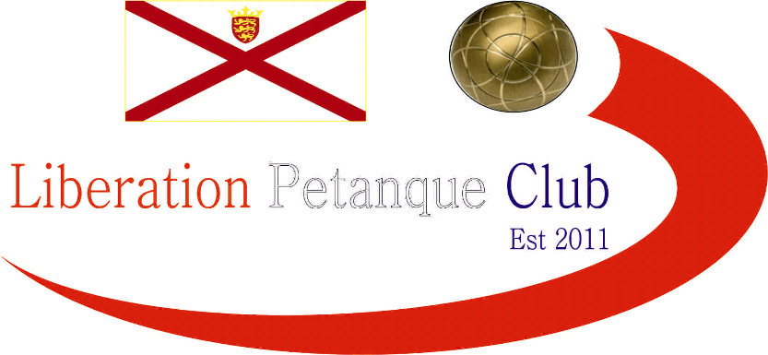

Summer 2023
End of Season
Report
What another great season it has been again this season with more new faces creating waves amongst the experienced members, we hope you all enjoyed it.
Premier League Double Champions
Andrew Bellamy-Burt & Callum Stewart
Well, its their first Summer Premier League Doubles title. Three times champions Laurent Pellaton & Matt Pinel finished Runners up. Neil Selby & Ross Payne again finished in the top three in third.
Commiserations to Branden De La Haye & Tim Jackson and Andrew & Lorna Limbrick who returned to Division 1.
Division 1 Double Champions
Dawn Buckley & James Gennoe
Wow, undefeated title win for Dawn & James with Daniel Deveau & Toby Northern runners up and Keith White & Mo De Gruchy in third place.
Commiserations to Colin Myers & Steve Simpkin and Daniel & James Villalard who were relegated.

Premier League Singles Champion
Geoffroy Buffetrille
Winning his sixth Premier League title and trailing Andrew for much of the season Geoffroy Buffetrille took his opportunity with Andrew dropping points late on in the season to finish Runners Up.
Third place went to Toby Northern
Commiserations to Tim Jackson, Alice Dilks and Andrew Limbrick who were relegated.

Singles Division 1 Champion
Daniel Deveau
Daniel stole the show this Summer taking the Division 1 title in his maiden playing season which meant Joey had to settle for second place.
Brigitte Ibitson five match winning streak towards the end of the season saw her take third place.
Commiserations to Branden De La Haye, Lorna Limbrick and Cassie Stewart Le Gallais on relegation.

Club Singles Cup Winner
Laurent Pellaton
Laurent won his first Singles Cup beating Andrew Bellamy-Burt in the final with Andrew Limbrick third.

Club Doubles Cup Winners
Keith White & Mo De Gruchy
A shock this season as Keith & Mo beat Gary Cowburn & Wendy Ritzema in the final with Nwil Selby & Ross Payne taking third.

Club Super 7’s Cup Winner
Geoffroy Buffetrille
Geoffroy Buffetrille won his second Super 7’s title beating Andrew Bellamy-Burt in the final with Paul Bell taking third.

Club HandyCap Cup Winner
Keith White
Another win for Keith beating Jim Waddell in the final with Geoffroy Buffterille third.

Club Precision Shooting Cup Winner
Callum Stewart
Just three players scored the minimum amount required to progress with Paul Bell runners up and Ross Payne third place.

#

Liberation International Singles Open Winner
Benny Bel Lafkih
All the way from Norway!

Liberation International Doubles Open Winners
Simon Bird & Ian Barnes
From England!

Liberation International Triples Open Winners
Benny Bel Lafkih, Gabriel Bel Lafkih and Eli Gjenstoe
All the way from Norway!

Player of the Seasons

Find out at the End of Season Presentation

None club tournaments won by members
Island Singles Championship
Andrew Limbrick

Island Doubles Championship
Laurent Pellaton & Toby Northern

Island Mens Triples Championship
Andrew Bellamy-Burt, Callum Stewart & Laurent Pellaton

Special Thanks

Club Committee – Toby Northern, Matt Ryan & Geoffroy Buffetrille

Other Helpers –Laurent Pellaton for their hard work on the terrains and support throughout the season. Gary Cowburn and Wendy Ritzema and anyone else who has helped out setting up the terrains for competitions/leagues etc and running competitions, very much appreciated.

Well, I hope you have all enjoyed the season and are looking forward to playing again in the Winter 2023 / 24 season.

Kind Regards

Toby Northern

Chairman

Liberation Petanque Club

