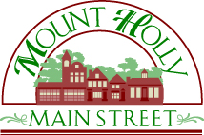
Robert V. Drapala
Mount Holly Car Show Committee Chairman
Ph: 609-346-2416
Email: msmhnj@gmail.com
www.MainStreetMountHolly.org
PO Box 747, Mount Holly, NJ 08060
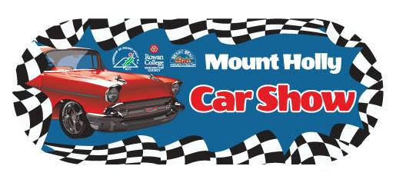

Sponsorship Agreement

Sponsor Information:

Name/Business (as it should appear in marketing materials): __________________________________________

Website Address: _____________________________________________________________________________

Contact Name: _______________________________________________________________________________

Street Address: ______________________________________________________________________________

City: _______________________________________ State: ________________________ Zip: _____________

Email: _____________________________________ Phone: __________________________________________

Please provide a business card if possible.

We agree to pay Main Street Mount Holly the amount of $___________________ for the ___________________ level sponsorship of the Mount Holly Car Show. The Mount Holly Car Show committee agrees to provide the benefits outlined described for that level in 2018 Mount Holly Car Show Sponsorship Flyer.

Authorized Signature: __________________________________________________________________________

Date: _______________________________________________________________________________________

Please make check payable to “Main Street Mount Holly”. We can also accept PayPal (please just email us and we can send you a link for payment.) PO Box and email address are listed at the top of this form.

Thank you for your support!

Proceeds from the event benefit Main Street Mount Holly, a volunteer-driven nonprofit organization, whose mission is to protect, promote and enhance our historic downtown. Main Street Mount Holly is a NJ 501c3 registered organization so your donation is tax deductible (EIN 04-3668475).

