THE BIBLE PROJECT

Getting IT (What the Bible Means)
(Interpretation/”Hermeneutics”)

THE KEY:
You search the Scriptures because you think they give you eternal life. But the Scriptures point to me! -- Jesus [NLT, John 5: 39 ]

Bible Text ~~~~~~~~~~~~~~~ Reader

PRINCIPLES

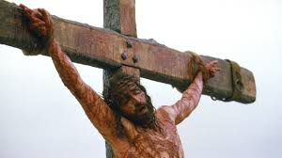

- Think Hebrew instead of Greek: doing v. thinking; concrete v. abstract; historical v ideological… Pictures, drama and video is Hebrew-think: descriptions, philosophy and equations are Greek-think. It’s the statement in one of the debates: “we need more welders than philosophers.” When God speaks, it’s not thoughts it becomes reality. And God said, “Let there be… and there was…” Not the philosophers: I think, therefore I am. (Cogito ergo sum.) Man defines love; God exhibits it.

- east-think
- Relationship with Nature
- Unit or Community?
- Abstract or Concrete?
- Pointing or defining?
- Cognition or demonstration?

- Limitation Principle: the Bible is not meant to tell us everything about everything. It is true in what it intends to teach.

- Historical Principle: God works in history—actual events. He is not contained by contemplation or theory. Therefore, history is itself revelatory and when God wants to be revealed, he does NOT send more words, but a person. And the final revelation is the WORD incarnate, not in writing or a vision or a message.

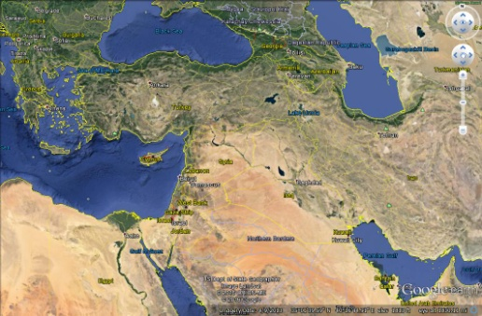

- Geographical Principle: Where an event takes place expresses a whole lot of its meaning. Again God’s revelation is in time and SPACE.

- Literary Principle: The interpretation of a passage depends on its literary form. Is it prose? Is it imperative? Is it narrative? Is it poetry? Is it story? Illustration? Parable? Metaphor? Meaning comes from form as well as content.

- Scriptura Principle: Scripture interprets scripture.


- Faith Principle: Jesus says to the Pharisees, you see not because you believe not—Jn. 9. Understanding is enhanced, even enabled, by belief. Doubt obscures, trust enlightens. So the believer approaches Scripture trusting that it is true and seeking to be shown.

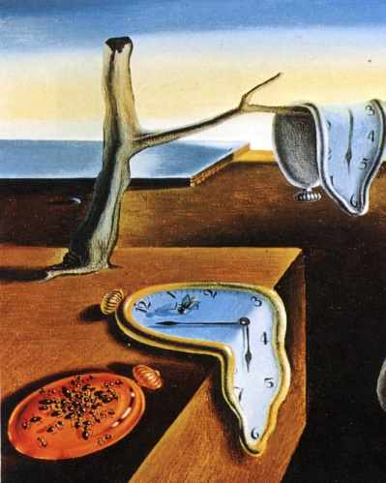
- Number Principle: Numbers in the Bible rarely are meant to be arithmetical or accounting tools. They carry meaning.

- Progressive Principle—Lobster (Mark 7: 18-19) God does not reveal everything in the OT. Further revelation comes as history progresses so that what Jesus teaches supersedes and corrects what we thought we knew from the OT.

10. Repetition Principle – The Bible is the same story over and over again. Not all learn quickly or in the same manner so it’s important for information to be repeated in many different ways. Of course, auditory and visual presentations of the same material immediately come to mind. Repetition, repetition, repetition.

12 Music Principle - A great deal of Scripture is remembered in song/psalm. Much of the scripture that we can remember and quote often comes from having sung it in a song or hymn. Music offers an easy way to fill hearts and minds with God’s word. For some reason it’s not as easy to retain just words…….but put them to music and we are “hooked”.

13.Shelf Principle: Be willing to put what you don’t understand on the shelf until you get further along.

14. THINK HEBREW
Assignment 1 to prepare for Week 2: Genesis 1

THINK HEBREW SUMMARY

GREEK HEBREW

Compete Cooperate
Individual GROUP (family/nation)
Abstract Concrete
Defines Points
Truth-Prose Truth-Poetry
Systematizes Accepts
Syllogism Paradox
Lit: Philosophy Lit: Story
Reality-Ideas Reality-History
God: Ideal Being God: Holy Personality
Error: Wrong thought Error: Disobedient act
Know thyself Know God
Contract Covenant

BIBLE PROJECT

Student Assignment 1

(to be handed out after the first meeting/GETTING IT.

OT -1 Genesis 1: Creation, CREATOR, Creatures
READ
Genesis 1:1 – 2:24
Psalms 8, 23, 46: 1-3 and 121
Search Psalms for other creation-related references (divide up Psalms among class members)

SEARCH for other ancient creation epics—use internet? Gilgamesh, for example.
What were the other ancient creation stories?

What is the prevailing modern/post-modern view of creation?

ANALYZE:
Gen 1:1-2:7: highlight days; Highlight what/who is created on each day. Highlight what’s repeated in the text.

CONCEIVE:
Images of CREATION
Have you seen a depiction in paintings/movies/music that gets the point of creation across?
Create something—sculpture, pottery, painting, craft, poem, song. It matters not how perfect. Bring it to share.

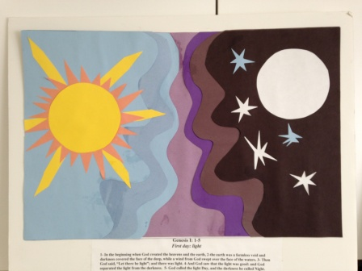
Markers:

(Make flash cards—either manually with 3x5 cards or with a flash card app for your smart phone.)

Genesis 1—Days of creation

Genesis 1—Image of God

Genesis 1—Cultural mandate

Genesis 1—All things created good

