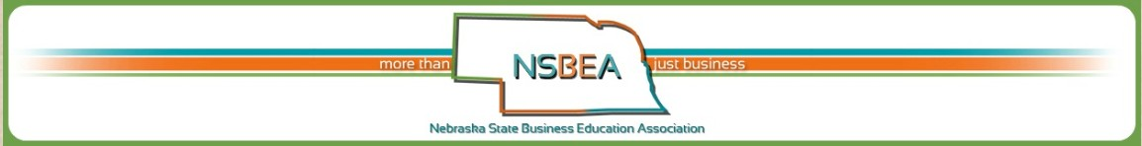

NSBEA Professional Development Stipend

NBEA Conference Attendee (2 @ $600)

LDI NCE Conference Attendee (5 @ $75)

LDI M-PBEA Conference Attendee (2 @ $250)
All Documents Due by Date Listed on Website

Stipends are awarded to NSBEA members who would like to attend NBEA, LDI NCE, and/or LDI M-MPEA in 2017- 2018. Members applying for this stipend MUST be members of BOTH NSBEA and NBEA.

Name:

Address:

Phone Number: E-Mail Address:

School/Organization:

Which conference would you like to attend?

Attending the conference will benefit me and our organization in the following ways:

NSBEA Membership Date Joined NBEA Membership Number
(If you already are a member OR the date you mailed your membership.)

Please send LDI NCE to: Please send NBEA & LDI M-PBEA to:
Kelly Means Deb Wolken
kdmeans@cox.net dwolken@lps.org

(Documents can be sent to the above email address. Indicate NSBEA Stipend in the subject line)

The winners will be notified in April, and the scholarship will be awarded Wednesday evening June 6, 2018 at the Nebraska Career Education Conference, June 4-7, 2018 in Kearney, Nebraska during the NSBEA/DPE Banquet.

