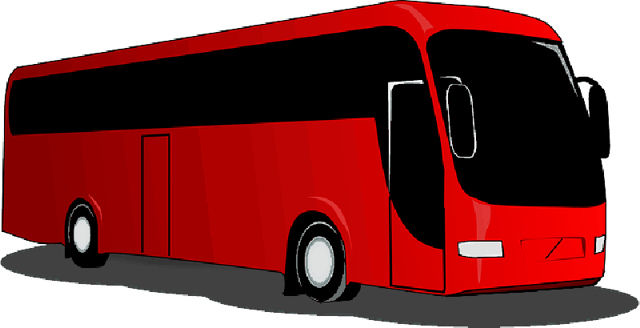
Girl Scouts Bus to Bentleyville
When: December 15th
Time: 2pm-9:30pm
Where: Meet at Southview Elementary by 1:30pm
We will return by 9:30pm at Southview Elementary
The bus will head up to Bentleyville promptly at 2pm. We will watch movies on the bus, play games, sing songs and have a drawing on the hour for fabulous prizes. We will have a pizza dinner on the bus too!
Cost: $25.00 per rider
Payment can be sent to PayPal jjank825@yahoo.com
Or cash/check to Jen Kane
992 Whitney Dr Apple Valley MN 55124
Any questions please let me know 651-434-2976
*We need at least 40 people for this event to work. If I don’t get enough by Dec 10th the event will be cancelled.
Please send payment before the 10th to reserve seats on the bus
https://www.bentleyvilleusa.org/

