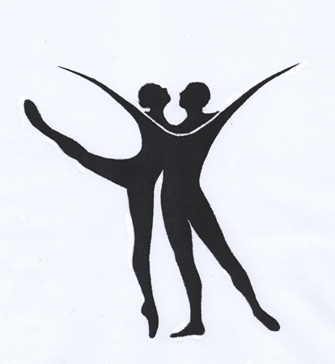
Central Maryland Youth Ballet
-Individual Attention in a Creative Atmosphere-
Kimmary- Williams & Jacob Rice: Artistic Directors
443-472-7772
www.cmyb.org
2017 Nutcracker Performance
Participation Contract
Dec. 9 & 10 Performance Dates

Production Fee $200.00 Due Saturday Sept. 30th 2017
*Your production fee will include a complimentary performance DVD and a photo DVD of both performances.
(Please make checks payable to: CMYBC)

Dancer’s Name: _____________________________Age:_____
Ballet Class Level: ___________________________________
Parent / Guardian’s Name:_____________________________
Home phone: ______________ Cell phone:________________
E-mail:____________________________________________

*I understand my child will be required to attend all scheduled rehearsals in order to participate in the Nutcracker Performances. Dancers will be allowed some excused absences over the Rehearsal Period. (Sept. – Dec. 2017)

Release of Liability:
I, the adult applicant or I, the parent or legal guardian of the enrolling student listed herein, hereby give approval of the applicant's participation in any and all Central Maryland Youth Ballet programs and activities for which they are registered and assume the risks associated with those activities, and agree to pay tuition in a regular and timely fashion. I waive, release, absolve, indemnify and agree to hold harmless CMYB, it's directors, faculty, contracted instructors, participants, school/performance locations and persons involved in the operation of Central Maryland Youth Ballet's programs for any claims, demands or causes of action which are in any way connected with, or may arise from the participation of the applicant in these activities, including but not limited to any injury or other loss to named applicant or any member of his/her family whether as a participant in the activities or as a spectator.

I also give permission for Central Maryland Youth Ballet to take photos and/or video of me or my child to use for the web site and for purposes of promoting the school.

*I have read and agree to this release.

Parent/Guardian Signature:___________________Date:_______

Please provide the following information.

Girl’s Dress Size: __________ Boy’s pant’s size:_____________

Girl’s leotard size:___________ Boy’s shirt size: ______________

Girl’s tights size: __________ Boy’s tights size: _____________

Girl’s street shoe size: _____ Boy’s street shoe size: _____

Girl’s ballet shoe size: _____ Boy’s ballet shoe size: _____

Please do not write below this line.

Height: _______
Neck: _______
Chest: _______
Waist: _______
Hip: _______
Girth: _______
Inseam: _______ Out seam: _______
Arm Length: _______
Shoulders: _______
Neck Back Seam: _______

