

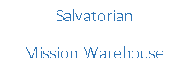

Summer 2017

Dear Friends,

On Earth Day, my 5-year-old son, Nicholas, and his class were asked to go outside and assess the litter that was blowing around the school yard. When his teacher asked the class what they could do about the trash, Nicholas was not shy and very quick with his response. He said, “We should go back inside so we can’t see it!” It was a very funny, very cute response to a social justice calling. However, we are no longer children and cannot simply turn away and go back inside when we are faced with the needs of the world.

A head-on response was not any more evident than what I witnessed at two parishes I visited: St. John Evangelist in Kohler and Blessed Trinity in Sheboygan Falls. A longtime volunteer of the Salvatorian Mission Warehouse, Jack Egan, approached me and asked if these two parishes could help in any specific way with the missions. I told him there was a tremendous need for rice in Africa, especially in Tema, Ghana. Soon, Jack and his team came up with the “Rice for Ghana” initiative and I found myself talking at both parishes as we kicked off Lent. Rather than turn back and go inside, these parishes responded by giving over $18,000 to send a container filled with rice for Ghana. This positive response to donate for the rice, has ensured over 400 families will be fed for a good portion of the year!

Often, I have parishes and groups ask me how they can specifically affect one of the social justice issues we face as a world: hunger. In reality, the issue with hunger is not that we don’t have enough food to feed the world; we simply haven’t come up with a reasonable way to effectively transport the food to the people who need it. The ministry of the Warehouse has helped curb this problem because our missions have direct contact with families needing food, particularly rice. Our overseas missionaries receive 20' containers of rice, and give it to families who are in need. The process is relatively simple, and the emails and pictures returned from the missions, show the immediate impact.

So, what can your parish or organization do to make a real impact on the hunger in the world? Please consider doing what these two very generous parishes did: start a campaign to provide rice for African nations. If you are local to the Warehouse, I am happy to visit and share details with your group. For those interested, but not nearby, we have many resources available on our website [www.salvatorianmissionwarehouse.org](http://www.salvatorianmissionwarehouse.org) and Facebook <https://www.facebook.com/salvatorianmissionwarehouse/> that help demonstrate the impact these containers have on the lives of those most in need.

God bless all of you and the wonderful financial help you always provide to the Mission Warehouse. God’s work through the Mission Warehouse would not exist without your constant support. Enjoy this summer’s newsletter and please consider joining us for our annual open house for all donors and volunteers August 20th this summer.

Peace in Christ,

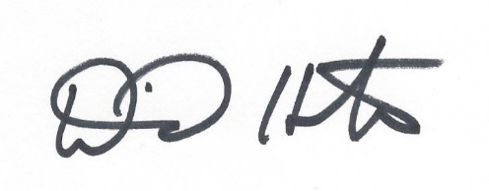

**Some of the Many Letters of *THANKS!***

***See more pictures at*** [***www.salvatorianmissionwarehouse.org***](http://www.salvatorianmissionwarehouse.org)

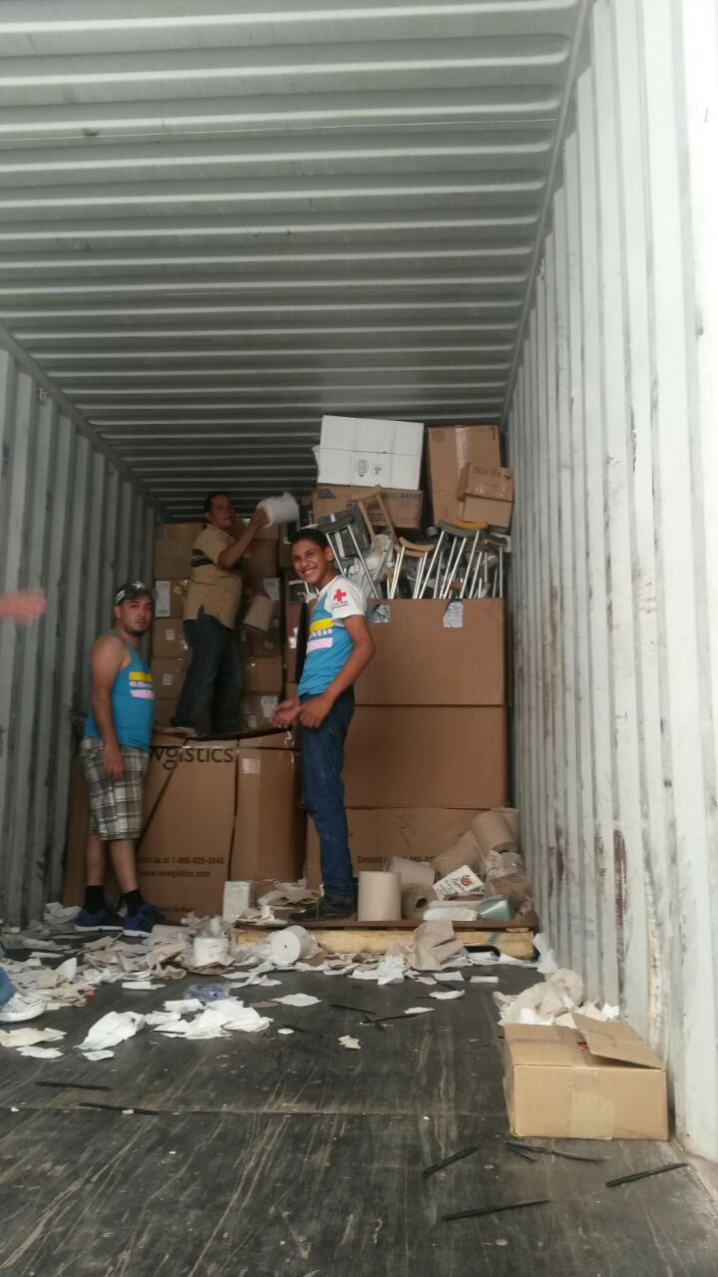

Dear Dave,

They loved all of the Beef Jerky. Roque has been distributing these items out to the poor people from many different areas.

Also, the mayor of Omoa was telling me the story about the cracker sticks that you send to them. For some of the poorer families, the children will put some of those sticks in a glass and put some milk around them and that is their breakfast for the morning. It's hard to realize that those cracker sticks are so valuable to many of the students in Honduras.

Even though they can be difficult with the containers in Honduras, thanks for all of your help. They are SO GREATLY APPRECIATED!

Blessings,

*Fr. Greg, Honduras*

Dear Friends at Salvatorian Mission Warehouse,

With a heart filled with gratitude, I wish on behalf of the Missionary Society of St. Theresa of the Little Flower to thank you so much for the container of sorted charitable goods for the children at St. Therese Youth Development Center in the village of Kaluri in the Diocese of Wa in Ghana. We simply do not have enough words to thank you enough.

The desks are already in use in our classrooms and the tools are used to fix broken items, and the children are enjoying the beef jerky and chocolate. Thank you so much for your ministry and may the good Lord bless you.

*Fr. Paul Kala, Ghana*

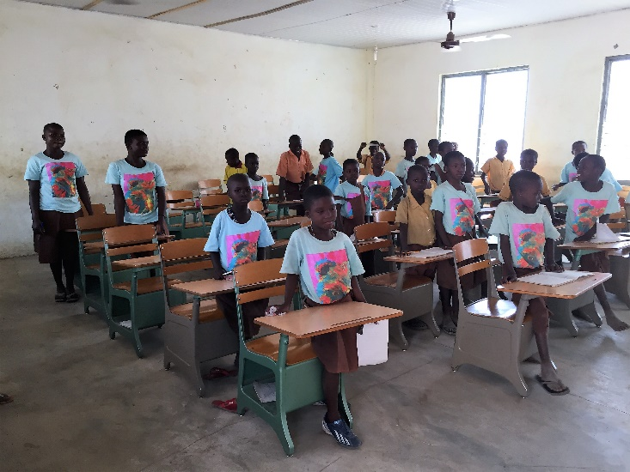

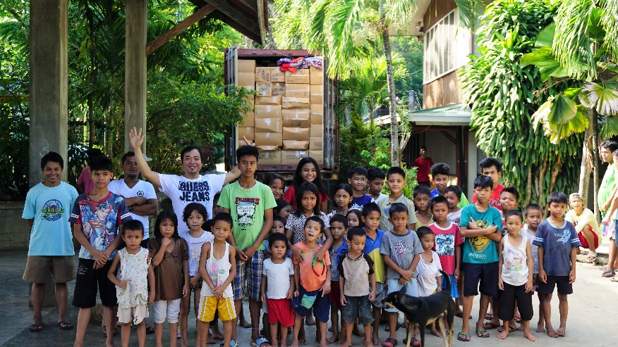

Greetings from Zamboanga!

The container finally arrived yesterday and it has been unloaded.

Thank you, Dave, for your patience and good work. The many items will be very useful to us. Please find attached some pictures of the unloading of the container and some of our children.

Thank you and God bless! Our children thank you so very much more.

*Fr. Art, Philippines*

**25 Shipments January – May, 2017**

**Relief Goods – Total of 475,241 lbs.**

* 13 to Ghana, Africa
* 1 Nigeria, Africa
* 2 Guatemala, Central America
* 1 Chile, Central America
* 1 Panama, Central America
* 1 Ecuador, South America
* 2 Paraguay, South America
* 1 Peru, South America
* 1 Chuuk, Micronesia
* 1 Haiti, North America
* 1 Philippines

**Plus 7 Rice Shipments to Ghana, Africa *(44,000 lbs. each)* totaling 308,000 lbs.**

Average shipping and rice purchase cost –

$14,000 per 40 foot container.

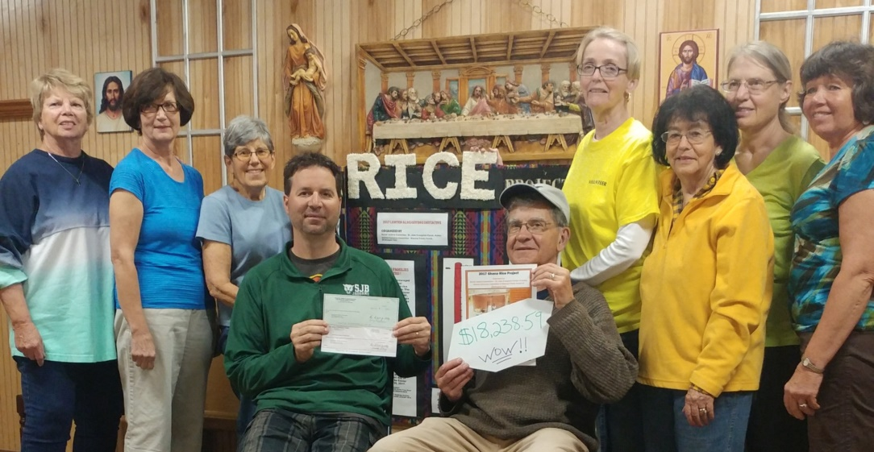

Jack Egan and ladies from St. John Evangelist & Blessed Trinity Parishes present a check for $18,238.59 to Dave Holton. Funds were collected from their Ghana Rice Project during Lent of this year.

**Other News & Special Requests**

* There continues to be **great need for bars of soap and shampoo**. Please consider a simple donation of new soap. You can order online and have it shipped right to the warehouse! We have had success purchasing from [www.dollardays.com](http://www.dollardays.com) and have ordered item #1790516 – Ivory Simply Bath Bar Soap.
* Our mission in Micronesia has made a special request for **musical instruments and science equipment**. Their high school was washed away in the last Tsunami. We will also be sending to another mission in Tanzania, Africa that is establishing a new school. They have requested **desks and farming tools** (including tractors). Please let us know if you are aware of a school updating their classrooms, sports uniforms or curriculums (no text books). Pick up can be arranged, contact [dholton@salvatorians.com](mailto:dholton@salvatorians.com) .
* Looking for a guest speaker to encourage fundraiser participation at your work, school or church? Dave Holton, Salvatorian Mission Warehouse Director, is excited to spread the word about how each of our thoughts, prayers and financial support can make a huge impact on those in need around the world.

Bring your **Church,** **School**, or **Work** group to the Mission Warehouse!

We would love to have your group of volunteers come and spend a morning learning and helping the many missions the Warehouse serves. Bringing a Church, School or Work group to the Mission warehouse is a great way to promote social justice and team building. We can take groups from 5-50!

**Group Volunteer Hours:**

Monday through Friday 8:30-11:30am.

Monday & Tuesday afternoons 12:30-3:30pm.

To schedule or to find out more information, please contact Dave Holton [dholton@salvatorians.com](mailto:dholton@salvatorians.com) or Beth Holbrook [bethholbrook@salvatorianmissionwarehouse.org](mailto:bethholbrook@salvatorianmissionwarehouse.org).

**Annual Volunteer & Donor Celebration**

*\*All people who donate and/or volunteer at the warehouse are welcome!*

Date: Sunday, August 20th, 2017 *(rain or shine)*

Time: 10:15am Outdoor Mass, followed by catered lunch

Location: Salvatorian Mission Warehouse *(outside – backyard)*

1303 Milwaukee Drive, New Holstein, WI

Bring: Lawn chairs or blankets for sitting

No need to RSVP

***Special recognition for years of service for John & Honey Leibham***



Donor Name (s)

Mailing Address

City State Zip

Phone ( ) Email

Please accept my gift of $

Salvatorian Mission Warehouse

1303 Milwaukee Dr., New Holstein, WI 53061

***Donations also accepted through PayPal at*** [***www.salvatorianmissionwarehouse.org***](http://www.salvatorianmissionwarehouse.org)