CELEBRATION OF WORSHIP August 7, 2022

Prelude “He is Lord” medley Fettke

Welcome and Announcements
Opening Ourselves to God

Call to Worship Psalm 138 NRSV Pg. # 709

*Hymn # 336 “There Is a Fountain”

Confession of Sin
Merciful God, We confess that we have sinned against you in thought, word, and deed, by what we have done, and by what we have left undone. We have not loved you with our whole heart and mind and strength. We have not loved our neighbors as ourselves. In your mercy, forgive what we have been, help us amend what we are, and direct what we shall be, that we may delight in your will and walk in your ways, to the glory of your holy name.

*Affirmation of Faith (The Apostle Creed)
I believe in God the Father almighty, maker of heaven and earth; and in Jesus Christ his only Son, our Lord; who was conceived by the Holy Ghost, born of the Virgin Mary, suffered under Pontius Pilate, was crucified, dead, and buried; he descended into hell; the third day he rose again from the dead; he ascended into heaven, and sitteth on the right hand of God the Father almighty; from thence he shall come to judge the quick and the dead. I believe in the Holy Ghost; the holy catholic church; the communion of saints; the forgiveness of sins, the resurrection of the body; and the life everlasting. Amen

*Gloria Patri “Glory Be to the Father”
Glory be to the Father, and to the Son, and to the Holy Ghost; As it was in the beginning is now and ever shall be, world without end. Amen, Amen.

Giving of Tithes and Offerings

Offertory “Holy Ground“ Davis

*Doxology
Praise God from whom all blessings flow. Praise Him all creatures here below. Praise Him above ye heavenly host. Praise Father, Son, and Holy Ghost. Amen

*Hymn # 342 “Rock of Ages”

Hearing God’s Word

Scripture Readings:
Old Testament “James 5:13-20” NRSV Pg. # 281

Sermon “Power of Prayer” Heath Dennison

*Hymn # 581 “ ‘Tis So Sweet to Trust in Jesus”

Prayers of the People

Benediction Lord’s Prayer
Our Father who art in Heaven, hallowed be Thy Name, Thy kingdom come, thy will be done on earth as it is in heaven. Give us this day our daily bread, and forgive us our debts, as we forgive our debtors
and lead us not into temptation but deliver us from evil; for thine is the kingdom, and the power, and the glory forever. Amen.

Postlude “Love Lifted Me” Smith *Congregation Stands (All who are able may stand)
Worship Service Notes:

Worship: 11:00
*************************************************************************
We welcome all visitors who are worshipping with us today. Please fill out the Welcome card located in the pew and place it in the offering plate. Thanks for visiting with us and we invite you to make this your church home. If you are interested in joining this congregation, you may do so by 1) profession of faith, 2) transfer of letter of membership from any Christian congregation, or 3) re-affirmation of faith when you meet with the Session. Please ask our Pastor or one of our Elders for additional information.

LET US JOIN IN PRAYER FOR
Church Members: Rose Stallins, Rose Owens, and Sally Teer.
St. Andrew’s Friends: Rick and Emily Hataway, A friend of the Wades, Lorie Torres.
Announcements:
Sadly, long term member of this church, Edna Earl Kelly passed away earlier this week from Covid. She was 103 years old. Graveside services will be held Monday, August 8 at 11:00 am at Greenwood Cemetery. A memorial service will be held at a later date. Sympathy cards may be sent to her daughter, Karen Williams at 2301 Andrews Rd, Lynn Haven, FL 32444.
Bible Study – Wednesday’s at 4:30pm.
Happy Birthday, today August 7, to Sara Daffin.
Birthday Wishes: Wanda Sherman-Aug 11th and Emily Hataway-August 12th
50th Wedding Anniversary congratulations to Jimmy and Jennifer Whisenant on August 12th.
As we approach the 136th anniversary of the September 13, 1886 founding of the church, it is important to remember our history. The original church building was completed on July 22, 1888 but was relocated from Drake and 14th St to 14th and Bayview on June 8, 1917. The watercolor rendition on the bulletin cover was prepared by Sheila Palmer. More history in future bulletins.

VILLAGE CHURCH OF
ST ANDREWS
Established September 13, 1886

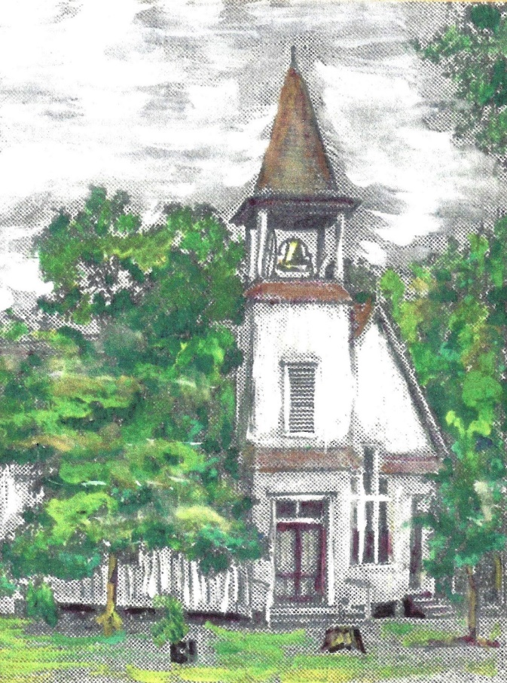
Historical Bulletin Cover Series
Where a warm welcome awaits you!
3007 West 14th Street, Panama City, Florida 32401.
Phone 850/785-8358 standrewspresch@knology.net
Heath Dennison Worship Leader
Wanda Sherman Music Director
August 7, 2022

