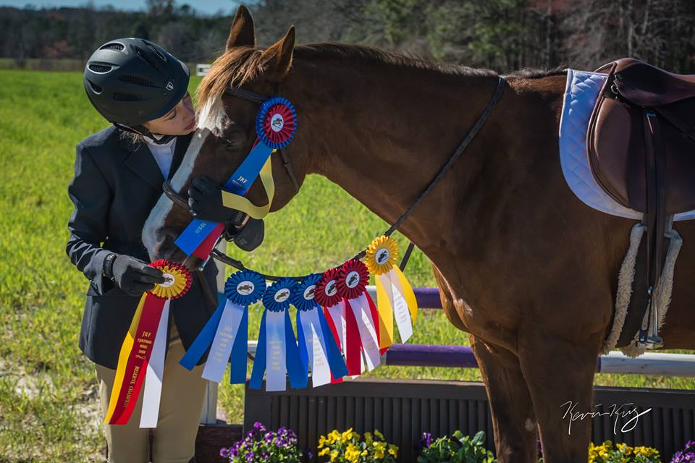
Little Miss Impressive "Rachael"
DOB: September 18, 2001
​SIRE: Unknown
DAM: Unknown
HEIGHT: 15.3 HANDS
BREED: QUARTERHORSE
​DICIPLINE: HUNTER
JRF purchased Rachael in September of 2016 after a year of leasing her for the lesson program. Rachael is the Go To Gal for teaching anyone from beginners to advanced as this mare can hang with the best of them. She has a sweet and agreeable demeanor and a pretty mover which catches the judges eye at the shows. Rachael is currently leased out by our student of the month, Brooke, and they are making great progress towards the 2018 show season. Rachel has recently overcome an eye injury which threatened the likelihood Rachael would be able to keep her eye. After continuous treatments around the clock for two months, Brooke’s love for her horse and an excellent vet, Rachael was able to pull through with only minor cosmetic changes. Rachael’s winning attitude and perseverance has earned her “Horse of the Month” honors.

