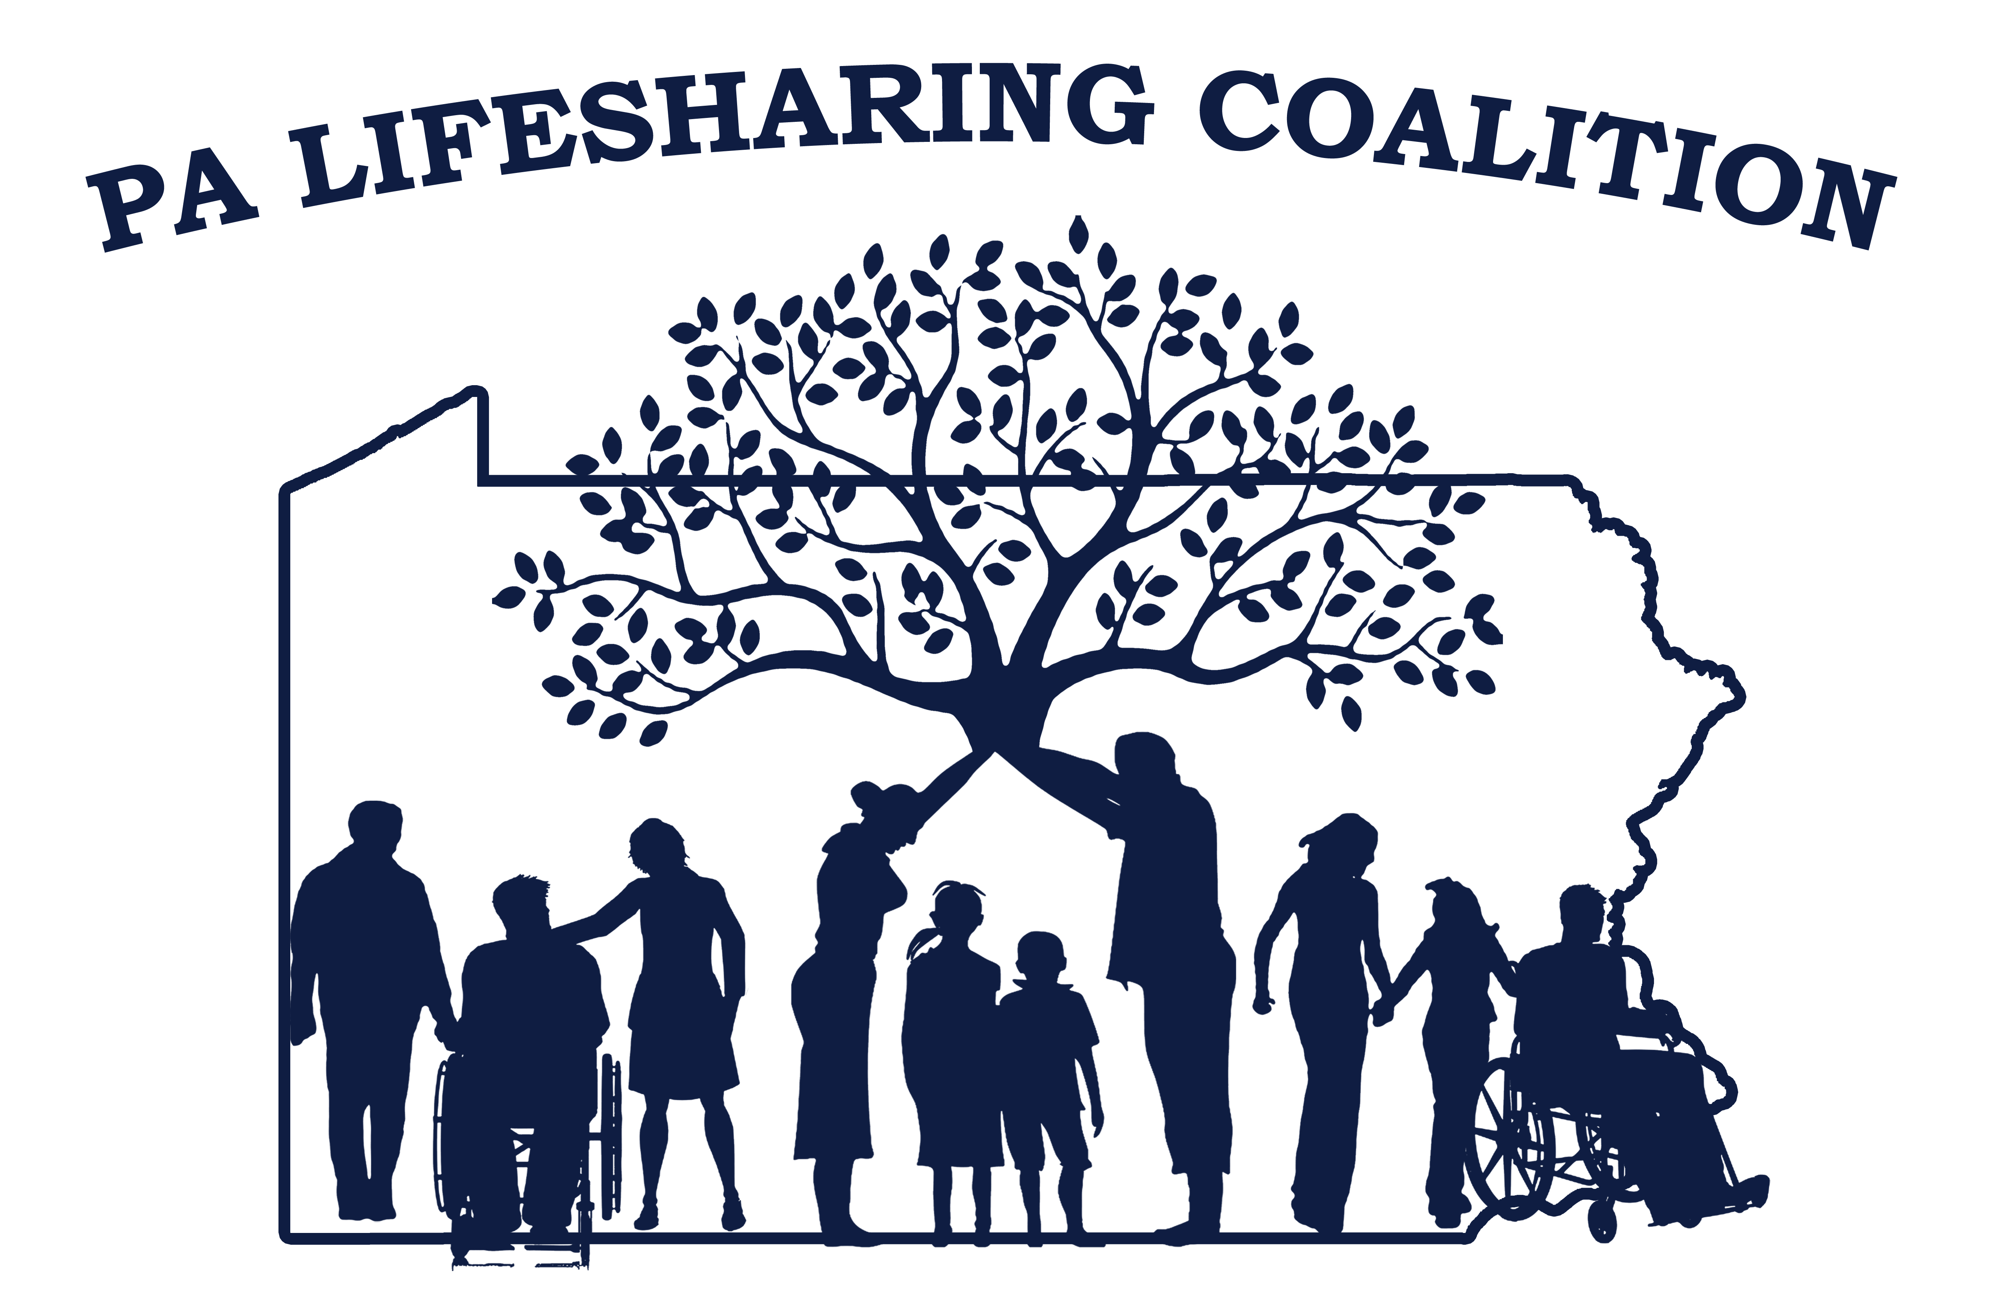
Lifesharing State Coalition
April 19, 2018 10am-3:00pm
Mission: The mission of the PA Lifesharing Coalition is to promote, support, and embrace the concept of Lifesharing and the philosophies of self- determination and everyday lives.
Question or topic | Owner | Decision/ Information | Come Prepared to | Outcome | Allotted Time
Opening round- the rates for lifesharing went up January 1st, overall did your agency’s lifesharing revenue go up or down? | Facilitator | Group Discussion—several agencies stated that they have been able to pass some of the increases on to the lifesharing providers; others are looking to do so; some are basing the increase in stipends of needs assessment and some are including longevity of the provider as well | Introduce Yourself
Reminder of Positive and Productive Meeting format | Facilitator | Information/  Group Discussion—reviewed format
ODP Updates  Self-Inspection and Tool updated- on website  Entrance Conference Guide for Chapter 6500 – recommendations – not mandatory  ODP 023-18 ISP Manual Update- Lifesharing Codes in the Consolidated and Community Living Waivers (2/27/18)  ODP 026-18 Clarifications of Residential Service Staffing Ratios and Supplemental Habilitation Services (3/9/18)  ODP 027-18 CDS and Fire Safety Licensing Requirements (3/9/18)  ODP 028-18 Lifesharing and Respite Question and Answer Document (3/20/18)  ODP 031-18 Electronic Visit Verification Update (4/5/18)  ODP 035-18 HCBS Settings Self -Assessment Period (4/11/18) DUE June 12, 2018.  ODP 00-18-01 Guidelines Concerning Sexual Health, Personal, Relationship, Sexuality  ODP 033-18 Person Centered Thinking Training—Malvern and Hbg—two day training |  | After discussion with Ron Melusky, ODP updated the Chapter 6500 Self –Inspection Instructions and tool and posted them to the website.  ODP recommends, but it is not necessary.  The ISP manual was updated 2/27/18. The 522 code was added and definition of day.  People are a little confused about supplemental hab. You may use the communication as a reference. Ron spoke about the service during the morning session.  College of Direct support has a training that meets 6500 Regs  PAR Teresa Miller and Nancy Thaler were not sure if the electronic visit verification will impact our services.  HCBS Self-assessments are due by June 12th. Reminders will be sent June 5th.  Guidelines Concerning Sexual health etc. was placed in parking lot for future review. Please check your agencies polices
Open Minds –April 2018 State Coverage of Shared Living for Adults with I/DD |  | NASDDDS Shared Living –a new take on an old approach  Shared Living Guide (2011) State by state review (79 pages) interesting reading
2018 PAR Conference—October 22, 23, 24 at Hilton in Hbg |  | Nurses work group was added to PAR meets April 24th  HR Roundtable- May 10th  Fiscal—May 8th  Coalition looking to offer to present possibly on biological families and lifesharing
RCPA Conference---October 1-4 –Fueling the Future—Hershey Lodge
Imagine Different Coalition |  | Survey by Lifesharing Coalition will go out in the next month or so asking if agencies support children in lifesharing and if they would be interested in connecting with Imagine Different
Focus Group Kathy T. | Kathy T | Focus Group – There was discussion surrounding guardians. We will invite Rick Smith to speak to fiscal issues and possibly someone from DRP to talk about guardianship around decision making  Discussion Surrounding the reduction of rate if you are serving 2 individuals in a home. This question will be addressed with Rick Smith.  There’s no update on the med admin training  Licensed professionals do not need to go to diabetes training according to the current Med Admin training.  Clarification on Interpersonal Dynamic training. What is interpersonal Dynamics training? You may choose to rename your family dynamics to interpersonal dynamics and family dynamics. It’s a matter of semantics.  Questions regarding tax exempt status surrounding biological families. ODP cannot make any statement related to status related to birth family. Providers should have their own attorneys or tax person if in fact it would be tax exempt.
PATH Areas of Focus |  | Lifesharing Expansion subgroup- the areas of focus on is trying to get data from ODP regarding numbers by counties. Looking at what is available for support coordinators to use. Powerpoint needs updated. Coalition Brochure is almost ready. Look at ODP video and decided to determine if there is a way to develop something that is short that could be used by SC’s. If you want to join the group contact Sarah Shaw or Kate Park  Service Definition’s ISP manual, RCG’s – talked about the HCSBS survey; next call tomorrow; **Regional Agenda Item—looking for input from group regarding RCG  Birth Families Providing Lifesharing Services- working on developing a draft Pre-service agreement, Training for families, Developing best practices.
2017 Lifesharing Conference | Sunday Z | Conference Update- Date October 15 & 16th at Seven Springs. “Light a Spark, Start a Lifesharing Firestorm” is the theme. Kristen Mattei is keynote speaker. Putting a panel of providers who have been providing services for 20 years plus. Please contact Alison Karnish, if you have any providers interested. Please submit suggestions for breakout sessions. Any suggestions for a person who does the guided painting session. Please let Alison Karnish know. Save the Date will be going out shortly.
Regional Reports | All Regional Leads | Western Region. Looking for another lead. Anna Rankin has moved on. Next meeting May 17th 10-1:30pm  Southeast Region - Next meeting at Kencrest May 15th.  Central Region- May 16th next meeting, in State College  Northeast- Picnic July 20th, Next meeting at CSG in Bethlehem May 8th.
Lifesharing Website |  | E Please visit our PA Lifesharing  Website at: palifesharing.com
Hot Topics- Any issues to take to State Committee? Any innovated ideas or approaches to share? | Facilitator | Out of home respite is 16 hours, if it’s in home it’s 8 hours ****Regional Agenda Item—how are agencies paying people?
Parking Lot- | Facilitator | Group Input/Discussion— ODP 00-18-01 Guidelines Concerning Sexual Health, Personal, Relationship, Sexuality
Closing Round: | Group | Next meetings:  June 21, 2018—State College  August 16, 2018—Camp Hill  October 15-16, 2018--Conference  December 6, 2018—Camp Hill  Month Leadership Date Coalition Date Location Region Responsible Note Taker  April 18 19 State College Western Northeast  June 20 21 State College Northeast Western  August 15 16 Camp Hill Western Southeast  December TBA TBA Camp Hill Southeast

Roles for April Meeting
Facilitator: Carrie Kontis
Agenda Builder: Carrie Kontis and Leadership group
Note Taker: Joe Karpinske
Timekeeper: To be assigned
Ground Rules:
1. Arrive on time & start training at 10am. Take Lunch orders and ask for lunch to be served by at 12pm
2. No side conversations while other participants have the floor a trainer is presenting.
3. Take Cell phone calls out of the meeting area
4. Parking lot items – the Parking Lot Method will be used for items that should be put on the next meeting agenda or discussed at the end of the current meeting if time allows.

Facilitator: Leads discussion
Agenda Builder: Receives information and builds agenda
Note Taker: Note taker highlights agenda items from current meeting discussion, records decisions
Timekeeper: Keeps group on track with overall time
PARKING LOT_
____________________________________________________________________________________________________________________________________________________________________________________________________________________________________________________________________

