GENEFORCE EMERGENCY POWER SYSTEM | 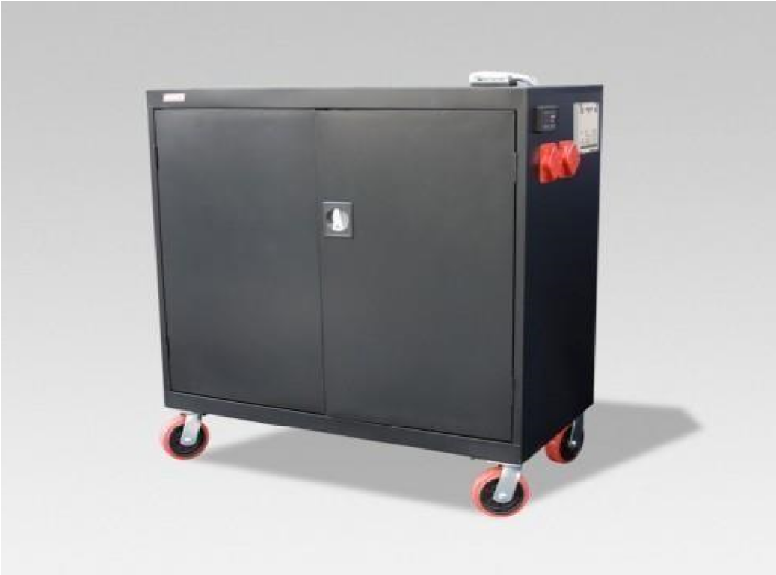
GEN-1760 4.0 kVA-120V/240V-60Hz-21.1kW-16Yr
Product Features
Silent operation; Safe for indoors; No gas or emissions; No Maintenance or permits required; Automatic & one-touch start; Remote monitoring & configuration.
Advanced System Control Panel with Graphical 128 x 64 pixel, backlit LCD display that allows for setup and monitor of entire system including multiple solar charge controllers and auxiliary battery banks. Panel displays power reserves, amp hours consumed, fault conditions, solar panel output, charging, power consumption.
120/240V AC; Adapts to single, split-phase or three-phase systems
Dual AC inputs with capability to work with two-wire and three-wire generator starting systems
May be used with a solar panel array to recharge 12V-24V DC
True sine wave and Built-in voltage regulation system provides clean output for sensitive electronics.
Electrical Specifications | (120V / 240 V split-phase)
Output power (continuous) at 40°C | 4.0 kVA
Output power (surge) at 40°C | 8.0 kVA (20 sec)
Peak output current (rms) | L-n: 70 Arms (20 s) L-L: 35 Arms (15 s)
AC Input Voltage range (240V by Default) (Bypass/Charge Mode) | 240 V AC (L-L) - bypass/charge mode  120 V AC (L-N) - bypass/charge mode
AC Input Current | 178 A DC at rated power
AC Input Frequency Range (Bypass/Charge Mode) | 55 to 65 Hz (default); 44 - 70 Hz (allowable)
Input voltage limits (bypass/charge mode) | 160...270 V AC (L-L) - bypass/charge mode  80...150 V AC (L-N) - bypass/charge mode
Output wave form (signal type) | True Sine Wave
AC output voltage | L-L: 240 V +/- 3% L-N: 120 V +/- 3%
Service Life (No Maintenance) | 12-16 Years
Auxiliary relay output | 0 to12 V, maximum 250 mA DC
Stored Electrical Energy | 21.1 kVA (21,120 W)
Charging Current | 150 A
AC Input 1 (Grid) (240V by Default)(split-phase) | 240V (6AWG-4 Wire) 60A 2-Pole breaker & box
AC Input 2 (Generator) (240V by Default) | 240V (6AWG-4 Wire) 60A 2-Pole breaker & box
AC Output 1 | 120V/240V (6AWG-4 Wire) 60A 2-Pole breaker & box
Automatic Transfer Relay | 60A
Typical transfer time | 8 ms
PWM Solar Charge Controller (for use with 12V-24V DC panels) | Input (60A-12V/24V) Maximum Output 800W
CEC power rating | 4.0 kW
General Specifications
NEMA degree of protection | NEMA1R (indoor rating)(electronic components sealed inside enclosure)
Ambient air temperature for operation | -25 to 70°C (-13 to 158°F) (power derated above 45°C (113°F)
Monitor (two monitors) | Graphical 128 x 64 pixel, backlit LCD Display (reads V, Ah, etc.)
Product Dimensions (H x W x L) & Part Number | 16" x 29" x 72" GEN-1760-4KW-16YR-PU
Product Weight – Construction - Color | 1,300 lbs. Heavy Steel Color – Black
Warranty | 5yr. warranty-components; 4yr. warranty-cells
Regulatory approvals
Safety & EMC | Components UL1741, CSA 107.1 & FCC and Industry Canada Class B
Interconnect | IEEE 1547 and CSA 107.1
Price | $13,979
Geneforce Incorporated www.geneforcepower.com (305)215-5443 email: sales@geneforcepower.com

