

**REAL ESTATE &**

**PERSONAL PROPERTY AUCTION**

**Sunday, July 23rd @ 10:30 AM**

**LEROY EHLERS ESTATE – 104 Benton Street, Andrew IA**

**34’ x 45’ Building & Lot to be auctioned at approximately 12:00PM**

**34’ X 45’ Building**

**Dual Overhead Doors**

**Vinyl Siding & Newer Roof**

**Loft Storage Area**

**Electric & Water**

**Auctioneer Note:** Property to be sold at 12:00 PM July 23rd. Auction on site. Property to be divided and assigned a new parcel from deed. Taxes and assessment will be determined following new parcel assignment. OPEN FOR VIEWING July 22nd 8:00 AM -4:00 PM.

**Terms:** 10% nonrefundable down payment required on sale day. Property to be sold as-is, where-is. Sellers Attorney to represent Real Estate Sale

**For More Info, call Ben (563) 357-9901**

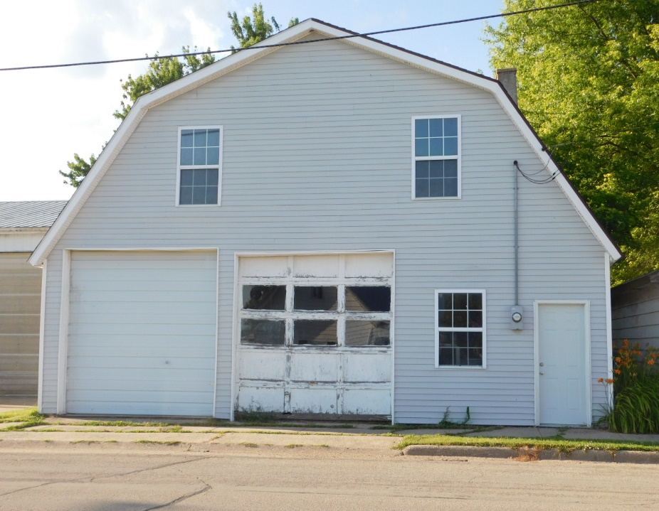

Copper Boiler

Galvanized Water Cans

Vintage Scale

Wooden Advertising Boxes

Vintage Chicken Crate

Big H Chicken Feeder

Fruit Jars & Apple Baskets

Wooden Pulleys

Incubator

Hand Crank Grinding Stone

AC Spark Plug Clock

Gillett Tire Sign

DX, Mobil & Other Cans

Wilco Tin Sign

Hood Ornaments

**ONLY A PARTIAL LISTING!**

**MANY UNLISTED ITEMS THAT HAVE NOT BEEN UNCOVERED YET!**

Work Benches

Skis

Heaters

Jacks

Grease Guns

Air Hose

Air Tools

Fire Extinguishers

Lincoln Arc Welder

Fish Nets

Grinders

Hub Caps

Torch

LP Cylinders

Pump Jack

Sleds

Oil Burners

Grinder on Stand

Gas Cans

Socket & Wrench Sets

Chains & Binders

Lumber

Extension Ladders

Saw Horses

Weed Eaters

Leaf Blower

55 Gallon Barrels

Air Compressor

Fence Stretcher

Tool Chest

Barrel Pump

Oil Drain Pans

Rakes, Shovels & Brooms

Mail Boxes

Antiques & Collectibles

**Tools – Hardware- Outdoor Equipment**

**For More Information, Contact Auctioneer Ben Schueller (563) 357-9901**

Website: [www.schuellerauctionco.com](http://www.schuellerauctionco.com) Email: [ben.schueller@hotmail.com](mailto:ben.schueller@hotmail.com)

Announcements made on sale day, take precedence over advertisements or verbal statements.



Many Hand Tools

Heavy Duty Vice

Stihl Chain Saw

Halo Lights

Nails, Screws & Hardware

Chain Hoist

Hand Planes

Circular Saws

Tap & Die Sets

Pipe Wrenches

Drill Bits

Cum-a-Longs

Extension Cords

Step Ladders

Snow Blower

Sealed Power Thermometer

Rough Sawn Lumber

Window Frames

Lawn Seeder