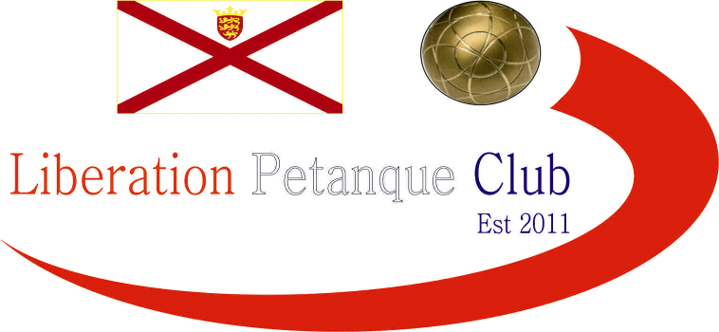

Liberation
2015 Singles Open

This year saw a sell out as the maximum 32 entries were received, in fact had it not been for a number of withdrawals over the last few weeks we would have well exceeded this figure which is great for the club so thanks to all who entered for your support.

Five qualifying rounds were played under timed matches (40 mins) with only one match failing to be played in this time.

As the matches got tougher for those on a winning streak some big matches were played. Matt Ryan lost to Matt Pinel before the latter lost to Andrew Bellamy. Ross Payne also lost to Toby Northern.

Some surprises though as Jake Day came within 2 points of beating Matt Pinel but did beat Carrefour singles champion Alan Lahiffe (a top ten ranked player). James Gennoe beat the Island Number 1 and 2 in Toby Northern and Andrew Bellamy on his way to finishing top of the rankings and the only player to win all 5 matches in a remarkable performance.

Geoffroy Buffetrille also took one of the big fours scalps with a win over Ross Payne, who as a result failed to qualify for the knockout stages.

1st James Gennoe

2nd Matt Pinel

3rd Andrew Bellamy

4th Toby Northern

5th Geffroy Buffetrille

6th Seb Renaud

7th Matt Ryan

8th Jake Romeril

The Quarter finals saw James again play Jake whom he beat in the qualifying rounds however at 12 – 9 down but holding 2 James moved the coche with his last boule to gift the win to Jake. Geoffroy took the first 2 points against Toby, but that was all as Toby took the next 13 points for a surprisingly easy win.

Matt Ryan played Matt Pinel for the second time and again a defeat as the Islands number 3 made successive semi finals following last weeks Island Singles Championship. Andrew Bellamy with the added pressure of playing Guernsey man Seb Renaud came through a very close match 13-11 and this is maybe what gave him the confidence going forward.

James Gennoe 11 13 Jake Romeril

Andrew Bellamy 13 11 Serb Renaud

Toby Northern 13 2 Geoffrey Buffetrille

Matt Pinel 13 6 Matt Ryan

This mean’t the semi finals were as follows.

Andrew Bellamy 13 v 6 Matt Pinel

Toby Northern 10 v 13 Jake Romeril

Andrew has faced Matt 4 times in the last two competitions held within the last week and having never previously beat Matt recorded his fourth straight victory and all have been fairly comfortable wins.

Jake Romeril took a 6-0 lead, and 9 – 2 lead over Toby who failed to grasp the terrain at the beginning before coming back to 12-10, but on the next end tried to push Jakes boule out of the way but it landed on the coche in the very soft area (where a whole used to be) and couldn’t move it with his last boule as Jake went through.

Third place play off saw Toby beat Matt Pinel for the third consecutive singles tournament as a much better terrain saw excellent placing to pick up bronze medal.

Andrew therefore played Jake in the final (and inspired by a pep talk earlier in the day from Toby (his words not mine) held his nerve to play some excellent shots to win his first ever Open Singles title after losing his previous two finals (2014 Carrefour Singles and 2015 Island Singles Championship), Jake Romeril a worthy runner up just as he was in the first ever Liberation Singles Open in 2012. Andrew now holds the Liberation Singles Open, Carrefour Triples and both Island Triples titles, no wonder he is now Jersey’s No. 1 ranked player and the one everyone should be looking to beat.

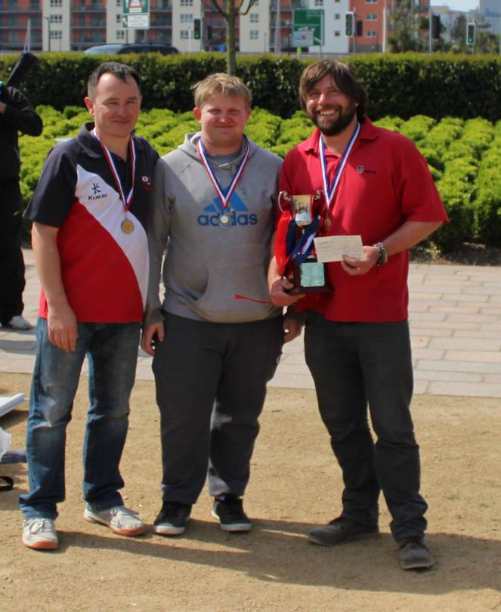

Below Swiss Rankings from the tournament (5 qualifying rounds)

 |  | Score | BHN | Points
1st | James Gennoe | 5 | 15 | 65-53 | Liberation
2nd | Matt Pinel | 4 | 16 | 61-40 | Liberation
3rd | Andrew Bellamy | 4 | 16 | 64-45 | Liberation
4th | Toby Northern | 4 | 15 | 62-39 | Liberation
5th | Geoffroy Buffetrille | 4 | 14 | 58-40 | Liberation
6th | Seb Renaud | 4 | 11 | 59-35 | Guernsey
7th | Matt Ryan | 3 | 18 | 61-48 | Liberation
8th | Jake Romeril | 3 | 16 | 59-54 | Carrefour
9th | Ross Payne | 3 | 16 | 56-55 | Liberation
10th | Matthew Schofield | 3 | 14 | 54-40 | Carrefour
11th | Steve Simpkin | 3 | 14 | 50-41 | Liberation
12th | David Siouville | 3 | 13 | 55-42 | Liberation
13th | Keith Boleat | 3 | 13 | 55-43 | Carrefour
14th | Chris Romeril | 3 | 12 | 52-52 | Carrefour
15th | Jake Day | 3 | 11 | 56-48 | Independent
16th | Colin Myers | 3 | 11 | 54-56 | Liberation
17th | Alan Lahiffe | 2 | 14 | 49-59 | Carrefour
18th | Brendan Jones | 2 | 13 | 49-59 | Liberation
19th | Neil Selby | 2 | 12 | 49-42 | Carrefour
20th | Callum Stewart | 2 | 12 | 51-55 | Liberation
21st | Craig Kelly | 2 | 11 | 55-43 | Liberation
22nd | Delphine De La Mare | 2 | 11 | 59-50 | Guernsey
23rd | Paul Le Moine | 2 | 10 | 50-50 | Liberation
24th | Robert Hillis | 2 | 10 | 44-46 | Liberation
25th | Teresa Koradi | 2 | 9 | 36-49 | Liberation
26th | Brian Harris | 2 | 8 | 49-56 | Liberation
27th | Tom Pope | 1 | 14 | 25-59 | Liberation
28th | Fay Schofield | 1 | 13 | 26-57 | Independent
29th | Martin Koradi | 1 | 10 | 30-54 | Liberation
30th | Richard Sowerby | 1 | 9 | 37-54 | St Mary's
31st | Alex Stewart | 1 | 9 | 35-61 | Liberation
32nd | Nathan Wheller | 0 | 10 | 25-65 | Liberation

Four big tournaments are held in May, JPC Doubles, Carrefour Triples and Singles and the Island Doubles Championship on the 30th May.

Club email address - liberationpc@gmail.com

Club Website - www.liberationpetanque.co.uk

Kind Regards

Toby Northern

Chairman

Liberation Petanque Club

SPONSORED BY

