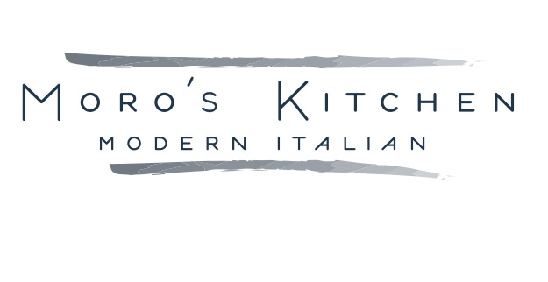

Family Style for 4 Carry-Out Menu
Menu can change with availability. Gluten free options are available.

Salads
Caesar Salad crisp romaine, cherry tomato, smoked pancetta, anchovies, parmesan 15
Baby Greens & Radicchio Salad dried apricot, basil, croutons, balsamic vinaigrette, Parmesan Reggiano 15
Beet Bruschetta & Arugula Salad creamy local goat cheese, toasted pistachios, poached pear, lemon vinaigrette 15

Pasta
Rigatoni Marinara fresh rigatoni, house made red sauce, parmesan 12
Linguini Alfredo with Broccoli garlic cream, parmesan, broccoli 14
Slow Roasted Pork Rigatoni swiss chard, braised pork, tomato sauce 22
Wild Mushroom Risotto mushrooms, parmesan, truffle oil 19
Shrimp & Linguini spinach, tomato sauce, garlic crumb 22
Three Cheese Ravioli pancetta, wild mushroom ragu, tomato puree 19

Entrees
Chicken Parmesan sautéed panko breaded chicken, tomato sauce, mozzarella, parmesan 23
Chicken Piccata pan roasted chicken, lemon, capers 23
Chicken Marsala pan roasted chicken, wild mushrooms, parmesan 23
Braised Beef Short Rib slow braised beef, barolo beef sauce 36
Garlic Crusted Cod fresh cod, roasted garlic herb butter, lemon 23
Balsamic Glazed Angus Sirloin 42
Balsamic Glazed Salmon 37

Sides
Tomato Braised Meatballs house made meatballs, tomato sauce, garlic crumb, parmesan 16
Mixed Roasted Vegetables seasonal vegetables, fresh herbs 8
Oven Roasted Potatoes gold potatoes, garlic, fresh herbs 8

Desserts
Gelato by the Pint 10
Cannoli for 4 10

