

# Summer 2018 Season

# Week 12 – 13.06.18

# Doubles League Report

# 

**Remember if you cannot play on the scheduled fixture date; please try to play in advance and notify club of new date.**

**Liberation Doubles Cup (Members Only – Free)**

**Wednesday 20th June 2018**

**Entry Now Closed**

Matt Pinel & Toby Northern had a scare against Tom McMinigal & James Rondel, but came good in the end to take another valuable three points. This was also the case for Callum Stewart & Andrew Bellamy-Burt who beat PES teammates Joey Le Clech & Jonny Hill.

Fresh from their win over Matt & Toby last time out, Matt Ryan & David Ibitson faced Jake Romeril & Mark Nicol needing another win to keep their title hopes on track. It wasn’t to be as Jake & Mark top the table with four straight wins as they aim for back to back titles.

Brian Harris & Paul Le Moine took on Keith & Sue Pinel with both teams searching for three valuable points. This was a very one sided match as Brian & Paul only let Keith & Sue score three points including a 13 – 0 win.

**Premier League Outstanding Matches Re-arranged Date Expiry Date**

Callum & Andrew **v** Matt & Geoffroy N/A 27.06.18

Mark & Jake **v** Alan & Craig N/A 27.06.18

James & Tom **v** Brian & Paul N/A 27.06.18

Alan & Craig **v** Ross & Neil N/A 11.07.18

Alex & Cassie **v** Matt & Geoffroy N/A 11.07.18

***Expiry date relates to date to notify club of when match will be played***

Division 1

Mo de Gruchy & Stephen Stoneman, bottom of the table had a tough match against top of the table Alice & Brigitte Ibitson. This resulted in the Seventh!! Fanny certificate in the Doubles league so far this season, with Brigitte & Alice running out 13 – 5, 13 – 0 winners.

Alan Mitchel & Mike Robinson won a close match against Karen & Colin Hidrio with the second game going to 13 – 12. Three vital points towards a potential top three finish.

Harrison Marie & Richard Williams were another team with promotion aspirations and faced Martin & Teresa Koradi who were in the relegation zone. A good win for Harrison & Richard who move up to third place as a result.

The tie of Division 1 this week though was second place, playing third place in Paul Bell & David Le Gresley verses Colin Myers & Steve Simpkin. Both teams undefeated with Paul & David on a 100% record. Colin & Steve rediscovered some form of old as they inflicted the first defeat on David & Paul to move second in the league but are seven points off the top spot.

**Division 1 Outstanding Matches Re-arranged Date Expiry Date**

Eamonn & Karen v Paul & David 19th June N/A

Eamonn & Karen v Martin & Teresa N/A 27.06.18

Eamonn & Karen v Laurent & Matt N/A 27.06.18

Christophe & Iwona v Mo & Stephen N/A 27.06.18

Christophe & Iwona v Jean & Chris N/A 11.07.18

**Outstanding Singles Matches**

**Premier League Re-arranged Date Expiry Date**

Alice Ibitson v Paul Le Moine N/A 20.06.18

Andrew Bellamy-Burt v Paul Le Moine N/A 20.06.18

Andrew Bellamy-Burt v David Ibitson N/A 20.06.18

Andrew Bellamy-Burt v Toby Northern 27th June N/A

Neil Selby v Geoffroy Buffetrille N/A 04.07.18

Keith Pinel v Matt Pinel N/A 04.07.18

***Expiry date relates to date to notify club of when match will be played***



**SUPER RESULTS**

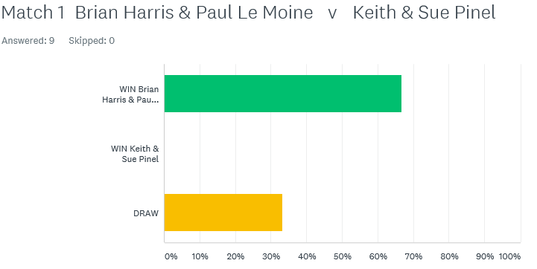

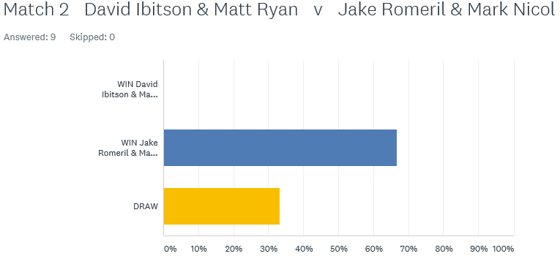

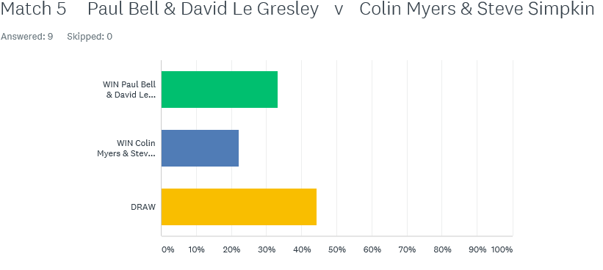

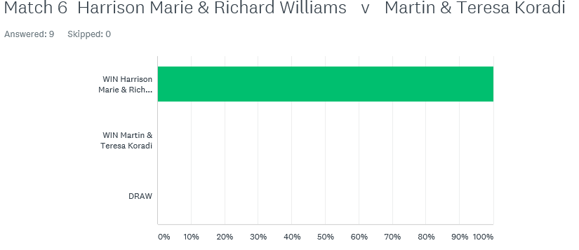

Best of Luck to everyone

***NEXT WEEK***

**20th June – Liberation Cup (Doubles) Members Only**

**Entry Closed**

**WEBSITE** [**www.liberationpetanque.co.uk**](http://www.liberationpetanque.co.uk)

**EMAIL** [**liberationpc@gmail.com**](mailto:liberationpc@gmail.com)

**Kind Regards**

**Toby Northern**

**Chairman**

**Liberation Petanque Club**

# SPONSORED BY

# http://nebula.wsimg.com/135a1bd6338e1b589a50cdec98bd84d1?AccessKeyId=C6E923731F1A482DD910&disposition=0&alloworigin=1