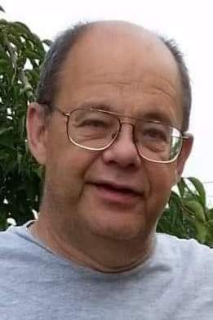

Name: Alan Vincent Cole
Age: 64
Hometown: Harbor Beach, MI
Funeral Date: May 11, 2019
Date of Birth: June 15, 1954
Date of Passing: March 21, 2019
Funeral Home: Cremation Society of Mid Michigan

Funeral Information
Cremation has taken place. Al's life will be celebrated at a Memorial Service at 10 AM, Saturday, May 11, 2019 at Our Lady of Lake Huron Catholic Church, 413 S. First Street, Harbor Beach, MI. Burial of cremated remains will follow at Rock Falls Cemetery.​ To sign online guestbook, visit www.cremationsocietymidmi.com

Family of the Deceased
Alan is survived by his wife of 27 years,​ Beth​ (O'Neil)​ Cole; his two daughters, Crystal​ Cole​ of Howell, MI. and Casey​ Cole​ of Ann Arbor, MI; two sisters, Roxanna (Cole) Corum of Pontiac, MI and Loretta (Cole) Olson of Warren, MI; aunt, Patricia Stalker of Pahrump, NV; and brothers and sisters-in-law, Sharon O'Neil of Port Huron, MI, Gerald and Joan (Scholtz) O'Neil of New Hampshire, Gene and Kathy (O'Neil) Hickey of Clio, MI, Robin and Susan (Lupp) O'Neil of Frankenmuth, MI, Tim and Toni (Minda) O'Neil of Port Hope, MI., Ken and Mary (Winters) O'Neil, Pat and Susan (Ginther) O'Neil, Michael and Peggy (Uicker) O'Neil, Dennis and Nancy (Kammerzell) O'Neil, and Thomas O'Neil, all of Harbor Beach, MI; many nieces, nephews, and extended family members. He was preceded in death by his parents-in-law Morris and Violet (Schroeder) O'Neil, and grandparents, Irene Phelps, Edward​ Cole, Margaretta (Scheall) Stalker, and Charles Stalker.​

Biography
Alan Vincent​ Cole, age 64, died March 21, 2019 at Harbor Beach Community Hospital after a short battle with cancer. He was born June 15, 1954, in Pontiac, Michigan to the late Vincent and Arloa (Stalker)​ Cole. Alan graduated from Troy High School in 1972 and the University of Michigan in 1976, receiving a Bachelor's degree in Education. In 1989 Al and Beth​ became Domino's Pizza franchise owners in Saginaw, MI. After 10 years, they sold the business and moved to Harbor Beach, MI. In 1999 Alan opened "Cole's Computers", later "Huron Computers" in Bad Axe, MI, retiring in 2014 due to health reasons. He was a member of Holy Name of Mary Parish in Harbor Beach, MI, where he enjoyed serving as a lector for Sunday Mass. Alan and​ Beth​ were married at Our Lady of Lake Huron Catholic Church, on April 20, 1991. His greatest joy was in watching his two daughters, Crystal and Casey​ Cole, grow up. He was extremely proud to see them both attend his alma mater, the University of Michigan in Ann Arbor. He loved his Michigan Wolverines and watched all the football and basketball games he could. Al loved all animals, but especially his faithful dogs.​

