6/17/2017 Similarities Between Ancient and Modern Babylon

We're in the 70th year of the modern State of Israel being protected by modern Babylon the great. There is scripture that prophesies that after 70 years YaHuWaH Elohim will visit Babylon and cause His people to leave and return to Jerusalem.

Jeremiah 29:10 For thus saith YaHuWaH , That after seventy years be accomplished at Babylon I will visit you, and perform My good word toward you, in causing you to return to this place.

The book of Daniel was written in ancient Babylon as Daniel and his people endured their 70 year captivity in the foreign land over 2500 years ago.

We can examine various chapters of the book of Daniel and see how some of them might relate to our current experience in modern Babylon the great.

A reader sent a question concerning Daniel chapter 4. The reader was wondering how the situations in our current day in modern Babylon the great are comparable with those of ancient Babylon.

Prophecy and history are cyclic, like a wheel that rolls around again and again as the wagon of time moves down through the ages.

There are types, symbols, and patterns in the bible that appear in one form at an earlier time and then in another form at a later time in history. There are similarities when the types and patterns repeat, but the same precise parts of the original sequence will probably not be repeated. There are also certain precise time periods prophetically announced in the bible pertaining to YaHuWaH 's people and the end of the age.

Daniel chapter 4 would probably not follow exactly as it did 2500+ years ago, but perhaps in a general sense.

In Daniel chapter 4, the King of ancient Babylon was allowed to continue in power for 1 year after he was given a supernatural dream, and then he was removed from power.

Likewise, Donald Trump might be allowed to continue for 1 year after winning the election that most people in the country thought he would lose.

It was YaHuWaH Elohim who put King Nebuchadnezzar in power, and it was YaHuWaH Elohim who put Donald Trump in power.

The King of ancient Babylon was removed from power after the 1 year period. That means that someone else had to take over and rule the Kingdom for the next 7 years.

The current unrelenting intent of most Democrats and also some Republicans is to remove Trump from office. They want Trump out. If they succeed in getting him out, then someone else will rule in his place, just as happened in ancient Babylon.

The end of Trump's first year in office will be on 1/20/2018, which is the 100th anniversary of all religious property being confiscated in Russia by the communists, right after the communist revolution of 1917. So we'll soon see what happens, as most of the trouble makers in this country are Democratic socialists acting like the commies in Russia did 100 years ago.

In Daniel chapter 4, the King of Babylon becoming "as a beast" for 7 years reminds me of the "beast of Revelation" who makes everyone on earth take a mark on his hand or forehead or else he can't buy or sell.

On 10/11/539 BC, ancient Babylon was taken control of quietly in the middle of the night by the enemy that had sneaked in unawares. The King was assassinated by his own bodyguards.

The same sort of thing might be going on in this country, with a "Deep State", members of Donald Trump's own government, leaking confidential information with the intent of assassinating his character and removing him from power.

6/15/2017 Revisited

Below is a photo taken on 6/15/2017 through a telescope by an astronomer in Jersey City, New Jersey, about 6 air miles west of Manhattan.

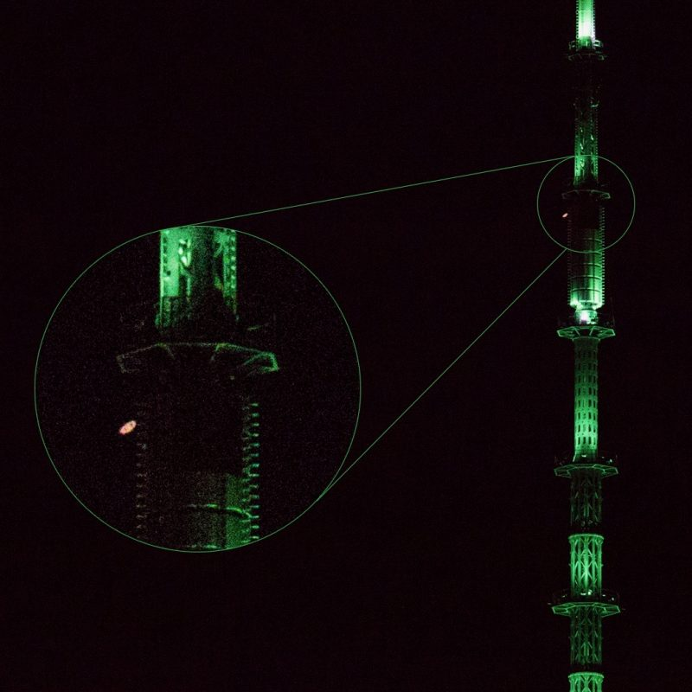
Photo courtesy astronomer Gowrishankar Lakshminarayanan

Above: The planet Saturn with its ring system beside the greenly lit spire of the modern Tower of Babel, the Liberty Tower, One World Trade Center, on 6/15/2017.

The Sun, Earth, and Saturn were in line on 6/15/2017. Saturn is noted for the strange huge hexagonal storm at its North Pole. Exactly 2 years from 6/15/2017, on 6/15/2019, the 7 "years of years", (7 x 365.24219 years or 933,813 days) anniversary of the Handwriting on the Wall event of 10/11/539 BC will occur. The Handwriting on the Wall event signaled immediate judgment on ancient Babylon.

We should note that ancient Babylon wasn't destroyed on 10/11/539 BC. It was merely quietly captured by the enemy. King Cyrus (Koresh) himself entered the city 18 days later, on the 19th inclusive day, on 10/29/539 BC. The name Cyrus (Hebrew Koresh) means "like the sun", which is a precise description of the detonation of a hydrogen type nuclear device.

The Sign of Asteroid 163 Erigone and David Rockefeller

David Rockefeller died on 3/20/2017. He is identified by some as having been the unseen President of the United States for the last 50 years.

Below: The path of an asteroid named Erigone that passed in front of the King star Regulus, sign of Israel's King Messiah, at 2:06 AM on 3/20/2014 as seen from Manhattan.

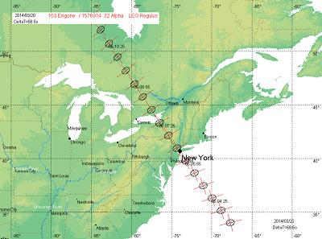
Illustration courtesy Aldo Vitagliano

Above: New York City, Babylon the great, was marked by the star Regulus as the asteroid 163 Erigone passed between Manhattan and Regulus at 2:06 AM on 3/20/2014. David Rockefeller died exactly 3 years to the day later on 3/20/2017.

Note that the name David Rockefeller carries with it a description of King David, a symbol and type of Israel's YaHuShua Messiah. King David was the same David who as a young man miraculously slew the giant Nephilim Goliath with a rock. The anointed David used a rock to fell the giant.

Manhattan has been marked and doubly warned by our Creator YaHuWaH Elohim on the same date, 3/20, exactly 3 years apart.

Add to the double warning above (double unto her double) the designation of the name "Manhattan" to the top secret program that developed the first atomic weapon, and further, the 72nd (double 36) anniversary of the Trinity Test, firstfruits of the Manhattan Project, will be on 7/16/2017, a date previously noted as being 50 days from the Taormina (1 + 50) G-7 meeting.

The above mentioned events are warnings, not prophecies. The prophecy is below.

Revelation 18:9 And the kings of the earth, who have committed fornication and lived deliciously with her, shall bewail her, and lament for her, when they shall see the smoke of her burning,
10 Standing afar off for the fear of her torment, saying, Alas, alas, that great city Babylon, that mighty city! for in one hour is thy judgment come.

