August 2017 Strathmere Event and Activity Calendar | 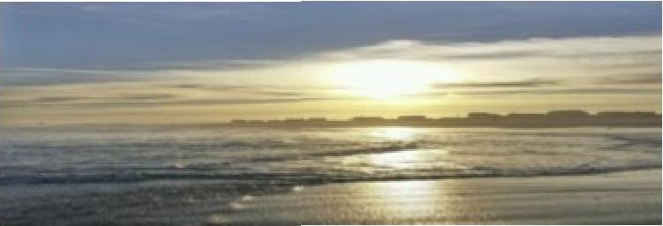

 | August 2017
Sun | Mon Tue |  | Wed Thu |  | Fri Sat
 |  | 1 Schiavo Library  Activities:  Storybook Time (all ages) 10:30-11:00am  LEGO Club (all ages) 11:00-11:30am | 2 | 3 Schiavo Library  Activities;  Team Scavenger Hunt 7:00pm | 4 | 5 St, Augustine kappella Choir Concert STM United Methodist Church 7:00pm
6 STM Unibd Methodist  Church  Hymn Sing 9:15 am  VVorship 9:30 am | 7 | 8 Schley° Library  Activities:  Storybook Time (alleges) 10:30-11:00am  LEGO Club (all ages) 11:00-11:30am  Jr. Lifeguard Race 11:00am  Tecumseh-Sherman beach | 9 | 10 | 11 | 12 SFEC Crab Tournament Bay 7;00am Awards 4;00pm Whale Creek Marina Castaway Lounge 3'  Concert of the Season f :45 p trl
13 STM United  Methodist Chursh  Hymn Sing 9:15 am  VVorship 9:30 am Strathmere Volunteer Fire&Rescue Fire Prevenbon/Saty Day 2:00-4:00pm Firehouse | 14 TWP Committee Meeting,7:30pm TWP Hall | 15 Schley° Library Activities:  Storybook Time (all ages) 10:3041:00am  LEGO Club (all ages) 11:00-11:30am | 16 | 17 | 18 SIA General Meeting 7:30pm elections, ice cream& Fitness/Health Awareness  At the Firehouse SFEC Tuna Classic Captains Meeting 7:00pm Whale Creek | 19 SFEC Offshore Tuna/Mahi Tournament 6:00am -5:00prnOcean
20STM United Methodist  Church  Hymn Sing 9:15 am  Worship 9:30 am | 21 | 22 | 23 | 24 | 25 | 26 5FEC  Nightmare in 5trathmere 6:30pm, Bayfront Awards 9:00pm Deauville Inn
27 STM United  Methodist Chursh  Hymn Sing 9:15 am  Worship 9:30 am | 28 TWP Committee Meeting,7:30pm TWP Hall | 29 | 30 | 31 Strathmere Are Co. BBQ Fundraiser 6130-10:00pm Deauville Beach Bar | NOTES: Strathmere hats & visors sale! Call 609-970-0157 or Sue at site 96, Trailer Park  Benefits the Sfrafhmere Improvement Association Activities

