2015
Liberation Cup

Another fantastic competition last night with 18 teams participating in the 5th Annual Liberation Cup.

Three teams with eye’s on the Premier League title all with 100% records, Andrew & Callum, Matt & David and Ross & Antony were hoping to take the first part of a league & Cup double which has only been done once in the history of the club.

Andrew & Callum fresh from their JPC Doubles Open win were hoping to retain the cup and started off with a big win over fellow premier league team Alice & Brigitte 13-5. This was also the score for Toby & Matt against Gary & Pat who took the first 5 points before Toby & Matt reeled off 13 straight points to hand out a (Technical).

The biggest win though went to Ross & Antony in round one over Alex & Cassie 13-1.

Round 2 saw Andrew & Callum then win convincingly against Matt & David 13-3, Alan & Craig won the second in a row this time over Matt & Nathan and Toby & Matt just beat Joey & Luke by 1 point on the final end.

Geoffroy & James moved into contention with a second win over Keith & Sue as did Colin & Steve who beat Gary & Pat. Matt & David though saw the league and cup double chances blown away with a second defeat against Dawn & John.

The biggest tie of the round saw a very close match between holders Andrew & Callum and Toby & Matt, with the latter winning with some great placing on a very difficult terrain with a few holes and bumps which made for some interesting shots rolling round other boules onto the coche.

The Final round (4) saw several teams move into and out of the top 8 places that would make up the quarter finals. Ross & Antony finished top after handing Toby & Matt a lesson in Petanque winning 13-2 to finish the only team on 4 wins with an impressive +38 conceding an average of just 3.5 points per game, that’s some record.

Callum & Andrew got back into it though handing Alan & Craig their first defeat with both teams finishing on 3 wins and qualifying. Geoffroy & James beat Dawn & John and this meant they took the latter’s place in the quarter finals. Joey & Luke beat Matt & Nathan to be the only team with 2 wins to qualify.

Alice & Brigitte though could have made it through losing on the final end against Brian & David which meant it was the latter who took their place in the top eight.

Final Rankings

 |  |  |  | Won | Bulchoz | Games | Points
1st | 193 Antony Di Santo | & | Ross Payne | 4 | 9 | 4:0 | 52:14
2nd | 183 Andrew Bellamy | & | Callum Stewart | 3 | 10 | 3:1 | 48:27
3rd | 189 Toby Northern | & | Matthew Pinel | 3 | 10 | 3:1 | 41:39
4th | 196 Brian Harris | & | David Siouville | 3 | 9 | 3:1 | 49:38
5th | 185 Alan Oliveira | & | Craig Kelly | 3 | 7 | 3:1 | 45:30
6th | 195 Colin Myers | & | Steve Simpkin | 3 | 6 | 3:1 | 40:33
7th | 182 Geoffroy Buffetrille | & | James Gennoe | 3 | 5 | 3:1 | 43:36
8th | 187 Joey Le Clech | & | Luke Nightingale | 2 | 10 | 2:2 | 48:35
9th | 188 Dawn Buckley | & | John McGaw | 2 | 10 | 2:2 | 39:45
10th | 181 Alice Ibitson | & | Brigitte Ibitson | 2 | 8 | 2:2 | 43:34
11th | 191 David Ibitson | & | Matthew Ryan | 2 | 7 | 2:2 | 40:41
12th | 198 Brendan Jones | & | Stefan Riccio | 2 | 3 | 2:2 | 46:33
13th | 184 Paul Le Moine | & | Rob Gregory | 1 | 10 | 1:3 | 28:51
14th | 192 Gary Cowburn | & | Pat Cooper | 1 | 8 | 1:3 | 31:42
15th | 197 Keith Pinel | & | Sue Pinel | 1 | 8 | 1:3 | 35:50
16th | 194 Matthew Buesnel | & | Nathan Wheller | 1 | 7 | 1:3 | 29:47
17th | 190 Alex Stewart | & | Cassie Stewart | 0 | 10 | 0:4 | 20:52
18th | 186 Anna Shipley | & | Lauren Shipley | 0 | 7 | 0:4 | 22:52

Quarter Finals

1st placed Ross & Antony faced 8th Joey & Luke, and what was one of the most dramatic matches seen saw Ross & Antony lead 12-9 going into the final end after some excellent placing from Antony & Luke and matched in the firing department by Ross & Joey. So 12-9 up, Ross & Antony just needed to keep the end tight and not concede more than 2 points and although holding with Ross’s final boule Joey & Luke had 4 to come. Joey tried firing to clear the way but missed, then one by one they placed three perfect shots to make it 12-12.

So a final extra end had to be played and again some great shots saw Ross fire with his last boule but a perfect shot, the only problem was Joey had one boule left and put it right on top of the coche to win a great match. Ross & Antony suffering the curse of finishing top of the Swiss rankings, the third time out of 4 that the top ranked player/team has lost in the quarter finals.

The shocks didn’t end there as holders Callum & Andrew were comfortably beaten by Geoffroy & James 13-5 as the two players continue to beat the more experienced players in big competitions.

Brian & David beat Alan & Craig (last year’s losing finalists) in a close match 13-10.

Colin & Steve took on Toby & Matt, and started the match with 4 on the first end, Colin then fired to coche out on the next end to give himself and Steve another 3 points to move 7 nil ahead, but what can only be described awesome, saw Matt fire every single one of Steve’s boules out of the terrain for the next 5 ends and when he had no boules left to fire Toby took over to take Colin’s boules out as they turned the match around in style to win 13-7 (the second technical handed out on the evening by Toby & Matt).

Joey & Luke must have been worn out after the dramatic win over Ross & Antony as they were well beaten by Brian & David 13-4 as the light had completely faded by then.

Geoffroy & James won the first end against Toby & Matt who were getting used to this happening by this point, but that was it as a combination of pressure and again brilliant placing and firing saw the third Technical handed out by Toby & Matt 13-1 win.

Joey & Luke took Bronze medal with an easy win over Geoffroy & James 13-3 and despite only winning 2 matches in the qualifying rounds certainly deserved 3rd place.

The final again saw Toby & Matt lose the first end and were 7-2 after 3 ends with Brian firing exceptionally well before a 5 on the next end for Toby & Matt to make it 7-7. Another 2 points off the next one was fortunate for Brian & David who could have lost 4 points, but they drew level at 9-9 on the next in a tense final. Matt fired 5 boules out of the way with just one boule to leave the nearest boule 3 meters away, with Brian holding one boule and Toby 2, Brian placed a perfect shot right next to the coche. Toby though fired this out and rolled in to take 2 points to lead 11-9 and the pair finished it off in the next end to win 13-9.

This is Matt Pinel 3rd Liberation Cup win (2012, 2013, 2015) and the only individual to have retained the cup and each time he has played with a different partner. That’s some record.

Many thanks to James, Steve, Colin, Matt and everyone else who helped out on the evening, another great job. I hope you all enjoyed the evening.

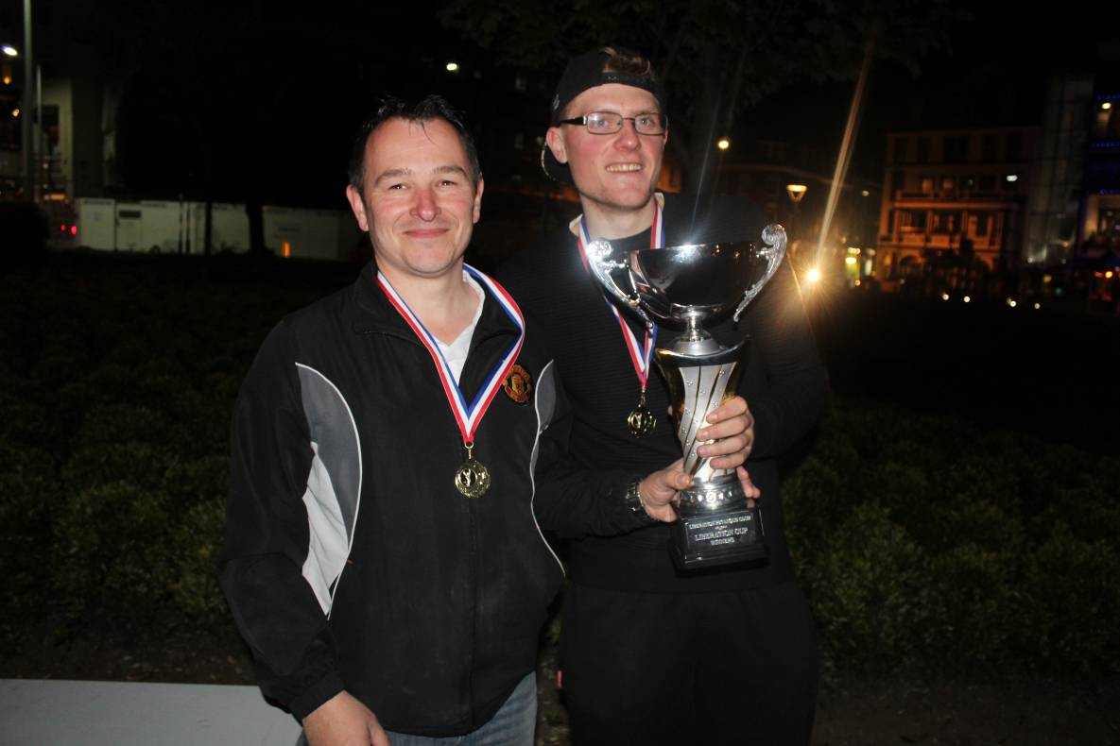

League tables updated are on the website, see below.

Club email address - liberationpc@gmail.com

Club Website - www.liberationpetanque.co.uk

Kind Regards

Toby Northern

Chairman

Liberation Petanque Club

SPONSORED BY

