Pleasant Township Board of Trustees Meeting Highlights
Date __February 28, 2023 Next Resolution No.__ 18-----02-28-2023_______

- Call to Order -- The meeting tonight will also be on WebEx.
- Please stand for moment of silence. --Pledge of Allegiance-----Roll Call
- Minutes to approve- none
- Financial Reports – Motion to pay expenditures.
- Visitors –
- Hanna Poling with the Southwest Messenger via WebEx.
- Scott Belcastro with Trebel – working on Electric bids.
Working on a new contract hopefully to continue through May 2025. Rates at the present time are running between 6 and 7 per kwh. June/July they will be up to 10 and 11.
The present contract that we have will expire in July is 4.67 kwh. From July 2021 to December 2022 the present contract has saved the township residents a combined total of $444,328.44 for AEP customers and $359.085.21 for Ohio Edison customers for a total savings of $803,413.65. We enjoyed a low rate while the market was rising because of the contract negotiated almost 2 years ago. Scott will be watching the market for a low rate and give trustees a call to
lock in the lowest he can get.
Resolution__18_____ to give Trebel authorization to sign on the behalf of Pleasant Twp. Trustees for the Emergency Management Agreement.
- Department Reports
- Franklin County Sheriff’s Report- Deputy Hamilton
  - Total calls for service for 2-14-23 to 2-28-23 were _121__
  - Total reports – 18
  - Arrest – 0
  - Tickets-1
  - Burglary/B & E- 2 – unrelated and still on-going investigations
  - Thefts – 3 – unrelated and different things taken
  - Accidents – 7
  - Suspicious Activity –9
  - Alarm Drops –5
  - Traffic Stops –17
  - Disabled vehicles –5
- Road Department- Robert Bausch, Superintendent
  - Bay 3 insulated.
  - Filling potholes.
April
28th-29th
  - Brush mowing.
  - Storm damage.
  - Spring clean up.- April 28th – 29th
  - Johnson Rd. tile. There is a petition ditch there that is over 100 years old and has no maintenance agreement. Trustees agree to file for a petition ditch we first need to hear from residents involved how they feel and what they would like us to do. If they are all willing to pay for this petition ditch to improve their drainage problem. Robert will investigate this further to see if we can get a list of those it would involve.
- Fire Dept. – Fire Chief, David Whiting

- New Medic is in and in service
- Had a tornado response yesterday
- Old Business-
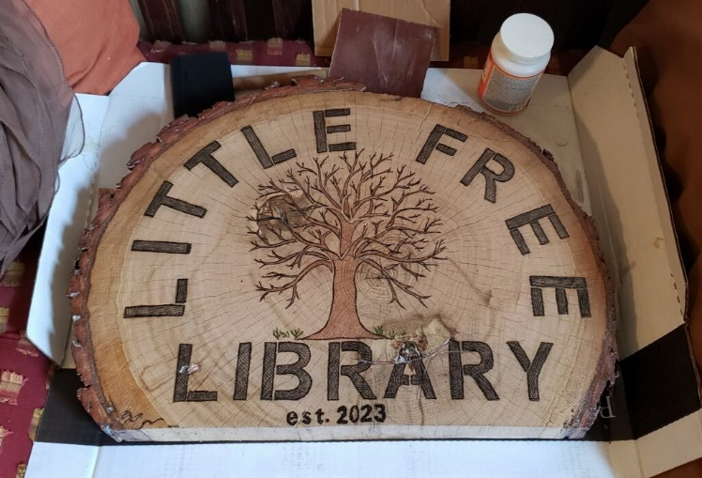
- A big THANK YOU to thank Bill Dawson for applying for and receiving a grant from Franklin Park Conservatory in the amount of $1,300 for the purpose of supporting Ebenezer Cemetery Beautification Project. Bill is planning a Volunteer Work Day on May 10. He is also constructing a Free Tree Library at the cemetery, out of the standing trunk of an old oak tree. He is making a sign for the library out of part of the tree.
“It is with pleasure that a grant is approved for your organization. This grant is for the purpose described in your request, subject to any Contingencies described below. By accepting this grant, you agree to Franklin County and Franklin Park Conservatory Grant Administrator’s Terms and Conditions found below in the Grant Agreement. As we have moved to all electronic communication, you will not be required to return a signed document. When possible, it is helpful to reference the grant number and the grant purpose in future communication regarding this grant. This grant is to be used for the express purpose as listed in the Funded Purpose, and any deviation from this will require approval by the Franklin Park Conservatory Grant Administrator.
Date Authorized: January 12, 2023
Grant Organization: Pleasant Township
Grant ID Number: CFB22-0081 Amount: $1300
Grant Period: February 1, 2023 through October 28, 2023
Funded Purpose: To support Ebenezer M.E. Cemetery Beautification Project
- New Business –
  - We have an email of questions to answer from Jason Ward with the Ohio State Auditor’s Office
- Announcements-
  - Received the following email about the next Franklin County Twp. Assoc. Meeting-
ORC 3709.03 creates the General Health District Advisory Council (DAC):
· Villages Mayor are obligated to attend
· Township Chairpersons are obligated to attend (by resolution another trustee can be designated)
· Meets each year in March
o Elect a chair and secretary
o Make appointments to the Board of Health

The last several years have presented a challenge for attendance at the DAC. Given the importance of the DAC, I am asking all townships to please make a concerted effort to attend our next meeting, which will be March 23rd, 2023. This meeting will be held in cooperation with the Franklin County Township Association (FCTA), so please come early and enjoy dinner.
Thursday, March 23rd, at Memorial Hall (280 East Broad Street – First Floor)
· 5:30pm – Registration Opens
· 6:00pm – FCTA Business Meeting
· 6:30pm – Dinner
· 7:00pm – DAC Meeting
Please RSVP with Debra Smith by telephone at (614) 525-3670 or by email. For questions regarding the FCTA business meeting, please contact Chet Chaney at (614) 439-6269 or by email.
—Joe Martin, District Advisory Council Chairperson
- Clerk Updates- Paula
  - Misc. correspondences
  - Resolution__19____to transfer $10,000 to the Medical Account from General Fund
  - Trustees received an invitation to the Farm Bureau Meeting is April 4 at Schmitt’s from 11:00 to 1:00.
  - Received request for liquor licenses for Gidgets Garden Center, no problems with it.
- Speaker Sheets- none
- Adjourn- at 7:40 pm

