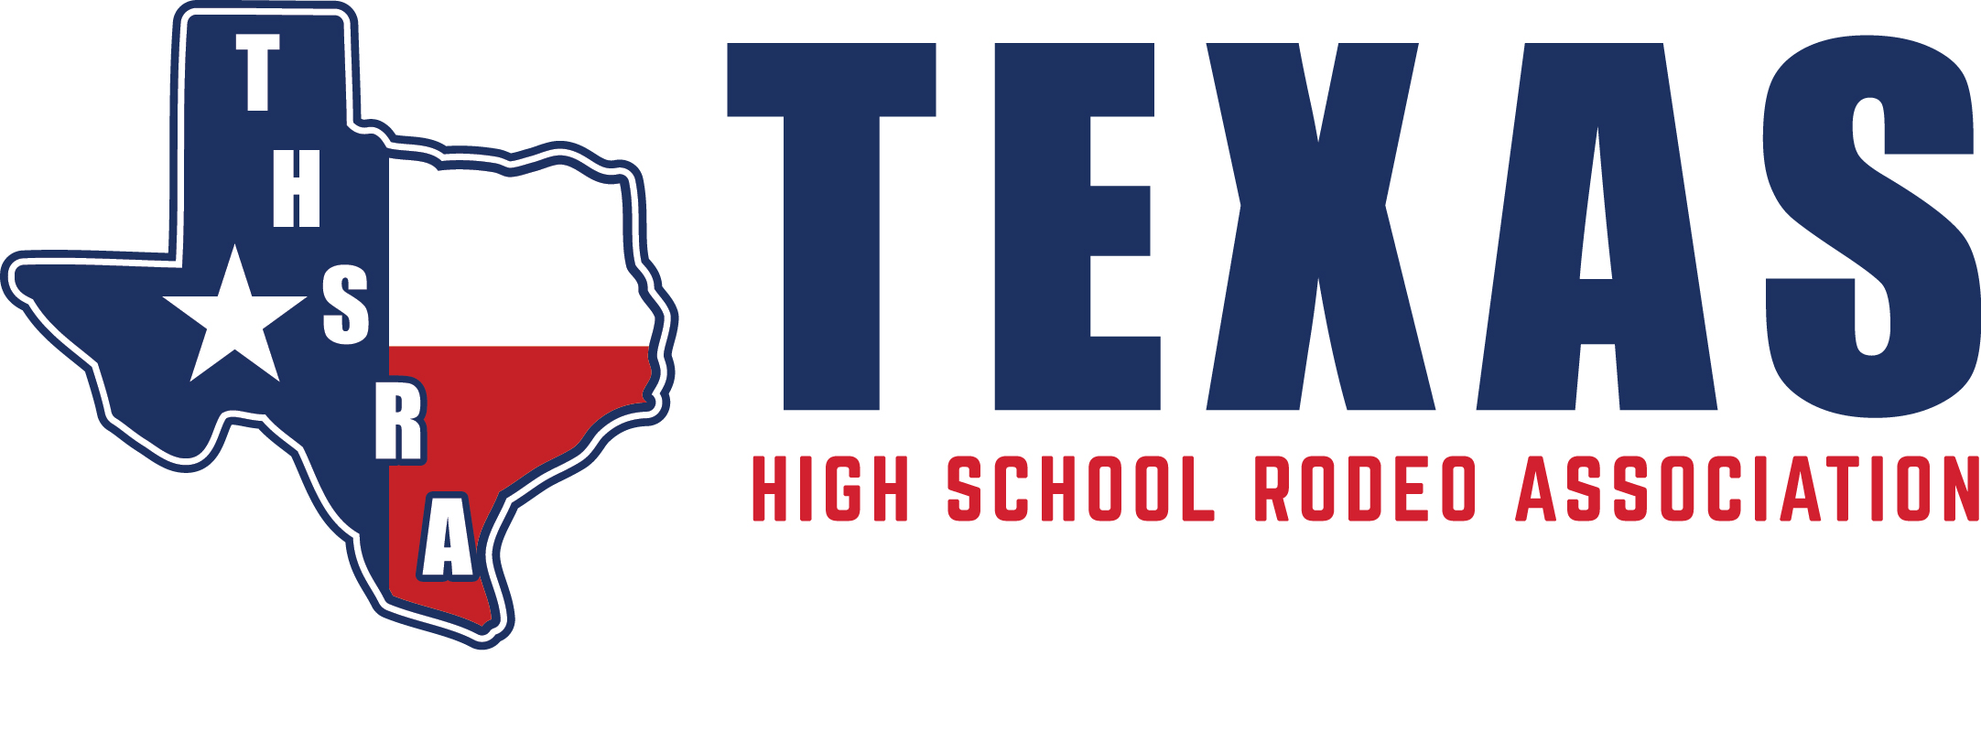

Texas High School Rodeo Association
704 ½ Southview Circle
Center, Texas 75935
(P) 830-815-1800
www.thsra.org
NEWS RELEASE
FOR IMMEDIATE RELEASE
May 1, 2019

Local Student Qualifies for Texas High School Rodeo State Finals
YOUR CITY, TX . – Athlete Name a City native will be traveling to Abilene, Texas, June 8-15 to compete in the Texas High School Rodeo Association State Finals.
The state finals rodeo is an annual, week-long event where high school students across Texas and surrounding states come and compete. Numerous awards, scholarships and the opportunity to represent Texas at the National High School Finals Rodeo held each July are all up for grabs.
Contestants compete in rodeos throughout the year in one of 10 regions across the state. At the last rodeo of regional level competition, the top 10 competitors in each event are announced. These contestants are then given the opportunity to represent their region on the state level at the THSRA state finals.
Athlete Name, a School name High School senior, THSRA Region _____ member, will be competing on the state level in the qualifying events here events.
INSERT ATHLETE QUOTE ABOUT WHAT IT TOOK TO MAKE THE STATE FINALS.
Athlete Name will be competing in the event names [insert day of first round competition] and [insert day of second round competition].
Rodeo performances, as well as, other events held throughout the week are open to the public each morning and afternoon. Shuttle services will be offered on the Taylor County Expo Center grounds, and tickets will be sold at the gates. Schedule updates will be posted to the THSRA Facebook and Twitter pages regularly throughout the week.
The Texas High School Rodeo Association is a 501-C non-profit organization, which is the largest, most prestigious state high school rodeo association in the nation. THSRA sponsors over 125 rodeos per year throughout 10 regions across Texas. The rodeo year begins in August and concludes with the Texas High School Finals Rodeo in June. It is here, at the largest rodeo in the state of Texas, where “The Elite Compete” featuring the top cowboys and cowgirls from each Region. They compete for numerous awards, scholarships as well as the coveted honor of representing the state at the National High School Finals Rodeo held each July in Wyoming. For additional information visit www.thsra.org or contact Holly DeLaune at delaune.holly@gmail.com.
###

