WWIC Radio Christmas Coloring Contest

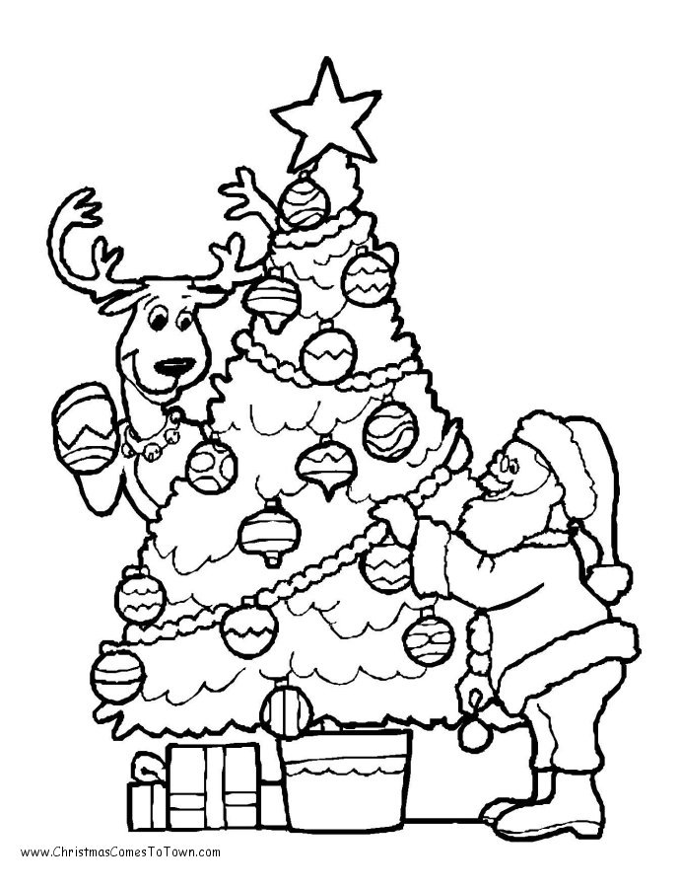
WWIC Radio Coloring Contest “Rules”
Contest is open to all children ages 5-12.
Only one entry per child please.
All completed entries must be turned in by Monday, December 18th.
Winner will be announced Friday, December 22nd.
Winner will receive a GIANT 6-foot Christmas stocking filled with toys and surprises.
Selected entries may be posted on WWIC Radio social media platforms (Twitter, Facebook, Website)

Name ______________________________________________
Address ____________________________________________
Phone Number ______________________________________
Parents Name(s) _______________________________________
School child attends __________________________________
Grade ______________________________________________
Signature of parent/guardian granting child permission to participate in contest.

__________________________________

