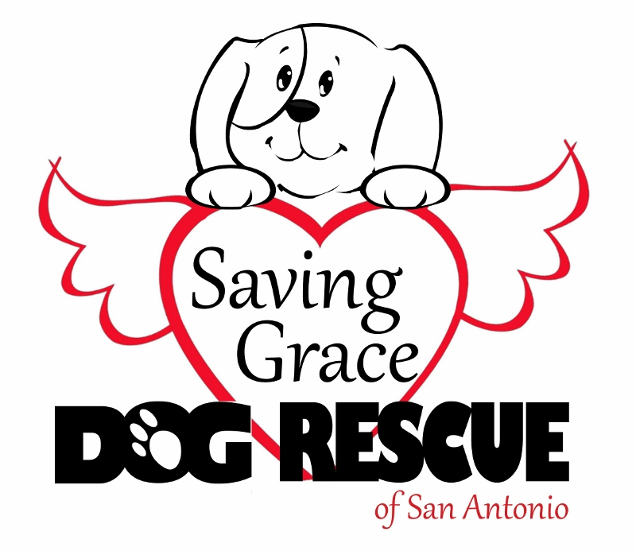
SAVING GRACE DOG RESCUE OF SAN ANTONIO
PET ADOPTION CONTRACT

Name:
Address:
City: |  | State: |  |  |  | Zip :
Telephone (Home): |  | (Cell): |  |  |  | (Work):
E-Mail: |  |  |  | Emergency Contact Person & Phone #:
Pet’s Name: |  | DOB: |  |  | Breed/Description: |  |  |  |  | (Circle) Cat Dog
Foster Name: |  | Spayed/Neutered: |  |  | Yes No |  | Gender: |  | Male Female
Adoption Fee: |  | Paid By: |  |  | Cash Check |  | Check Number:
Adopted at (Circle): | PetCo Petsmart Foster Other (specify): |  |  |  |  |  | Shot Records Given: |  |  |  | Yes No
Microchip Number:
(Sticker)

As an adopter, I understand that I am committed to this dog for his/her life and I agree to abide by these adoption conditions (please initial):
The above named dog (the “dog”) is being transferred to me with the understanding that I am taking possession of the dog to treat and to be responsible for it as my own dog. The dog will be treated as a family member with loving care and affection. I will do my best to ensure the dog’s safety and well-being. I will never allow any physical, mental or emotional abuse of the dog. ______ (initial)

I agree to provide shelter, fresh water, proper food and adequate companionship for the dog at all times. ______ (initial)

I agree that the dog will live inside my home and will not be isolated from the family. I will walk my dog on a leash or exercise my dog in a fenced yard, which must be provided unless waived by Saving Grace Dog Rescue of San Antonio (“SGDRSA”). I will not leave my dog outdoors, even in a fenced yard when no one is at home unless waived by SGDRSA. I will never let my dog run loose or roam, keep my dog chained or tied up, or keep it continuously in a yard, garage, patio, balcony, or pen. ______ (initial)

I agree to keep this dog as a pet and companion; it is never to be used as a guard dog, as a gift, or for experimental purposes in any way whatsoever. I am adopting the dog for myself and I agree to not give away, sell, or trade my dog, even as a gift to a friend or family member. ______ (initial)

I agree to take the dog to my veterinarian within 30 days of adoption to continue heartworm and flea prevention and/or well care, at my own expense. I will provide all required and/or needed veterinary care (including monthly heartworm prevention and annual vaccinations) and prompt treatment by a licensed veterinarian for any illness or injury. ______ (initial)

If this dog has not been spayed/neutered prior to adoption, I agree to allow the dog to return to SGDRSA once surgery appointment has been made. The dog shall go to SGDRSA the night before surgery and be returned to adopter the afternoon of surgery. ______ (initial)

I affirm that no member of my household has been convicted of an animal welfare law violation such as neglect, cruelty, abandonment, etc. ______ (initial)

I will ensure proper licensing of the dog and will attach the appropriate license tags, rabies tag, and personal identification tag to a non-choke collar to be worn at all times. I will ensure compliance with all applicable local and statutes. ______ (initial)

I understand that SGDRSA highly recommends that I enroll the dog in obedience training classes as a puppy and/or as an adult. I agree that I will not use a choke-type collar at any time, except for training under the guidance of a qualified dog trainer. ______ (initial)

I understand and acknowledge that I must notify SGDRSA, without delay, if I can no longer care for or keep my dog and agree to give SGDRSA reasonable time (maximum of 60 days from date of written notification) to find an appropriate home (to be determined by SGDRSA) for my dog or place my dog in an approved foster home, if available. I agree that I will not take the dog to a shelter or abandon the dog. Transfer of ownership of this dog is strictly prohibited without prior written authorization of SGDRSA. I further acknowledge that I must notify SGDRSA of any behavioral problems that have occurred at any time before I return my dog and I agree to pay for a professional trainer’s evaluation in case of biting or aggression. ______ (initial)

I understand and acknowledge that I may return the dog for adoption donation refund within 14 days from the date of this contract. ______ (initial)

In the event the dog becomes lost or dies, I will immediately notify SGDRSA. I will also immediately notify SGDRSA of any change of contact information (address, phone number, or email address). ______ (initial)

I understand and acknowledge that the dog is a rescued animal, and that no claims, representations, or warranties are made or implied by SGDRSA as to this dog’s age, breed, physical or mental characteristics, prior experiences, current or future health, behavior or temperament. ______ (initial)

I agree to permit SGDRSA to make inquiry about and enforce any of the above conditions and requirements at any time after adoption. This can include visits to my home and contact with my veterinarian. I UNDERSTAND THAT FAILURE TO COMPLAY WITH ANY OF THE ABOVE PROVISIONS WILL RESULT IN FORFITURE OF THE DOG TO SGDRSA. ______ (initial)

I UNDERSTAND THAT ALL RESCUE DOGS ARE A “RUNAWAY” RISK AND SHOULD NEVER BE ALLOWED OFF LEASH, ESPECIALLY DURING THE FIRST 30 DAYS IN A NEW HOME. YOU MUST TAKE EXTRA PRECAUTIONS TO PREVENT THIS DOG FROM GETTING LOOSE OUTSIDE, RUNNING OUT AN OPEN DOOR, OR LEFT UNATTENDED IN A YARD WHERE THEY COULD DIG OR CLIMB OVER A FENCE (LARGER DOGS HAVE BEEN KNOWN TO PULL FENCE PICKETS APART AND ESCAPE). NEVER UNDERESTIMATE THE MIND OF A DOG. _______ (initial)

ENFORCEMENT OF CONTRACT
This contract is binding and enforceable by Civil Law. Any breach of the contract in part or whole requires that the adopter voluntarily relinquish said dog and any papers that pertain to said dog to SGDRSA’s designated representative within five days of notification at the adopter’s expense without entitlement of any refund or damages of any kind.

ANY and ALL suits for breach of or enforcement of this contract concerning said dog and/or SGDRSA must be filed in Bexar County, Texas.

RELEASE OF LIABILITY AND INDEMNIFICATION
Adopter promises and agrees to be solely responsible for this dog and to indemnify and hold harmless SGDRSA from any and all claims of liability for the conduct of this dog.

Signature: _________________________________________________________ Date: ____________________________

Please check if you would like to: Volunteer □ Foster □

APPROVED AND ACCEPTED BY: ______________________________________ Date:_____________________________
Saving Grace Dog Rescue of San Antonio
If you have any questions or concerns,
please do not hesitate to contact us:
Saving Grace Dog Rescue of San Antonio
6990 Tezel Road
San Antonio, TX 78250
(210) 827-6524
sgdrsa@outlook.com
www.sgdrsa.org

