REGULAR MEETING
NOVEMBER 19, 2020

A Regular Meeting of the Town Board of the Town of Hampton, County of Washington and the State of New York was held at the Town Hall and via Zoom, 2629 State Route 22A, Hampton, New York on the 19th day of November 2020.

Due to the Corona Virus, occupancy inside the Town Hall is limited at this time. Supervisor O’Brien did provide a link to join the meeting via Zoom.

PRESENT: David K. O’Brien------------Supervisor
Tamme Taran----------------Councilwoman
Donald Sady-----------------Councilman
Andrea Sweeney------------Councilwoman
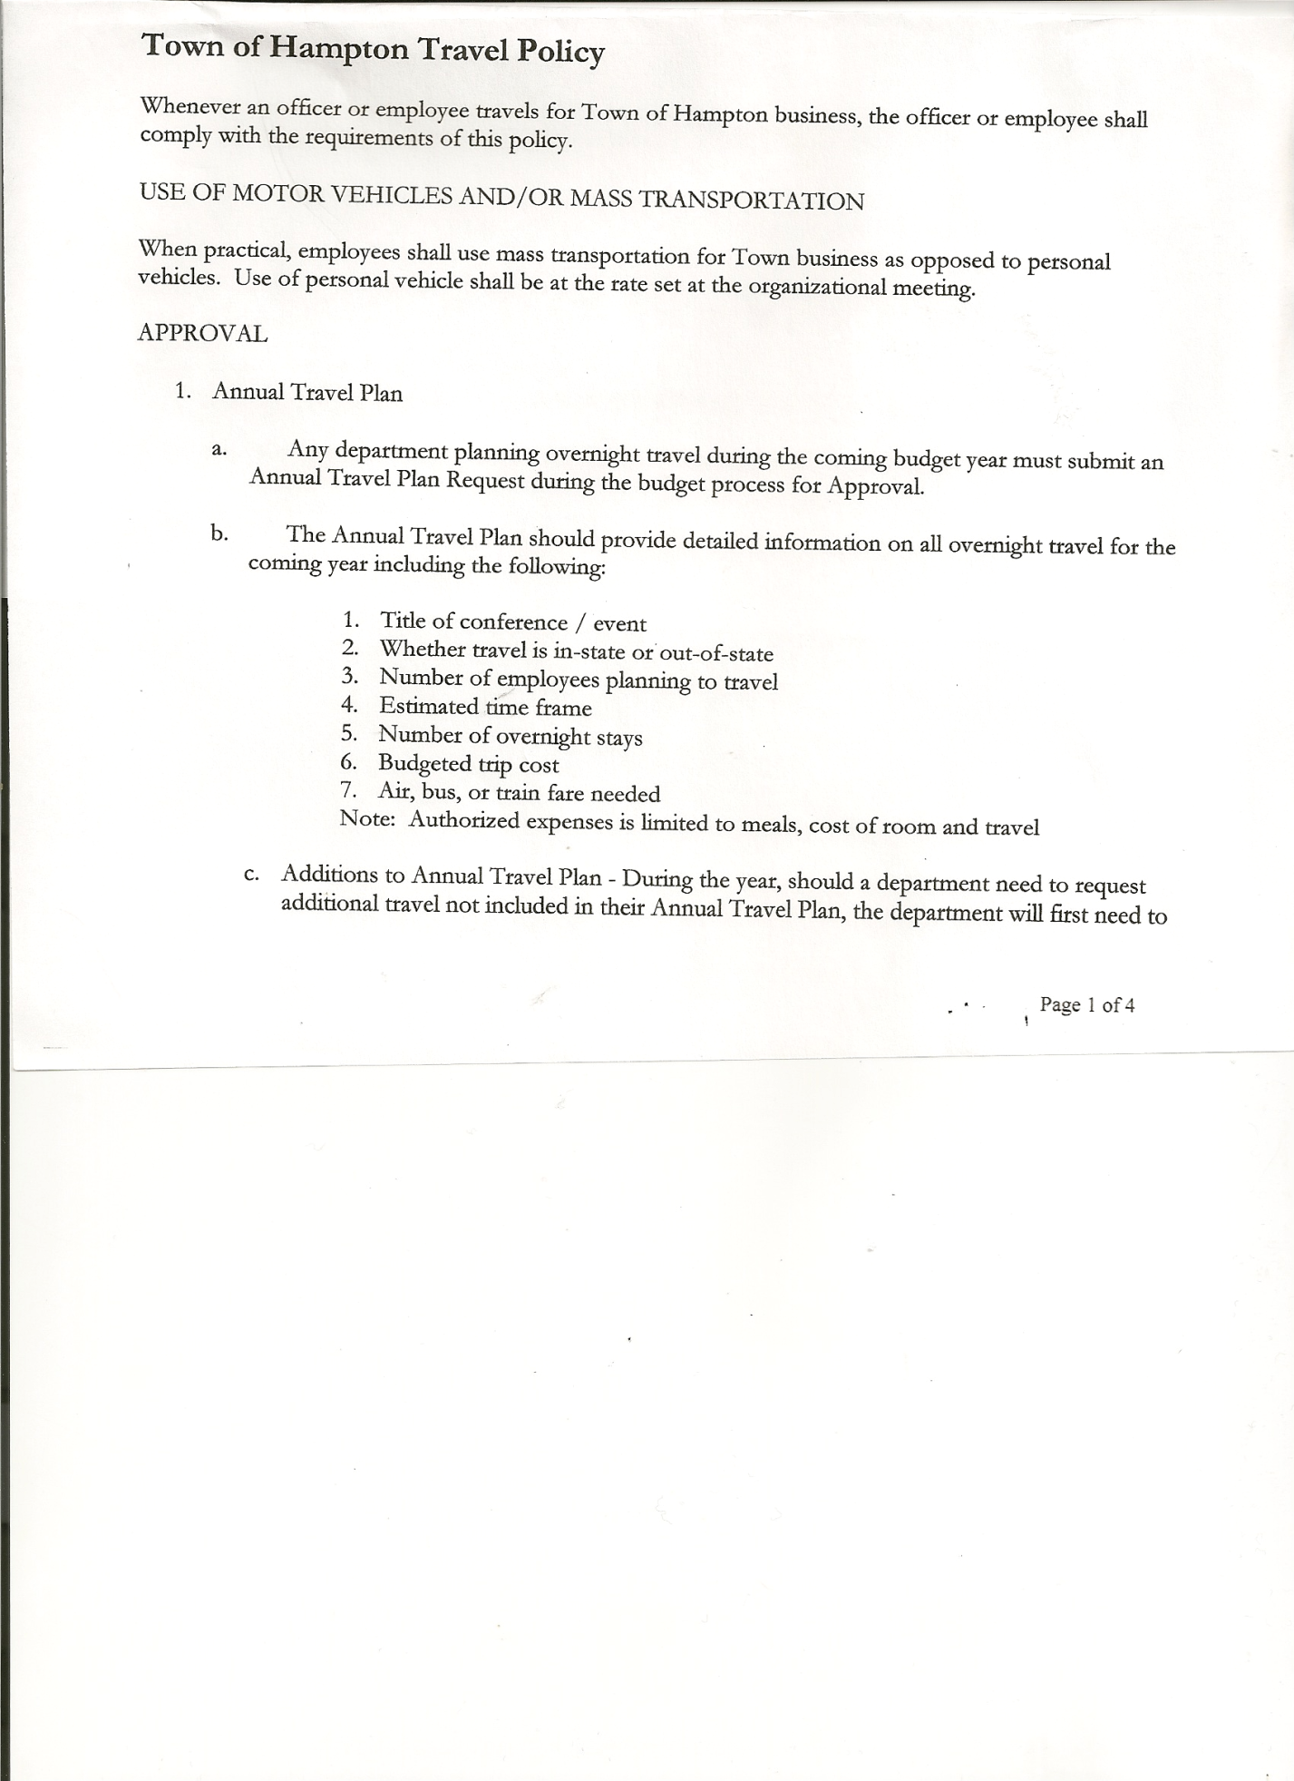
Michael Pietryka------------Councilman
Rebecca Jones---------------Town Clerk
Camilla Shaw----------------Tax Collector/Deputy Town Clerk
Herbert Sady, Jr.-------------Highway Superintendent

Planning Board Member(s): Bonnie Hawley and Matthew Pratt (via Zoom)
Others present at the Town Hall: Artie Pratt and Leonard Reed

The Regular Meeting was called to order by Supervisor O’Brien at 7:30pm, followed by the Pledge of Allegiance. Location of Fire Exits were given. Quorum of board members present.

Supervisor O’Brien asked for a moment of silence in memory of Linda Reed.

RESOLUTION NO. 93-2020
APPROVAL OF THE MINUTES
On a motion of Councilman Sady, seconded by Councilwoman Taran, the following resolution was ADOPTED: Ayes 5 O’Brien, Sady, Taran, Sweeney, Pietryka
Nays 0
RESOLVED, that the Regular Town Board Minutes for October 15th, 2020 and the Special Town Board Minutes for October 29th, 2020 are approved.

Tax Collector’s Report: Camilla Shaw, Tax Collector requested a Plexiglass shield for the office opening for the upcoming tax season as the office will be taking in person payments. Submitted Bank Statement to the Board for review and signatures.

Larry Carman, Dog Control Officer submitted his report, which was read by Supervisor O’Brien, copy of report is attached.

Bonnie Hawley, Chair gave Planning Board Report…copy of report is attached.
- Planning Board worked on the State mandated Sexual Harassment Prevention Training and Workplace Violence training and quiz.
- They reviewed 60 completed surveys. 12 were returned. A summary will be prepared next month. Most wanted to support farming and the Agricultural protection grant. They are reaching out to an agriculture protection agency. They are finding that new and beginning farmers are mostly veterans and newly retired folks. They are buying small parcels of good farmland. The grant needs to be submitted by February 1st for new awards by April 1st.
TOWN BOARD MEETING
NOVEMBER 19, 2020 PAGE 2

Herbert Sady, Jr., Highway Superintendent submitted his report, copy of which, is attached.

Ken Lufkin of Peckam’s has been contacted about the pot holes on Hickey road where the reclaimation was done. They gave some patching materials, but no other assistance.

Todd Mason has been hired as a temp for the winter. Matt Atwood from Whitehall has submitted an application, he has a Class B CDL permit and is taking his test on the 27th. Herb will interview Matt after Thanksgiving.

Maps have been made up and shared with Granville if help is needed due to COVID-19 illnesses in the highway departments of the towns. Whitehall may also be included.

Mike Pietryka asked about the damage by the logging trucks on the South Road. Herb has contacted the loggers and foresters who claim not their fault. Trying to contact the land owner.

Scott Taylor of Granville Highway resubmitted for Chips and received all the money back. Herb will resubmit Chips/Pave NY/ and Winter recovery as our town may be able to recover the 20% withheld.

Road side moving voucher has been received for $2,244.94

SUPERVISOR’S REPORT/COUNTY UPDATES/COMMUNICATIONS

RESOLUTION NO. 94 -2020
APPROVAL OF SUPERVISOR’S MONTHLY REPORT
On a motion of Councilwoman Taran, seconded by Councilman Sady, the following resolution was ADOPTED: Ayes 5 O’Brien, Sady, Taran, Sweeney, Pietryka
Nays 0
RESOLVED that, the Supervisor’s Monthly report be accepted as submitted for OCTOBER
09/30/2020 10/31/2020
ACCOUNT BALANCE RECEIPTS DISBURSEMENTS BALANCE
General Fund $ 49,062.11 $ 49,476.63 $ 7,118.73 $ 91,420.01
Highway Fund, $ 37,860.39 $ 1.52 $ 7,696.00 $ 30,165.91
Equipment Reserve $ 54,891.13 $ 2.32 $ 0.00 $ 54,893.45
Fire #1 $ 21,224.00 $ 0.00 $ 0.00 $ 21,224.00
Fire #2 $ 5,000.00 $ 0.00 $ 0.00 $ 5,000.00
Cemetery $ 1,739.49 $ 1.18 $ 0.00 $ 1,740.67
Totals $169,777.12 $ 49,481.65 $ 14,814.73 $ 204,444.04
All Board Members present signed the Supervisor’s Report.

The following Resolution is to adopt the new Retention/Disposition Schedule (LGS-1), which replaces the old Retention/Disposition Schedule (MU-1).
RESOLUTION NO. 95-2020

MOTION BY: Councilman Donald Sady
SECONDED BY: Councilwoman Andrea Sweeney

TITLE: RESOLUTION AUTHORIZING ADOPTION OF
RETENTION AND DISPOSITION SCHEDULE
FOR NEW YORK LOCAL GOVERNMENT RECORDS (LGS-1)
TOWN BOARD MEETING
NOVEMBER 19, 2020 PAGE 3

WHEREAS, the New York State Archives is revising and consolidating its local government records retention and disposition schedules and issuing a single, comprehensive retention schedule for all New York State local governments, including the Town of Hampton, entitled the “Retention and Disposition Schedule for New York Local Governments or LGS-1” (LGS-1)which will supersede and replace prior schedules effective as of August 1, 2020, and

WHEREAS, local governments must adopt LGS-1 prior to utilizing it, and

WHEREAS, the Town Clerk/Records Access Officer has recommended that the Town Board now adopt the LGS-1,

NOW, THEREFORE, BE IT

RESOLVED, in accordance with Article 57-A of the Arts and Cultural Affairs Law, the Hampton Town Board hereby authorizes adoption of the “Retention and Disposition Schedule for New York Local Governments or LGS-1” (LGS-1) which contains legal minimum retention periods for local government records for use by all officers in legally disposing of valueless records listed therein, and

BE IT FURTHER,

RESOLVED, that in accordance with Article 57-A:

- Only those records will be disposed of that are described in Retention and Disposition Schedule for New York Local Governments ( LGS-1), after they have met the minimum retention periods described therein;
- Only those records will be disposed of that do not have sufficient administrative, fiscal, legal, or historical value to merit retention beyond established legal minimum periods.

and

BE IT FURTHER,

RESOLVED, that the Town Board further authorizes and directs the Town Supervisor and/or Town Clerk/Town Records Access Officer to take such other and further actions as may be necessary to effectuate the terms of this Resolution.

RESOLVED, that this resolution shall take effect immediately.

DATED: November 19, 2020 Supervisor David O’Brien AYE
Councilman Donald Sady AYE
Councilwoman Tamme Taran AYE
Councilwoman Andrea Sweeney AYE
Councilman Michael Pietryka AYE

TOWN BOARD MEETING
NOVEMBER 19, 2020 PAGE 4

The Town Clerk’s report for October 2020 was submitted to the Board. The Town Clerk had Board Members review and sign bank reconciliation statements for the Town Clerk Account and Special Clerk Account dated October 31st, 2020.

RESOLUTION NO. 96-2020
END OF YEAR MEETING
On a motion of Councilman Sady, seconded by Councilwoman Sweeney, the following resolution was ADOPTED Ayes 5 O’Brien, Sady, Taran, Sweeney, Pietryka
Nays 0
RESOLVED, to set the End of the Year Meeting for 2020 for Tuesday, December 29th, 2020 at 7:00pm.

RESOLUTION NO. 97-2020
ORGANIZATIONAL MEETING
On a motion of Councilman Sady, seconded by Councilwoman Sweeney, the following resolution was ADOPTED: Ayes 5 O’Brien, Sady, Taran, Sweeney, Pietryka
Nays 0
RESOLVED, to set the Organizational Meeting for 2021 for Monday, January 4, 2021 at 7p.m.

RESOLUTION NO. 98-2020
AUDIT OF CLAIMS
On a motion of Councilman Sady, seconded by Councilwoman Taran, the following resolution was ADOPTED: Ayes 5 O’Brien, Sady, Taran, Sweeney, Pietryka
Nays 0
RESOLVED that the bills have been reviewed by the Town Board and are authorized for payment in the following amounts.
General Fund No. 104 through No.117 $ 4,420.79
Highway Fund No. 106 through No.117 $ 11,807.46
Total both funds $ 16,228.25

RESOLUTION NO. 99-2020
MEETING ADJOURNED
On a motion of Councilwoman Taran, seconded by Councilman Sady, the following resolution
was ADOPTED: Ayes 5 O’Brien, Sady, Taran, Sweeney, Pietryka
Nays 0
RESOLVED that the meeting adjourned at 8:03pm.

Respectfully submitted,

Rebecca S. Jones, RMC
Town Clerk

