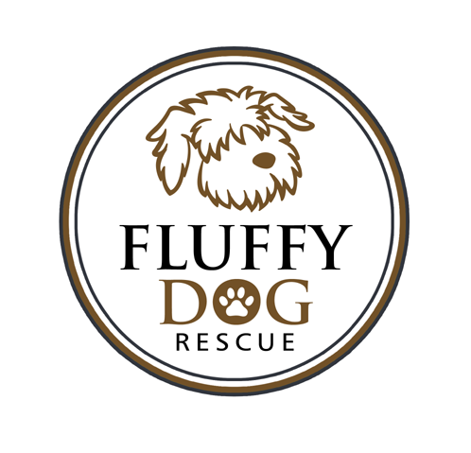 ADOPTION CONTRACT

The Adopter agrees to adopt the following dog (hereinafter called dog) from Fluffy Dog Rescue:
FDR Name/Breed_________________________________________________ Age________
Color/Markings_______________________________________________ Sex_________

As Adopter, I agree to the following:

1. To allow a representative from Fluffy Dog Rescue to visit my premises to insure the terms of this agreement have
been kept.

2. The dog will not be kept strictly outdoors.

3. The dog will not be kept on any type of tie-out, cable, or trolly system without supervision.

4. The dog will be provided adequate fresh food and water, and daily exercise.

5. To provide a safe collar, preferably harness, with rabies and I.D. tags to be worn at all times.

6. To obey all applicable laws governing control and custody of dogs.

7. To provide all medical care and treatment needed by the dog including, but not limited to yearly medical
checkups and vaccines, heartworm tests and preventative heartworm medication.

8. To adopt the dog only as a personal pet/companion and not as a gift, working animal, or guard dog.

9. The dog is not to be sold or given away for any reason. If it becomes necessary to find the dog another
home, Fluffy Dog Rescue will be contacted and the dog shall be returned to them. We do not refund adoption fees.

10. To have an initial exam and fecal sample tested by my veterinarian at my cost within two weeks of adoption.

11. To enroll the dog in a basic obedience classes within three months of adoption.

12. To not adopt, purchase or take over the care of another dog or cat within six months of adoption.

Fluffy Dog Rescue assumes no responsibility nor shall they be held liable for any damages caused by the adopted dog
to property, person or other pets. If any medical problems should occur after adoption, Fluffy Dog Rescue is not liable for
any medical bills.

As Adopter, I agree to accept full responsibility for the care of this animal releasing the previous owner as well as Fluffy
Dog Rescue, and its representatives of any liability from this date forward. I agree to abide by the adoption conditions, and
realize I am committed to this animal for his/her life. I have read and fully understand that Fluffy Dog Rescue may
repossess this animal at any time if the adoption conditions are violated or the animal is mistreated.

This adoption contract is entered into this ________ day of _________________, 2015, between Fluffy Dog Rescue and
Adopter's Full Name______________________________________________
Address________________________________________________________
City, State, Zip__________________________________________________
Home Phone ____________________Work Phone______________________
Adoption Donation of $_________ Received on __________ via ___________
Adopters Signature ________________________________________________
Received By Signature _____________________________________________

