SYDMOR STABLES
BOARDING AGREEMENT / CONTRACT
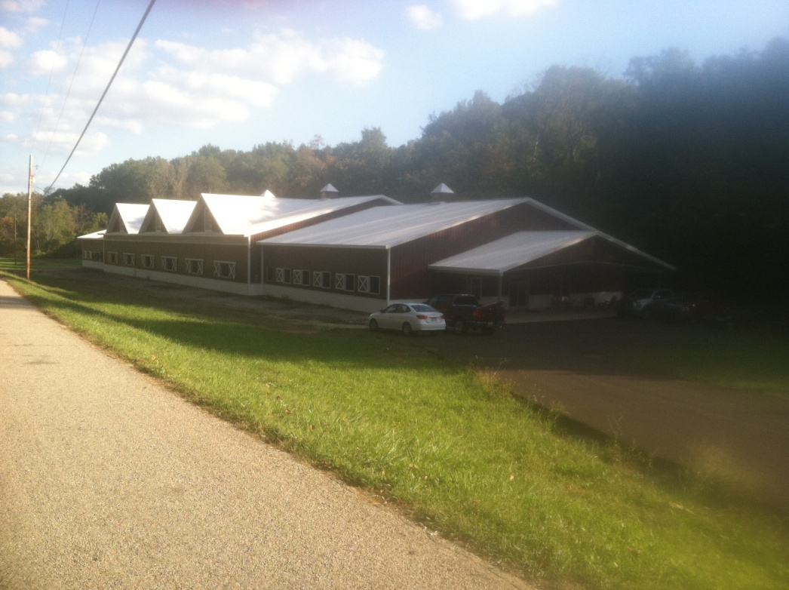
BOARDING AGREEMENT
THIS AGREEMENT, for good and valuable consideration receipt of which is hereby acknowledged, dated the __________ day of ____________, 2014 made by and between SYDMOR STABLES, hereinafter referred to as "STABLE", providing services as an independent contractor, located at Gilkeson Road, Eighty-Four, Pa, and (Owner’s name) _________________________ residing at (Owner’s address) _________________________________, hereinafter referred to as "OWNER." These parties warrant that they have the right to enter into this AGREEMENT.
1. FEES, TERMS AND LOCATION
In consideration of $ 375 per horse per month paid by OWNER in advance on the First day of each month, STABLE agrees to board the herein described horse (s) on a month to month basis commencing ____________, 2014. Partial months boarding shall be paid on a pro-rata basis based on the numbers of days boarded in a standard 30 day month.
Late Fees: Boarding fees paid between the sixth and fifteenth day of the current month due will be subject to a late fee of $15.00. Fees received after the sixteenth will be subject to a late fee of $25.00.

2. DESCRIPTION OF HORSE(S)
Name.
Age:
Color:
Registration/Tattoo
Sex:
Breed:
Number (if applicable):

3. FEED AND FACILITIES
STABLE agrees to provide the following, in addition to normal and reasonable care and handling to maintain the health and well being of the horse (s).
Horses will be fed alfalfa/oat hay and grain twice daily unless other feeding arrangements have been agreed upon.
Additional supplements such as specialty grain, vitamins, etc. can be provided at an additional charge.

4. ROUTINE FARRIER AND VETERINARY CARE
STABLE will provide the necessary routine Ferrier and veterinary care of the horse as is reasonably necessary. Provided however, such expense for same shall be the obligation of OWNER hereunder. Upon presentation by STABLE of the bill for said services rendered, including service charges, if any, OWNER shall pay said bill within fifteen days that the bill is submitted to OWNER.
The STABLE policy asks that OWNER (S) remove horse’s shoes prior to retirement unless medically required to prevent lameness.
Each horse will be administered a paste wormer upon arrival to STABLE and the fee for which will be added to the first month’s boarding fee.
Upon arrival of horse to STABLE proof of current tetanus, sleeping sickness, and influenza vaccinations is required. Vaccines against West Nile Virus and Strangles are recommended but not required.
A negative current Coggins test is required for all horses arriving from out of state

5. RISK OF LOSS
During the time that the horse (s) is/are in the custody of STABLE, STABLE shall not be liable for any sickness, disease, theft, death or injury which may be suffered by the horse. This includes, but is not limited to, any personal injury or disability the horse may receive while of STABLE’s premises. OWNER fully understands and hereby acknowledges that STABLE does not carry any insurance on any horse (s) not owned by STABLE, including, but not limited to, such insurance for boarding or any other purposes, for which the horse( s) is/are covered under any public liability, accidental injury, theft or equine mortality insurance, and that all risks relating to boarding of horse (s), or for any other reason, for which the horse (s) is/are in the possession of STABLE, are to be borne by OWNER.

6. HOLD HARMLESS
OWNER agrees to hold STABLE harmless from any claim resulting from damage or injury caused by said horse, OWNER or his guests and invitees, to anyone, including but not limited to legal fees and/or expenses incurred by STABLE in defense of such claims.
Please note that it is a requirement for all OWNERS and GUESTS to sign the separate HOLD HARMLESS agreement upon arrival to STABLE.

7. LIABILITY INSURANCE
OWNER warrants that he/she presently carries in full force and effect, and throughout the period of this AGREEMENT shall continue to carry and maintain in full force and effect, liability insurance protecting OWNER and STABLE from any and all claim (s) arising out of or relating to this AGREEMENT.

8. EMERGENCY CARE
STABLE agrees to attempt to contact OWNER, at the following emergency telephone number (________________), should STABLE feel that medical treatment is needed for said horse (s), provided however, that in the event the STABLE is unable to so contact OWNER within a reasonable time, which time shall be judged and determined solely by STABLE, STABLE is then hereby authorized to secure emergency veterinary care and/or blacksmith care, and by any licensed providers of such care who are selected by STABLE, as STABLE determines is required for the health and well-being of said horse (s). The cost of such care secured shall be due and payable by OWNER within fifteen days from the date OWNER receives notice thereof, provided however, that STABLE is authorized to arrange direct billing by said care provider to the OWNER.
Either party may terminate this AGREEMENT for failure of the other party to meet any material terms of this AGREEMENT, including but not limited to stable rules.

9. STABLE RULES
Owner hereby acknowledges receipt and understanding of the current STABLE Rules, which are incorporated by reference in full, as if fully set forth herein. OWNER agrees he/she and his/her guests and invitees will be bound and abide by these Rules, and accepts responsibility for the conduct of his guests and invitees according to these Rules. OWNER acknowledges the Rules include but are not limited to:
STABLE Safety Rules;
STABLE Hours of Operation;
Notice of Required Release and Waiver for minors;
Statement of Applicable state equine liability laws;
Required Veterinary care;
STABLE may revise these Rules from time to time and OWNER agrees any revision shall have the same force and effect as current Rules. Failure, as determined in STABLE’s sole discretion, of OWNER or OWNER’s guests and invitees to abide by STABLE Rules may result in STABLE declaring OWNER in default hereunder and result in termination of this AGREEMENT.

10. DEFAULT
Either party may terminate this AGREEMENT for failure of the other party to meet any material terms of this AGREEMENT, including but not limited to item 9 Stable Rules. In the case of a default by one party, the other party shall have the right to recover legal fees and expenses, if any, incurred as a result of said default. Any payment due STABLE under this AGREEMENT shall be due and payable by the tenth day of the month and immediately in the event of termination. Failure to make any payment by said due date shall place OWNER in default hereunder. Acceptance by STABLE of any late payment shall not constitute a waiver of subsequent due dates or determinations of default.

11. ASSIGNMENT
This AGREEMENT may not be assigned by OWNER without the express written consent of STABLE.

12. NOTICE OF TERMINATION
OWNER agrees that thirty (30) days notice shall be given to STABLE as to the termination of this AGREEMENT.

13. RIGHT OF LIEN
OWNER is put on notice that STABLE has and may assert and exercise a right of lien, as provided for by the laws of the State of PA for any amount due for the board and keep of horse (s), and also for any storage or other charges due hereunder, and further agrees STABLE shall have the right, without process of law, to attach a lien to your horse (s) after two (2) months of non-payment or partial payment and STABLE can then sell horse (s) to recover its loss.

14. MEDIATION/ARBITRATION BY EQUINE DISPUTE RESOLUTION SERVICE
In the event of any dispute or disagreement relating in any manner whatsoever to this AGREEMENT the parties agree and consent to engage in mediation in a good faith effort to resolve the dispute amicably before either party resorts to court action. Mediation shall be conducted by and according to the rules of the Equine Dispute Resolution Service (EDRS) and shall be commenced within 45 days of such disagreement or the request of either party to mediation. In the event that the parties are unable to successful resolve said dispute through said mediation, then, in that event, the parties agree to submit the dispute to binding arbitration by and according to the rules of Equine Dispute Resolution Service (EDRS), within 30 days of any declaration of impasse by EDRS.
15. Special Instructions to STABLE
________________________________________________
________________________________________________
________________________________________________
________________________________________________
________________________________________________
________________________________________________
________________________________________________
________________________________________________
________________________________________________
________________________________________________
THIS AGREEMENT IS SUBJECT TO THE LAWS OF THE State of Pennsylvania.
Executed at ____________________________ on the date first set forth above.
By: _______________________________
SYDMOR STABLES
By: _______________________________
(O w n e r’ s S i g n a t u r e)
Owner’s Name: _______________________________
Address: ____________________________________
City: ____________________________________
State: ____________________________________
Zip: ____________________________________
Day Phone : ____________________________________
Evening Phone : ____________________________________

