The RBA in on the Road Again...Up Next Minnesota!
​​
On Sunday, October 30th the Retail Bakers of America (RBA) will host an RBA Roadshow in St. Paul, MN. Designed to bring bakers, cake decorators, vendors, students and educators together. This one-day event will be held at St. Paul College.

Date: Sunday, October 30th, 2016

Location: St. Paul College, 235 Marshall Ave, St. Paul, MN, 55102

Event Schedule:
- Bakery Tours - 7:30am - 11:30am
- Hands-on Classes - 8:00am - 11:00am
- Vendor Showcase - 11:00am – 4:00pm
- Buffet Lunch - 11:30am - 12:30pm
- Educational Sessions - 1:00am - 5:00pm
Bakery Bus Tour:
- Dorothy Ann Bakery and Café, 710 Commerce Drive, Woodbury, MN 55125
- Jerry's Foods Woodbury, 7760 Hargis Pkwy, Woodbury, MN 55129
- Grandma’s Bakery, 1765 Buerkle Road, White Bear Lake, MN 55110

A "Suite" Hotel Deal
The RBA has partnered with the DoubleTree by Hilton St. Paul Downtown for a great deal. Click on the link to book your room. The RBA group code is 356 and guests may also ask for the Retail Bakers of America Block. http://doubletree.hilton.com/en/dt/groups/personalized/M/MSPMSDT-356-20161029/index.jhtml?WT.mc_id=POG

Talkin’ Turkey – Sculpting with Bronwen Weber
Moring Hands-On Session 8:00- 11:00am
Cost is $100 per person- Limit of 15 students per class

In this 3-hour hands-on session you’ll be talkin’ turkey with award winning cake decorator Bronwen Weber, the Executive Chef of Frosted Art Bakery & Studio in Dallas. Bronwen is an animated and energetic instructor who will have you creating a 3-D turkey just in time for your Thanksgiving sales. White meat optional!
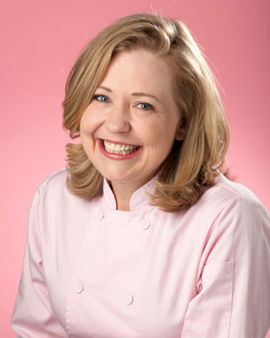

Bronwen Weber, Executive Chef of Frosted Art Bakery & Studio in Dallas, Texas, started her “twenty something” year career at the age of fourteen in a small bakery in Acton, Ontario. She is celebrated on the Food Network as one of the top pastry chefs in the nation. Bronwen has been on 27 of the Food Network’s Cake Challenges resulted in so many more gold medal wins than any other chef that she has been granted the title of Cake Challenge Champion.

Afternoon Education Sessions

Education Session: 1:00pm - 2:00pm

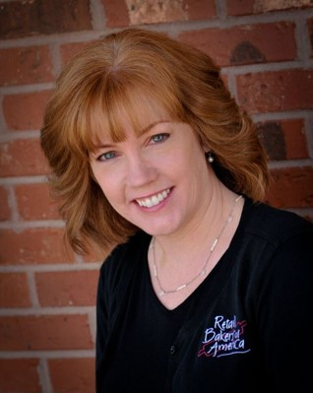
Decorator Track
Session: Pinterest & Profitability: Take Control of the Cake Ordering Process
Presenter: Beth Fahey, Creative Cakes, Bakery & Cafe

How much time are you spending quoting cake prices to customers? Tools like Pinterest and the Internet are great for idea generation, but are they actually killing your bottom line? Beth Fahey, owner of Creative Cakes in Tinley Park, IL, offers tips on how to get emails, wedding cake consultations, and walk-in inquiries under control and back on track - making your bakery profitable while also delivering excellent customer service.

Manager/Supervisor Track
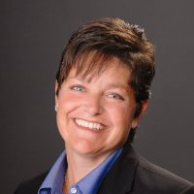
Session: Improved Employee Performance Through Coaching
Presenter: Renee Rouwhorst, Rouwhorst Consulting

Successful managers understand the importance of coaching to improve productivity, loyalty, and results especially working with millennials. Instead of telling them what to do, or just expecting them to perform, it is important to guide, discuss and encourage - in other words, coach. For millennials who are developing in their skills, knowledge, and self-confidence, coaching is a critical part of their learning process. In this session, participants will 1) Understand characteristics of a good coach, 2) Understand how to praise and to critique & the value of each, and 3) Understand when to give feedback, train, problem solve, discipline or coach.

Marketing Track Session
Session: What Millennials Can Teach Us: Customer-Centric Marketing Lessons for the Bakery
Presenter: Joanne Brockington, Marketing Manager, DecoPac

As Millennials become the largest share of the market, bakeries will need to re-think how they reach this dominant portion of the customer base. DecoPac Marketing Manager Joanne Brockington shares the research and insight into the Millennial customers.

Education Session: 2:30pm - 3:30pm

Decorator Track Session
Session: Copyright Matters
Presenter: DecoPac

Currently one of the hottest topics for retail bakers all across the country. There are so many questions about what can be put on a cake legally without the risk of violating trademark laws. In this session, a DecoPac licensing personnel will share their knowledge of the copyright laws.

Manager/ Supervisor Session
Session: YouTube It: Training Employees with Online Video Content
Presenter: Beth Fahey, Creative Cakes, Bakery & Café
Is there anything more energy-draining than training employees? What if there were a better way to train your employees, while at the same time, monitor their progress as they move through the levels? Beth Fahey, owner of Creative Cakes in Tinley Park, IL, discusses her bakery’s approach to employee training with videos and other cloud-based content. For today’s digital employee force, it’s the next great way to capture their attention and get them to learn in a mobile world.

Manager/Owner Session
Session: Finding Good (or Any) Employees in Today’s Labor Market – Round Table Discussion
Presenter: Renee Rouwhorst, Rouwhorst Consulting

This session will provide for an interactive discussion of strategies that bakery and in-store bakeries are using to find and keep employees in a very challenging labor market. Come to this session to share what is or is not working in your bakery. Different scheduling options, baking during different times of the day, different recruiting strategies, training ideas and more will be shared.

Education Session: 3:45pm - 4:30pm

Lively Decorating Demonstration
Session: Wafer Paper Flowers
Presenter: Bronwen Weber

What’s better at the end of the day than a little laughter and a lot of learning. Watch as the amazing Bronwen Weber makes wafer paper flowers that can be added to your wedding and specialty cakes.

SHORT VERSION AFTERNOON EDUCATION

1:00pm - 2:00pm
*Pinterest & Profitability: Take Control of the Cake Ordering Process
*Improved Employee Performance Through Coaching
*What Millennials Can Teach Us: Customer-Centric Marketing Lessons for the Bakery

2:30pm - 3:30pm
*Copyright Matters with DecoPac
*YouTube It: Training Employees with Online Video Content
*Finding Good (or Any) Employees in Today’s Labor Market – Round Table Discussion

3:45pm - 4:30pm
*Lively Decorating Demonstration, Wafer Paper Flowers with Bronwen Weber

