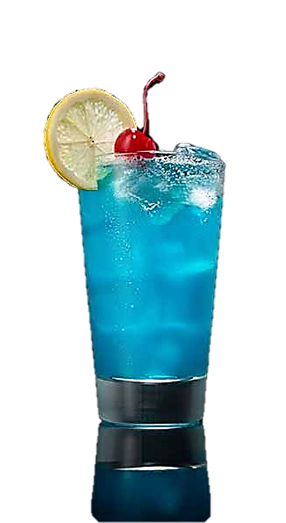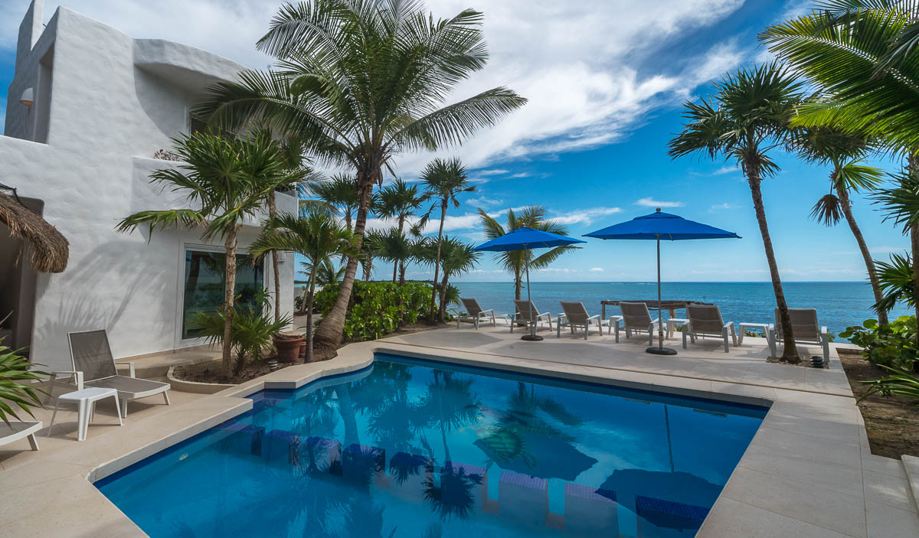

Gin

Rum

Tequila

Vodka

Blue Curacao

Triple Sec

Sweet & sour

Splash of 7up

$9.50

**MAR AZUL (AMF)**