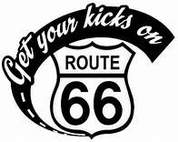
Hillsboro Homecoming & Festival Parade

“Get Your Kicks on Route 66”
21

Dear Parade Participant:

The Hillsboro Chamber of Commerce is planning the Annual Hillsboro Homecoming and Festival. The Parade and events get bigger and better each year.

Make your plans now and start thinking of ideas on how you can make your parade entry special. The theme this year will be “Get Your Kicks on Route 66”. Think “sock hop”, classic cars, motorcycles, leather jackets, poodle skirts!

Trophies will be awarded to the “Best of” in each designated category. Additionally a Grand Prize of $100.00 will be awarded to the “Best of Parade.” The parade will be Saturday, May 20th at 11:00 a.m. Parade lineup will begin at 10:00 am behind the Hillsboro Intermediate School located on Business 21. Please check in when you arrive to receive direction on where your place in line is located. The route of the parade will go from the Hillsboro Intermediate South onto 21 to Main Street and will end behind the courthouse parking area. Awards will be announced immediately following the end of the parade on the main stage located on Main Street.

VERY IMPORTANT – For the Festival parade you will be given a number BEFORE you get to the parade lineup. You will be notified by email your lineup number by Wednesday, May 17th. Please create a sign and place the number on your float on the passenger side as this is what the judges will be using to clearly identify entries.

Please join us in celebrating our community!

Sincerely,

Sara Sucharski, Parade Coordinator
sara@ponybird.org
PO Box 190
Mapaville, MO 63065
636-931-5818

Hillsboro Homecoming and Festival

“Get Your Kicks on Route 66”
21

PARADE ENTRY FORM
Saturday, May 20st, 2017 at 11:00 a.m.

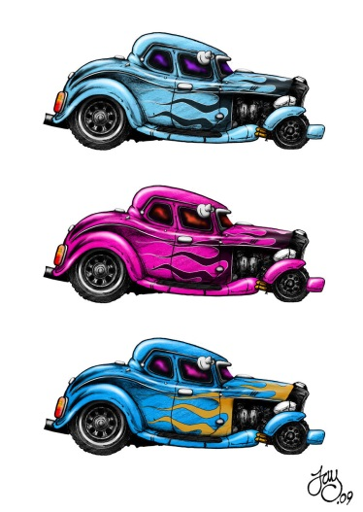
Lineup: 10:00 a.m. Parade begins at 11:00am
Behind Hillsboro Intermediate Campus
Continue south on Business 21 to RIGHT on Main Street in front
Jefferson County Courthouse, disperse on Maple Street.

Contact:
Sara Sucharski 636-931-5818 /sara@ponybird.org
Or Mandy Alley 636-789-4920/ chamberoffice@sbcglobal.net

Return form by May 12th 2017 to: Parade Coordinator P.O. Box 190
Mapaville, MO 63065

Detach and Return

Organization Name___________________________________________________________________________________________

Contact Person_______________________________________________________________________________________________
Print Name Signature Email Address

Address_____________________________________________________________________________________________________

Street City State Zip Phone

Alternate Contact________________________________________________________________________________________________
Print Name Signature

Address_____________________________________________________________________________________________________
Street City State Zip Phone
Float (Title)_____________________________________________________________________________________________________

Describe Float___________________________________________________________________________________________________

Walking/Marching Unit (Name & Type)________________________________________________________________________
Number of People__________________
Motor Unit (Name & Type)____________________________________________________________________________________
Number of Vehicles_________________
Vintage Unit (Year/Vehicle Description)__________________________________________________________________________

Best-Dressed Animal Describe)__________________________________________________________________________________

Please check the category your entry is to be judged. CHECK ONLY ONE CATEGORY
$100.00 will be awarded to the all around best of the parade – all entries are automatically entered for this category.
___Best Float ___Best Walking/Marching Unit ___Best Motorized Unit___Best Vintage Unit ___Best Religious ___ Best Dressed Animal

