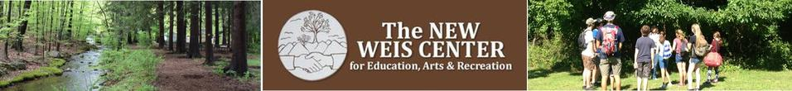

RAMAPO COLLEGE STUDENTS!

2020-2021 May H. Weis Environmental Internship Award
Recipients of the May H. Weis award participate in a paid internship at The New Weis Center (NWC) in Ringwood, NJ, and receive a full tuition scholarship for one semester at Ramapo College.

For Ramapo College students ONLY (undergrad/grad). Majors in environmental studies/science, education, sciences or related fields preferred. Recommendation letter from a dean/faculty member is required.

Training and career mentoring provided. Great opportunity for professional development and networking!

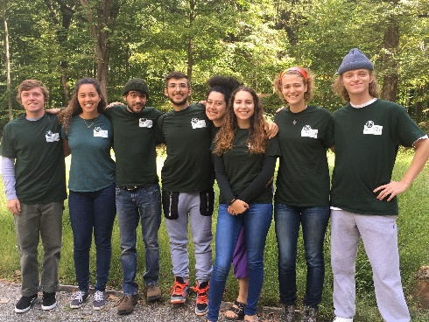
General Requirements
- Average of 15 hrs/wk (full-time in summer)
- Motivated and willing to take initiative
- Good communication and follow up skills
- Outgoing and comfortable engaging with all ages, especially children
- Must have own transportation
- Previous camp counselor, environmental educator or program leader experience is preferable
- Knowledge of local flora and fauna, or willingness to learn

Responsibilities - Interns are required to lead or assist with the following
- Counselor at summer nature camp and school break day camps
- Educator at school field trips
- Lead public nature programs; assist with arts and recreation programs; lead guided hikes and walks
- Community events (Farmers Markets, Environmental Fairs, school STEM programs, Earth Day)
- Lead scout programs and merit badges
- Gardening and grounds; including planting, maintenance and upkeep, invasive species management

Optional Projects and Tasks - depending on individual interests, skills, and experience
- Gardening, including native/invasive identification, and planting/removal
- Sustainability initiatives such as composting, vermiculture, solar energy conversion
- Grant research and writing; fundraising initiatives; marketing and communications

Application period is from February-April, 2019: https://www.ramapo.edu/scholarships/single/may-h-weis-environmental-internship-scholarship/

More info and additional internship opportunities: http://www.highlandsnaturefriends.org/interns.html

The New Weis Center for Education, Arts & Recreation
150 Snake Den Rd, Ringwood, New Jersey 07456
Tel: 973-835-2160 | Web: www.highlandsnaturefriends.org | Email: info@highlandsnaturefriends.org
Facebook: @newweiscenter | Instagram: @thenewweiscenter
The New Weis Center if owned and operated by The Highlands Nature Friends, Inc., a 501(c)3 nonprofit

