Scales used in Kaschei’s Infernal Dance

Introduction:

In creating the ominous mood for Kaschei’s dance, Stravinsky chose to use a modified form of octatonic scale. Octatonic scales usually are constructed with an alternation of whole steps and half steps. In Stravinsky’s scale the composer has placed a half step between the 4th and 5th notes, which makes the scale operate as a mix of octatonic and chromatic structures. The fourth note of the scale does not occur in the melody shown below but is used later in scale passages for strings between rehearsal numbers 8 – 10. The “standard” octatonic scale appears in string scales between rehearsal numbers 10 and 11 as well as in woodwinds and strings just prior to rehearsal 15 as well as before rehearsal 19.

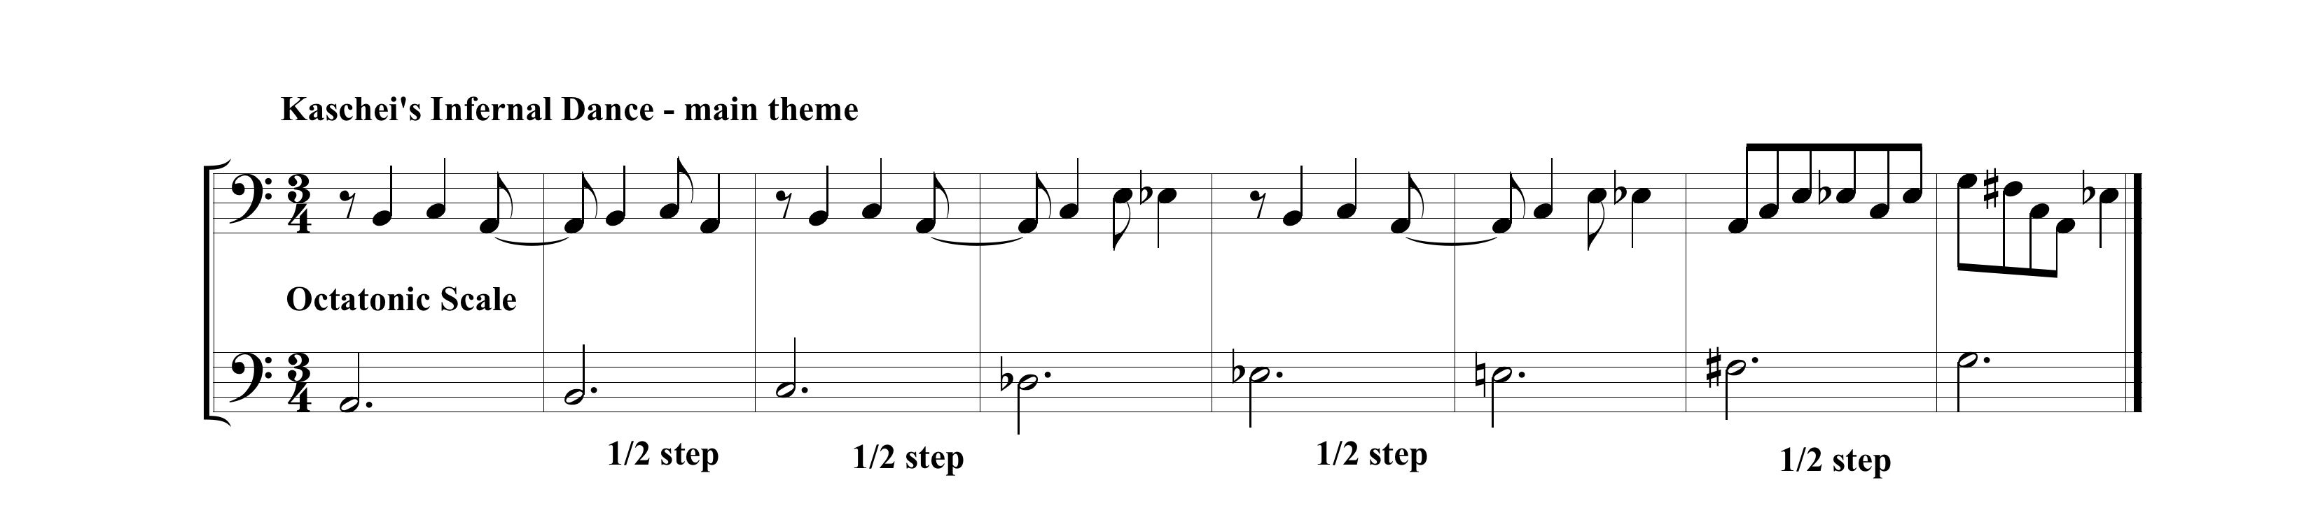
Whole Tone Scale:

The whole tone scale makes a brief appearance in woodwind runs across rehearsal 12.

Other Scales. Major and minor (diatonic) scales and chromatic scales are used in several scale passages as well.

Summary:

To establish the essence of Kaschei’s dark realm, Stravinsky used a sound palette well outside of his audience’s experience. The primal force of the rhythm, orchestration and dynamics of this movement combined with its scale resources constituted a major breakthrough in compositional structure, expression and style.

