Caraway Rug School
2018 Teachers

Jeannie Benjamin
All Types & Primitives
Judy Carter
Animals
Anne Hoffman
All Types & Fine Shading
Donna Hrkman
Faces & Steampunk
Lisanne Miller
Vintage, Landscape
Diane Stoffel
All Types
Tricia Travis
All Types and Primitive
-------------------------------------------------

How to Register For Caraway Rug School

- Fill out Registration Form
- Attach your check for $150
**Make payable to
Caraway Rug School

If you are mailing your Caraway Registration Form in:

Mail form with $150 check to
Jane Dunaway
43 Westridge Road
Brandon, MS 39047

At Caraway Rug School
Remember

No refunds for Caraway Rug School after January 1, 2018

Your balance is due by April 16, 2018 to avoid late fees

LATE REGISTERING?

If registering AFTER April 15th
$50 late fee applies.

Also, this is based on availability in the classes you selected!

Questions About Caraway Rug School???

Lisanne 207-360-0762 or lisannemiller1@aol.com
Eric 757-709-4481

www.carawayrugschool.com

Caraway Rug School is located in Sophia, NC very close to Asheboro NC
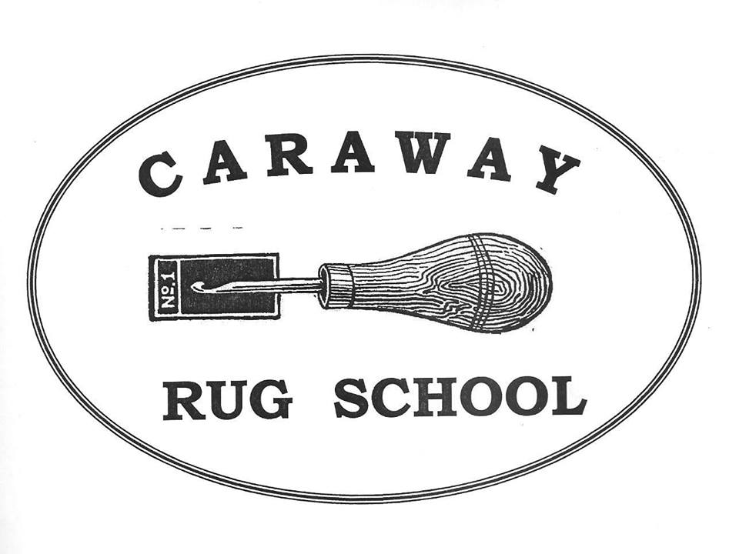
Caraway Rug School
June 17-22, 2018
Registration
(Please Print Clearly)

Name:___________________________________

Address:________________________________

City:____________________________________

State:________Zip:_______________

Phone:__________________________

Email:___________________________

Skill Level: (Circle One)
Beginner Intermediate Advanced

Teacher: (1)_____________________

(2)______________________________

Roommate:_____________________

Fees: (Circle All That Apply)

Commuters $475 Each

Special Needs:

Caraway Rug School
Important Information

First Class Accommodations Include:
Towels
Bed Linens
Hair Dryer
Clock Radio
Private Bathrooms
AC in ALL Rooms
Smoke-free Environment
Internet Access Available
No Alcoholic Beverages
Elevators
Linen Service As Needed

Meals: Sunday Dinner to Friday Breakfast
(Meals are cafeteria style with a great salad bar at both lunch and dinner)

Fun Stuff That Makes Caraway, Caraway!

Movie Night with popcorn
Rug Show Walk and Talk
Flea Market Day
Auction Night
Scholarships
Rug Store & Supplies provided by “Tomorrow’s Heirlooms”
“W. Cushing & Co.”

At Caraway Rug School,
We continue the tradition of rug hooking while pushing our art forward!

Caraway Rug School
June 17-22, 2018

Open School * All Patterns Taught * All Levels from Beginner to Experienced

Join us for an exceptional Rug Hooking School and Exhibit of Traditional & Primitive Hand Hooked Rugs

WHEN: June 17-22. 2018
Registration Sunday 2 – 5 pm
Orientation 6:30 pm

WHERE: Caraway Conference Center
4756 Caraway Mountain Rd
Sophia, NC 27350
336-629-2374

CLASSES: Monday –Thursday 9 to 3:30 pm
Friday 8:30 to 10 am Hooking
Classrooms Open Nightly

RUG SHOW: Wednesday, June 20, 2018
11 am to 6 pm
OPEN TO THE PUBLIC

RATES/FEES: Double Occupancy $720 Each
Private Room $850 Each
Commuters $475 Each
Husbands $500 Each

DUE DATES: $150 Deposit To Register
Balance Due April 15, 2018

LATE FEES: $50 if Payment arrives AFTER
April 15, 2018

REFUNDS: FULL Refund prior to Jan 1, 2018
No Partial Refunds Given

What You Need to Pack
For Caraway Rug School!

Your Rug Hooking Supplies
Rugs to Exhibit at the Rug Show
Personal Clothing Items, toiletries and Remember A Sweater!
Rug Hooking Related Item for the Scholarship Auction & A Smile

When Will You Hear From Your Teacher?

You will hear from your teacher after March 1st!

So be sure to print your information clearly

What To Do Upon Your Arrival

Please register with Lisanne in the front foyer. Pick up your room key and
Registration packet
Nest in your classroom

Questions???

Lisanne 207-360-0762
lisannemiller1@aol.com

Eric 757-709-4481
www.carawayrugschool.com

