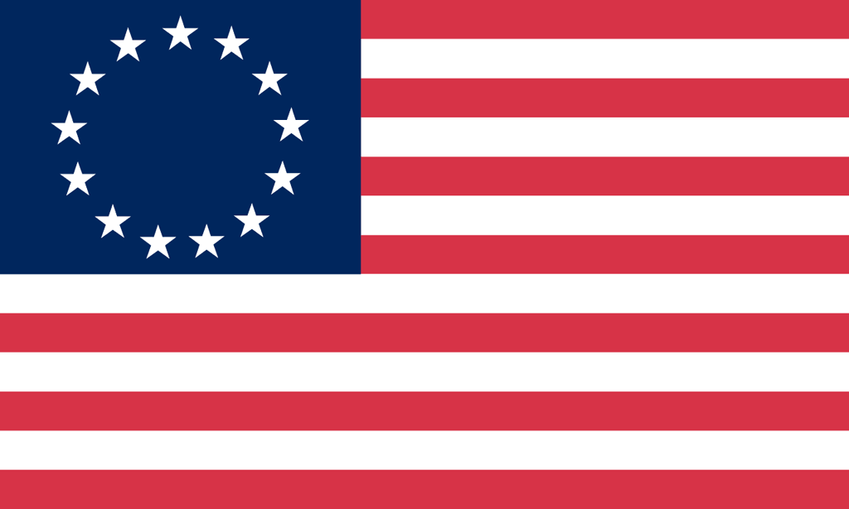U.S. History with Mr. Brown Name _______________________________ Period _____

Mercantilism Activity

Paper airplane and materials prices under mercantilism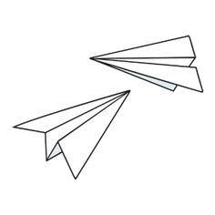

|  |  |  |
| --- | --- | --- |
|  | ¼ Sheet of Paper | Tiny Paper Airplane |
| What it is worth | $00.25 | $1.00 |
| **Actual market price** | **$00.15** | **$1.50** |

**Group Members**

Group leader and scribe (fills out this paper)

Banker

Merchant transporter of goods

Workers (Airplane Manufacturer or Paper Producer)

**Group 1**

**Home Country**

You need ¼ sheets of paper. You make tons of money selling tiny paper airplanes, especially to your colonies. You don’t have paper though and have to buy it somewhere else. It turns out that your colonies in the new world have a great supply of paper. They can produce it in the ¼ sheets that you need. You have to buy paper from your colony and sell them finished paper airplanes.

|  |  |
| --- | --- |
| How much Money are you starting with? | How many ¼ pieces of paper did you buy? |
| How many tiny paper airplanes did you sell? | How much money do you have at the end? |

**Group 2**

**Colonies**

The people of your colony LOVE tiny paper airplanes, they just cannot get enough of them. Luckily you have tons of paper that can be used to make paper airplanes but unfortunately no one in your colony is trained to or capable of making paper airplanes. You are forced to buy your tiny airplanes from your home country.

|  |  |
| --- | --- |
| How much Money are you starting with? | How many ¼ pieces of paper did you Sell? |
| How many tiny paper airplanes did you buy? | How much money do you have at the end? |