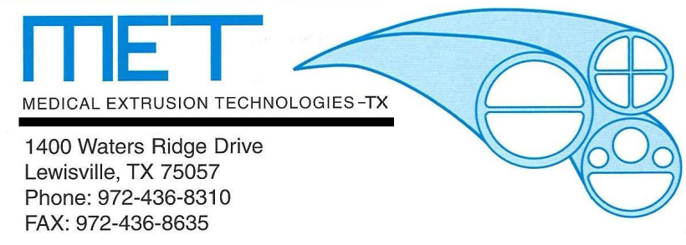

Medical Extrusion Technologies, Inc. Announces Expansion.
Medical Extrusion Technologies, Inc. is pleased to announce it's recent expansion to better serve the medical marketplace. We have expanded our capabilities for extruding thermoplastic flouropolymers (PFA, FEP, ETFE, Kynar) and PEEK products with the opening of MET-Texas in Lewisville, TX. Additionally, we have increased our capacity for all other thermoplastic extrusions with the opening of our MET-Minnesota facility in Elk River, MN. Typical mandates of one week delivery requirements, or less, as well as balancing the risk of a one-facility provider prompted us to be proactive with our customers. The additional six new extrusion lines will provide quicker response and expanded capabilities to service our customers and provide the flexibility for a steady stream of products drawn from multiple plant locations. Medical Extrusion Technologies, Inc. is based in Murrieta, CA.
Materials processed by MET include Pebax, nylon, polyurethane, polyethylene, polycarbonate and thermoplastic elastomers such as C-Flex. Additional capabilities include multi-lumen, striping, wire encapsulation, film and profile extrusion.
End Markets for tubing produced by MET include cardiology, neurology, nephrology, drug administration, endoscopy, and intravenous operations.

Brian Frechette
General Manager
Medical Extrusion Technologies, Inc.-TX
Brian@MedicalExtrusion.com

