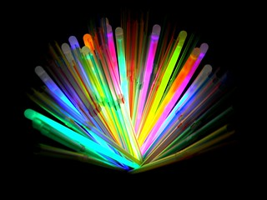
The Cromwell Glow Run will take place at Cromwell Park, at 7:00pm
$5 per person includes glow sticks

More info will be provided For more information:
Mary Kiser 260-894-2174

