

**LIBERATION DOUBLES OPEN**

**7TH JUNE 2014**

25 Teams expecting to brave the stormy weather ended up playing in red hot sunshine as the Liberation’s competitions were blessed with great weather again.

Playing under the Swiss system as used in the European and World Championships, teams played 5 rounds of matches.

Many of the Islands best players took part and for the first time teams from Guernsey were also in attendance.

After 3 rounds Matt Ryan and David Ibitson topped the rankings with Keith Pinel & Gerald Roland, Matt Pinel & Toby Northern and Nathan Wheller & Matt Buesnel amongst the teams with 3 wins out of 3.

Round 4 though was the turning point in the competition as Shane & Lee from Guernsey were drawn to play against Chris Romeril & Marc Nicol, however Marc had to play this match on his own after Chris failed to return in time and thus lost 13-0, this in the end made the difference for Shane & Lee as they just squeezed through to the quarter finals in 8th place on points difference courtesy of the 13-0 win, piped Richard Sowerby and Keith Baddeley.

The stand out result though was a 13-0 win for Nathan Wheller and Matt Buesnel over Ken Vibert & Graeme Follain

Keith Pinel & Gerald Roland finished 1st and were the only team to win all 5 matches.

Wins BHN Games For Against

1 Keith Pinel & Gerald Roland 5 15 05:00 65 34

2 Matt Ryan & David Ibitson 4 18 04:00 60 49

3 Nathan Wheller & Matt Buesnel 4 13 04:01 62 35

4 Michel Morel & Neil Selby 4 13 04:01 63 41

5 Alan Lahiffe & Stephen Leathem 4 13 04:01 57 37

6 Toby Northern & Matt Pinel 3 16 03:02 56 46

7 Seb Renaud & Delphine De La Mare 3 14 03:02 55 51

8 Lee Holberry & Shane Brehaut 3 13 03:02 57 40

The quarter finals saw some surprising results as 1st placed Keith & Gerald suffered a heavy defeat against Shane & Lee, Nathan & Matt B beat Toby & Matt P and Alan & Stephan inflicted a heavy defeat on last year’s runners up Neil & Michel.

Matt Ryan & David Ibitson, the competitions first ever winners also made the semi-final’s beating Delphine & Seb.

|  |  |  |  |  |  |  |  |  |  |
| --- | --- | --- | --- | --- | --- | --- | --- | --- | --- |
|  | **Quarter Finals** |  |  |  |  |  |  |  |  |
| 1st | Keith Pinel & Gerald Roland | | 1 | v | 13 | Shane & Lee Holberry | |  | 8th |
| 2nd | Matt Ryan & David Ibitson | | 13 | v | 7 | Delphine De La Mare & Seb Renaud | | | 7th |
| 3rd | Nathan Wheller & Matt Buesnel | | 13 | v | 8 | Matt Pinel & Toby Northern | | | 6th |
| 4th | Neil Selby & Michel Morel | | 3 | v | 13 | Alan Lahiffe & Stephan Leathem | | | 5th |

Matt Ryan & David Ibitson kept up their fine form in the semi-finals beating Nathan & Matt comfortably 13- 5 as they stayed in control the whole match. Alan & Stephan though will be rueing missed chances as lead 7-0 and 12-8 before a spirited fight back from Shane & Lee to seal a final spot.

|  |  |  |  |  |  |
| --- | --- | --- | --- | --- | --- |
| **Semi Finals** |  |  |  |  |  |
| Shane & Lee Holberry | | 13 | v | 12 | Alan Lahiffe & Stephan Leathem |
| Nathan Wheller & Matt Buesnel | | 5 | v | 13 | Matt Ryan & David Ibitson |

Alan & Stephan recovered from their disappointment to show their experience with a very one sided game against Nathan & Matt who should though be very pleased with 4th place and some excellent results throughout the day.

**3/4th Place Play Off**

Nathan Wheller & Matt Buesnel 1 v 13 Alan Lahiffe & Stephan Leathem

**Final**

Just as in the 3rd/4th place play off the final was one way traffic as from the quarter finals onwards Shane & Lee (who also currently hold the Guernsey Open title) performed exceptionally well giving little chance for Matt & David beating the Liberation pair 13 – 1 to take the trophy to Guernsey.

|  |  |  |  |  |
| --- | --- | --- | --- | --- |
| Shane Brehaut & Lee Holberry | 13 | v | 1 | Matt Ryan & David Ibitson |

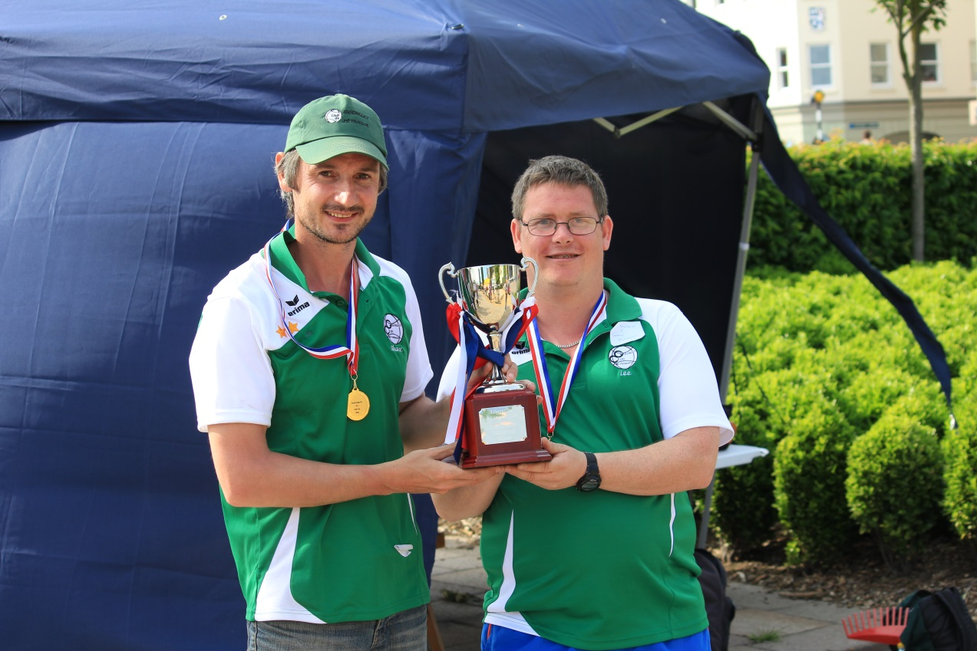

***Notices:***

1. **GUERNSEY OPEN** Weekend of 20/21st September – contact [seborenaud@yahoo.co.uk](mailto:seborenaud@yahoo.co.uk)

For information. It’s a great weekend of Doubles on Saturday and Triples on Sunday.

1. **Club Website and Facebook** page to be launched 1st July 2014

CLUB SPONSORS

|  |  |
| --- | --- |
| http://nebula.wsimg.com/581c5785b63ee3a672a15bb793008009?AccessKeyId=521D75783279793C7EE2&disposition=0&alloworigin=1 | http://www.inapub.co.uk/DisplayPhoto.aspx?width=290&height=290&photoid=3615 |

[www.**elementsmediajersey**.co.uk](http://www.elementsmedia.co.uk/)

Look forward to seeing you all back again next year!

Kind Regards

Toby Northern

Chairman

Liberation Petanque Club