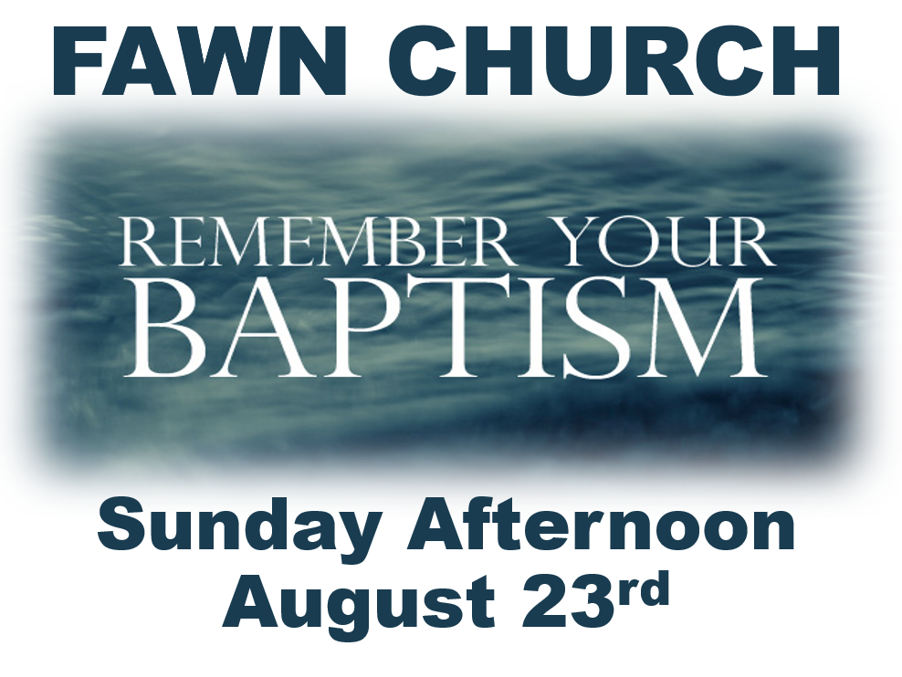
Through your Baptism your life came into agreement with the truth of God’s saving grace;
that through faith in Jesus your sins were crucified with Jesus on the cross, and the punishment and weight of them were buried with Jesus in His death, and then with undeserved grace, Jesus took hold of your hand and rose you to a new life of freedom and joy with Jesus in His resurrection.
While the eternal realities of Jesus’ work are held firm on your behalf by God, you may sometimes find yourself forgetting the power of your new life in Jesus. Though your spirit is held firm with God your life may begin to pick up and carry the burdens and struggles that Jesus left buried on your behalf.
Sunday afternoon on August 23rd Fawn Church will be celebrating an interactive “Remember Your Baptism” service at a local stream. This will be a time to remind yourself of the powerful realties that took place through your baptism; realties of a new life that God has not forgotten or forsaken.
This will be a time to prayerfully affirm your agreement with God realties as you allow those parts of your life, which Jesus has put to death, but you have begun to carry once more to be washed away.
While others will be “remembering their baptism” at the same time this service is designed to be a guided prayerful personal experience. If you desire to participate, or if you have never received baptism and desire to do so please Pre-Register by August 13, 2020 by emailing pastorstough@gmail.com. This will help us prepare for you and I will give you specific things I would like you to prepare as you come to the waters to meet with your Lord!

