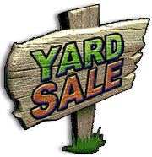

If you are interested in setting up your sale at the City Park, there will be a **FLAT FEE OF $15.00**-this will include both days. We will fill spots for the City Park on a ***FIRST COME FIRST SERVE BASIS***. Stop by or call the **Vienna Depot@618-658-8547** to get your name on the list for a spot!

If you plan on setting up at your home, there is no charge, but we would like to place you on our yard sale map so we can help you get business.

Please come by or contact **City Hall @618-658-5161**. This map will be available on the City of Vienna website June 3rd, and available for pickup at City Hall and the City Park Depot.

***\*ALL PROFIT MADE BY THE CITY WILL GO INTO THE CITY'S COMMUNITY FUND!***

THE CITY OF VIENNA WOULD LIKE TO INVITE YOU TO PARTICIPATE IN THE CITYWIDE YARD SALE THAT WILL TAKE PLACE ON **FRIDAY & SATURDAY JUNE 7TH & 8TH 2019!** VENDORS, CRAFTERS AND SMALL BUSINESS OWNERS ARE WELCOME!