CENTER DIRECTOR: NANCY LEE

ASSISTANT DIRECTOR: DEANA DILLON

TELEPHONE: (614) 837-3020 / FAX (614) 833-6471

HOURS: MON-THURS: 8:30 a.m. - 4:30 p.m.
FRIDAYS: 8:30 a.m. - 2:30 p.m.

WEB PAGE: http://pickeringtonseniorcenter.org
EMAIL: NLee@pickeringtonseniorcenter.com

Follow us on Facebook at:
Pickerington Senior Citizens Center

A NOTE FROM NANCY
The office staff would like to wish all the fathers and grandfathers a very “Happy Father’s Day!”

THANK YOU
A big thank you to the Friendly Ties Square Dancers for the purchase of three new fans for the Center. They were a blessing when the air conditioner was
not working.

THE BOOSTER CLUB
Just a reminder that you can donate any amount you would like to our Booster Club. The money donated helps with the purchase of items that we need for our kitchen, office supplies, etc.

WELCOME NEW MEMBERS
We welcome the following new members to the Pickerington Senior Center and hope they join us for some of our activities: Joann Case, JoAnn George, Leslie Markle, Jackie McCafferty, Beverly Muston, Kenneth and Katie Schneider, Margaret Shinn, and Jane White.

MEMBERSHIP INCENTIVE PROGRAM
Any member who signs up four new members will receive a $25.00 Visa Gift Card. Tell our office staff to put your name on the form when you sign up a new member. All you need is four members!
VOLUNTEER OF THE MONTH
Our Center would like to honor Richard Anderson as volunteer for the month of June. Richard is available anytime we need help. He sets up almost all the events we have, including noodles. He also helps make the noodles. Richard is an all around handyman. He even makes time for Line Dancing, Boxing and Exercise. He will receive a $15.00 gift card. Enjoy your reserved parking space for the month of June. Thanks again for all your help!

HEAL2TOE FOOT CARE SERVICES

THURSDAY / JUNE 2nd & FRIDAY/ JUNE 10th / 9 a.m.

Tonia is a State of Ohio Registered Nurse. She charges $35.00 for the following:

30-minute treatment
Expertly trim, thin and file nails
Corns & callouses are filed and buffed smooth
All tools are sterilized for each patient

* Payment is due at time of service
* Self-pay only – No Medicare or Insurance will be billed.

To schedule an appointment at our Center call: HEAL2TOE FOOT CARE SERVICES (614) 686-3646.

SHRED DAY and ELECTRONICS RECYCLING
SATURDAY / JUNE 11th
This event will be held on Saturday, June 11th from 9 a.m.–1 p.m. at Spence Funeral Home, 550 Hill Road North in Pickerington. Have your documents shredded for free by Royal Document Destruction.

TDR Recyclers will accept most electronics - TVs - $1.00 per inch.

Pickerington Lions Club will collect used eyeglasses.

The St. Vincent De Paul Society will be collecting clothing and household goods.

The Food Pantry will be collecting non-perishable food items and money.

Fairfield County Humane Society will be taking donations for pet supplies.
- Summer Concert Series -
AT SYCAMORE CREEK PARK AMPHITHEATER
SUNDAY EVENINGS / 6:30-8:00 p.m.
Bring a blanket or lawn chair and enjoy a variety of music throughout the summer.
June 10th – Popgun
July 8th – Divasl
August 12th – Fleetwood Gold

FARMERS MARKET
THURSDAYS / JUNE through SEPTEMBER
This will be the 12th season for the Pickerington Farmers Market. The market will run every Thursday through September 29th. Location: Public Parking Lot, 89 North Center Street.

STAYING HEALTHY IN YOUR HOME

The Violet Township Fire Department, Truro Township and the City of Whitehall Division of Fire are collaborating with Mt. Carmel Health Systems to develop a Community Paramedic program to further improve the health and welfare of the communities. For more information you can contact Lt. Postage at (614) 778-5561 or by email at para@violet.oh.us

PICKERINGTON FOOD PANTRY
Please try to help the Food Pantry so they can help people in need. Some of the most needed items are: personal hygiene products - soap - paper towels -toilet paper - toothpaste - toothbrushes – juices - condiments - tomato (paste, sauce or diced) - baking and pantry staples (flour, sugar, salt, baking soda and spices) - peanut butter and jelly – bread - butter. We have a collection container in our Center’s library.

Thank you to everyone who has made a donation to the Food Pantry recently, these items are very much needed and greatly appreciated! We hope you will continue to support us in our efforts to aid those in need at this time.

DOLL HOUSE RAFFLE
The winner of our Doll House Raffle is Gary Kincade. The first name drawn was Sheri Kreinbihl, who declined the prize. We drew again and Gary is our winner!

Many thanks to Jeri Heskett for donating the beautiful dollhouse for our raffle.

EQUIPMENT
Our Center has several walkers and a wheelchair that are available for our members to borrow. Just give us a call at (614) 837-3020 to check availability and we will have it ready for you to pick it up.

PICKERINGTON PARKS & RECREATION

- Friday Night Flicks -
PRESENTED BY FAIRFIELD FEDERAL
AT SYCAMORE CREEK PARK AMPHITHEATER
Movies will begin at dark (approximate start times are between 9:00-9:30 p.m.). Bring a lawn chair or blanket and enjoy the show.
June 10th – Encanto
July 8th – Luca
August 12th - Sing 2

MAH-JONGG ANYONE?

Is anyone interested in playing mah-jongg once a week at our Center? We are discussing starting a group. Both experienced and new players welcome! Please call our office at (614) 837-3020 if you would be interested in joining us.
* * * UPCOMING EVENT * * *

GARAGE SALE
SATURDAY / AUGUST 27, 2022
8:00 a.m. – 3:00 p.m.

Cost for tables: 12 foot table - $15.00
6 foot table - $10.00
Card table - $5.00

Our Garage Sale last year was a great success! We’re planning one for this year. Now is a good time to start getting things ready for the sale. To sign up and reserve a table, call us at (614) 837-3020.

LINE DANCING – MONDAYS / 11:15 a.m.-noon
No Class on June 20th or July 4th

The class is open to Drop-In students at a $1.00 pay-per-class option. The current session of line dancing will run through June 27th, on Mondays from 11:15 a.m. to 12 noon. Classes will continue to offer easy-to-learn dances so that all skill levels can participate. Payment of $12 is due upon registration. You can pick up a form in our office or from Marilyn. Make checks payable to Marilyn Morgan.
For additional information contact Marilyn at: mnm@columbus.rr.com

WATERCOLOR CLASS
EVERY MONDAY / 1-3 PM
Join Jenene Warmbier for adventures in watercolor painting. Jenene is a great teacher. No previous training, or talent necessary, just the desire to express yourself with “Paints and Brushes.” You can stop in the office and get a list of supplies you will need for the class.

STRENGTH CLASS
MONDAYS and/or WEDNESDAYS / 10 - 11 a.m.

Join us at our strength classes lead by Kelley Deibert. The focus is on building upper and lower body strength, stretching, and improving your balance. Bring your own weights. If you need a stretch band Kelley has bands you can purchase for $2.00.
CORNHOLE
EVERY TUESDAY / 11 a.m.
We play Cornhole every Tuesday. On the last Tuesday of each month, we have a tournament with prizes for the winning team. The winning team for the April Cornhole Tournament was Shirley Bowler and Jim (JJ) Joseph. Cornhole is open to both men and women. Come and join in on all the fun!

TUESDAY AFTERNOON MATINEE
JUNE 7th / 1:15 p.m.
Join us at our Center for a classic movie on our large screen t.v. The movie for the month of June will be “Rain Man” starring Dustin Hoffman and Tom Cruise. We’ll supply the movie, popcorn, snacks, coffee, and water. You may use our Center’s chairs or bring your own folding chair.

BINGO
TUESDAY / JUNE 14th & 28th
On the second and fourth Tuesdays of every month we play Bingo! No Potluck this month. Bingo starts at 1:00 p.m. The cost is $1.50.

CRAFT GROUP
EVERY WEDNESDAY / 10 a.m. – noon
Our craft group offers fun activities for our members, but also raises money for our Center. They provide tray favors for two carry out meals which our Center provides for our shut-in members. Another important fundraising activity they participate in is our Breakfast with Santa, usually held on the first Saturday of December.

SEWING CIRCLE
EVERY WEDNESDAY / 12:30 – 2:30 or 3:00 p.m.
We now have a sewing circle and would love to have anyone interested in sewing, knitting, crocheting, cross stitch or needlepoint come and participate. We’ll get together to sew and to socialize in our craft room! Bring along your own project and materials and join us!

EUCHRE
EVERY WEDNESDAY / 12:30 p.m.
Come in, join your friends and play some Euchre. We start playing at 12:30 p.m. The cost is only $2.25 which includes the games and the loner pot. Please be here at least 10 minutes ahead of time to get signed up so we can start on time at 12:30.

DUPLICATE BRIDGE | BRIDGE
WEDNESDAYS | THURSDAYS
9:30 a.m. | 12:30 p.m.

We’re looking for more members to play Bridge. Anyone interested in joining us, please call our Center and give your name and phone number. The cost to play either Bridge or Duplicate Bridge is $1.00 per week.

TITLE BOXING
THURSDAYS / JUNE 2nd, 9th & 16th

Maria Manzo from Title Boxing will lead the class at our Center from 9:15 to 10 a.m. Sessions are around the Rock Steady Boxing curriculum which increases the neuroplasticity of the brain to help produce healthy brain cells. The exercises are designed to improve quality of life, have fun, and get results - all at the same time! You can purchase a bag and gloves for $25.00 at the class.

*** NEW ACTIVITY ***

CHAIR VOLLEYBALL
(Free to Members)
THURSDAYS / JUNE 2nd, 9th, 23rd & 30th / 11:30 a.m.

We are pleased to announce that we are starting Chair Volleyball at our Center in June. It will be led by Darie Wilson. If you have any questions, please call Darie at (740) 358-6394.

FRIDAY FITNESS CLASS
EVERY FRIDAY / 9:15 – 10:00 a.m.

This is a 45-minute Cardio Class. It’s a total workout. Come see the power you have and make great things happen for your health and well-being. We have plenty of room for you to move and groove to great music with instructor Maria Manzo.

SOCIAL EUCHRE
EVERY FRIDAY / 11 a.m.

This is a relaxed paced Euchre game where we can meet and play cards non-competitively. If you like to play cards for fun and you don’t mind teaching others when needed, then please join us. We welcome anyone who wants to play cards.

GAME ROOM

Our Game Room is open all day, Monday through Friday. We have a shuffleboard table and a dart board. No need to call ahead, just come and enjoy.

OUR LIBRARY
We have videos, puzzles, and a large selection of books for you to choose from. Come check out our cozy library.

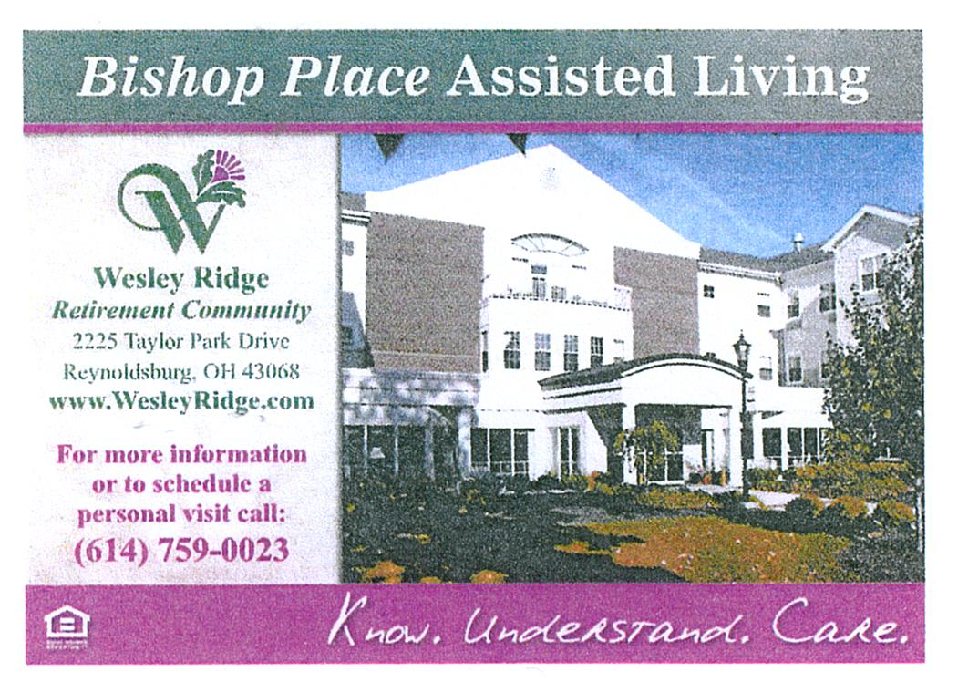

TRIPS FOR 2022
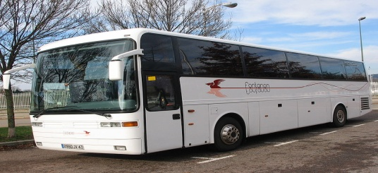

FRENCH LICK
TUESDAY / WEDNESDAY JULY 19th & 20th

Day 1: Depart our Center at 7:00 a.m. for Patoka Lake, Indiana.
1:00 p.m. We will enjoy a luncheon cruise on a 60-foot lake boat with indoor and an upper deck viewing area. Lake Patoka is the second largest manmade lake in Indiana.

3:30 p.m. We will enjoy wine tasting and dessert at the Patoka Lake Winery.
4:45 p.m. We will depart for our overnight lodging at the French Lick Resort where we will receive our room keys and a $25.00 voucher for dinner at the resort. The evening is yours to explore the grounds or visit the casino next door
Day 2: We will enjoy breakfast at the hotel.
9:15 a.m. Luggage out
10:00 a.m. A walking tour of the French Lake Resort dating back over a century. The Resort has hosted hundreds of celebrities over the years. Learn how tomato juice was first created and how gambling (illegal and legal) dominated the scene for years.
11:00 a.m. Depart for Wilstem Ranch where you’ll
enjoy a wagon ride to feed the animals. You’ll have your own bucket of feed. We’ll see everything from alpacas to zebras.
1:00 p.m. Enjoy a private barbecue luncheon with entertainment in the Barn at Wilstem.
2:30 p.m. Depart for home.

Cost is: $534 single - $449 double - $414 triple.
$200 payment due on sign up. Space Available

LACOMEDIA / AUGUST 25th

West Side Story has been canceled

BRANSON, MISSOURI
SEPTEMBER 11th – 17th

PACKAGE INCLUDES:
- 6 Nights Lodging
- 6 Breakfasts and 4 Dinners
- 7 Spectacular Shows:
- Peterson Family Bluegrass Band
- CJ’s Classic Country & Comedy
- Clay Cooper’s Country Express
- Showboat Branson Belle
- #1 Hits of the 60’s
- The Haygoods
- Entertainment at the Uptown Café
- A Guided Tour of Branson (including Table Rock Lake, The Strip, Downtown Branson, and The Keeter Center)
- Branson Landing & Downtown Branson
- Grand Village Shops
Cost per person: Single - $1,230 / Double - $930.
A deposit of $200.00 is due upon sign up. Balance due before Monday, July 15th.

NEW TRIP

AMISH GRAB BAG
TUESDAY / August 9th
- Roundtrip Motorcoach Day trip from Pickerington to Amish Country in Berlin, Ohio
- Hershberger’s Bakery - bread
- Der Dutchman for lunch
- Coblentz Chocolates – candy
- Back Country Roads Tour with local step-on guide
- Coblentz Leather Shop – key chain
- Walnut Creek Cheese – ice cream and a chunk of cheese

Cost is: $128.00 per person. Sign-up starts Monday, June 6, 2022. Payment due on sign-+ up.

NOTES FROM DEANA 😊

(1) Carol Akerman, Helen Kline, Wanda McFarren; (2) Ruth Ann Cunningham, Joan Lewis; (3) Georgia Logan, Dorothy Peterson, Jeff Sallee, Patti West; (4) Barb Hanners, Betty Kristoff, Shelby Lilly, Joann Welch, Beth Smith; (5) Shirley Bowler, Ann Burris, Laurie Crago, Stephanie Carney, Linda Fersch, Bev Hasson, Howard Martin; (6) Mike Crawford, Jerry Dirksen, Judy Morgan; (7) Kristen Hammond; (8) Nancy Curran, Doug Hutchinson, Angie Welling; (9) Pam Cline, Janice Foster, Peggy Shields; (10) Rosemary Davis, Steve Skoglund; (11) Pat Carroll, Norma Fenstermaker, Joanne Shannon, Elaine Watkins; (12) David Adamson, Tony Tedeschi; (13) Cheryl Legg, Marg Pizzuto, Sally Ross, Linda Ventresca; (14) Stephen Brown, Jody Donchess, Marge Klott, Erma Sickmeier; (15) Wilma Brehm, Audrey Hobbs, Beth Lewis; (16) Betty Fox, Madelyn Newlon, Faye Salyer; (17) Gary Jenkins, Earline Smoot, Lynne Wittman; (18) Roger Peacock; (19) Pat Deskins, Kay McGlinchey, Diane Paxton, Ellen Sabiers; (20) Judy Shook, Cliff Smith; (21) Rita Harrison; (22) Sara Alzner-Brown, Kathy Barnhouse, JoAnn Case, Linda Gerhardt, Elizabeth Wolfe, Donna Womack; (23) Ruth Kidwell, Rich Villec; (24) Jane Clagg, William Corallini Sheryl Donaldson, Rita Donovan, Jan Wolfe; (25) Linda Clyburn; (26) Linda Logue, Sondra Northrop; (27) Bunny Palmer, Deb Pierce, Melissa Ramey, Mary Kay Sturbois; (28) W. Gary Bush, Bill Curran, Deborah Guzman, Nancy Lee, Bob Matias, (30) Pam Overly.

MEMBERS IN SORROW
Thelma Kelly’s daughter – Elizabeth Ann Burba

MEMBERS KNOWN ILL
MaryAnn Green – Fell
Dick Smith – Broken Leg

THANK YOU
Thank you to Africa with Wesley Ridge for sponsoring our 90 plus yr. old luncheon.
Thank you to our volunteers, Jeanne Carroll, Annabelle Marion, Shirley Bowler, Faith Hoek & Richard Anderson for helping make this event a success. A big thank you to Jeanne Carroll for making all the desserts. We appreciate you all.
SOCK HOP PARTY
Please join us for our Sock Hop on Thursday, June 16th from 1-3 p.m. Dress for a 50’s Sock Hop or wear your everyday clothes. Either way we’ll have lots of fun, games, snacks & prizes. The party will be sponsored by Brookdale Senior Living, Embassy of Pickerington, and our Center.
RSVP in our office by June 10th

