March 28, 2018

New logo; new season:

Happy Spring! We’ve been busy planning for the summer season, keeping you in the loop of goings on in town and in the Township. We’re happy to unveil our new logo, designed to tip our hats to our 67th year of serving Strathmere and Whale Beach homeowners and visitors, and to represent our waters, sunshine and the community spirit we strive to preserve.

Easter Sunrise Mass slated for 6:15 am:

Bring a chair and perhaps a blanket to mass this Sunday on the Williams Avenue beach. Join parishoners from Saint Maximilian Kolbe, Marmora, for mass as the sun rises over the ocean. For more details: http://saintmaxkolbe.com/

UT Committee Passes Resolution Opposing Offshore Drilling
At the March 12 Township Committee meeting, by unanimous vote:

“The Township Committee of the Township of Upper hereby opposes offshore oil and gas exploration and drilling activities that would affect the coast of New Jersey, and calls upon Secretary of the Interior Ryan K. Zinke who oversees the Bureau of Ocean Energy Management to withdraw New Jersey and the entire Atlantic Ocean from consideration for the offshore oil and gas exploration, development, or drilling.”
Mayor Richard Palombo, along with Congressman LoBiondo and other South Jersey representatives attended a rally on the Ocean City boardwalk to voice public opposition to drilling.

Four Nor’easters in One Month!

It’s difficult to find anyone who can remember eight+ consecutive high tides the way we experienced during the third nor’easter this month. Last week’s brought slushy rain/sleet which switched over to snow in the afternoon, leaving us with about four inches of accumulation. As usual, the winds were fierce and blew sand and water throughout the island. Bayview flooding was per usual and access through Ocean City and Sea Isle at high tide was dangerous to impossible.

Be sure to follow us on facebook for more frequent postings of pictures and news. We’re grateful to the many folks who share their pix with us. Here are a few since the last newsletter:

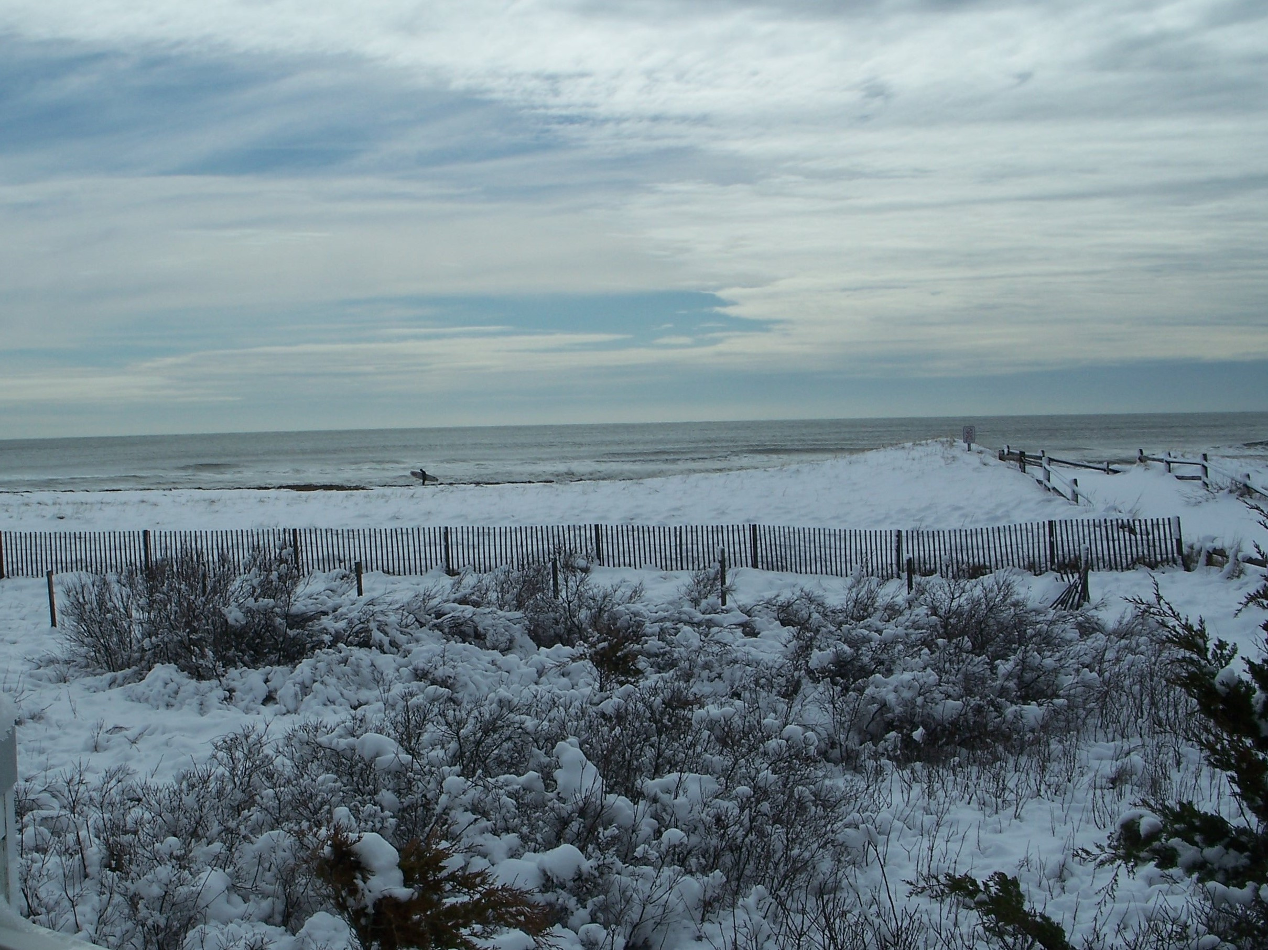

Do you know the lone Sherman Ave surfer? Thanks, Rose Marie Whelan for this super shot from 3/21.

Scroll down for four more pages of pix, two per page. If you ever have pix to share, email: sia1912@comcast.net. Thanks so much.

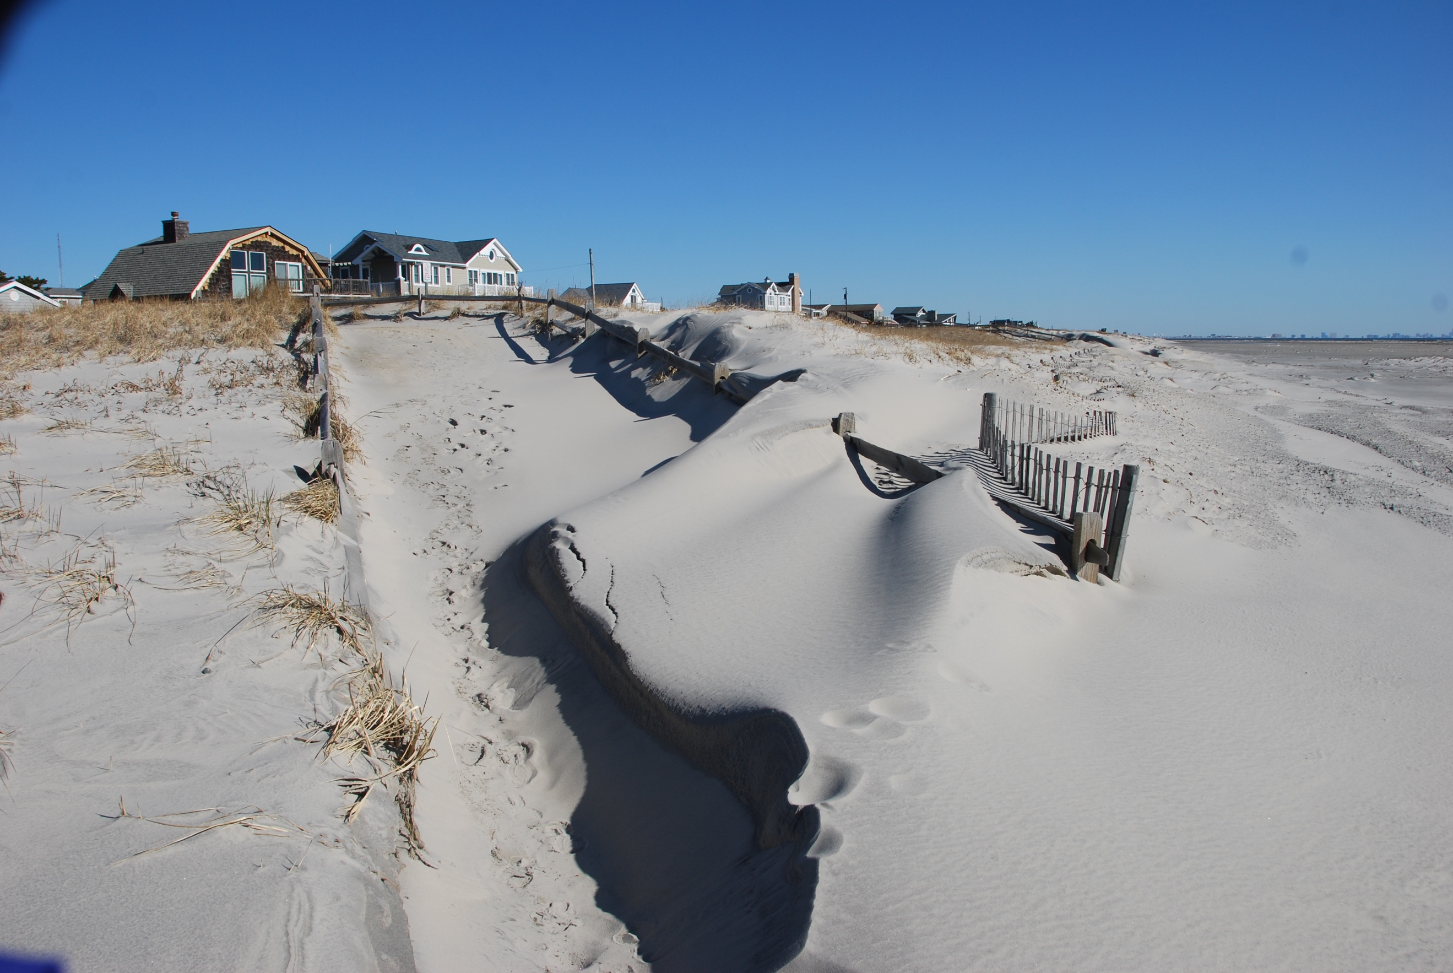
The winds have driven sand up to the fencing, forming a dune line. There’s a noticeable slope from the dune to the water; we’ve lost depth.

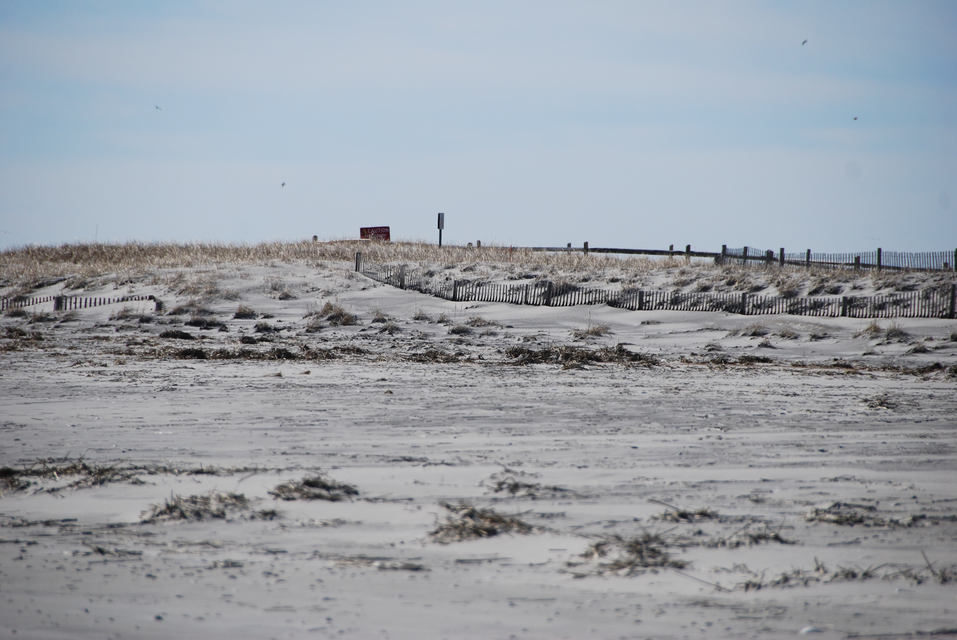

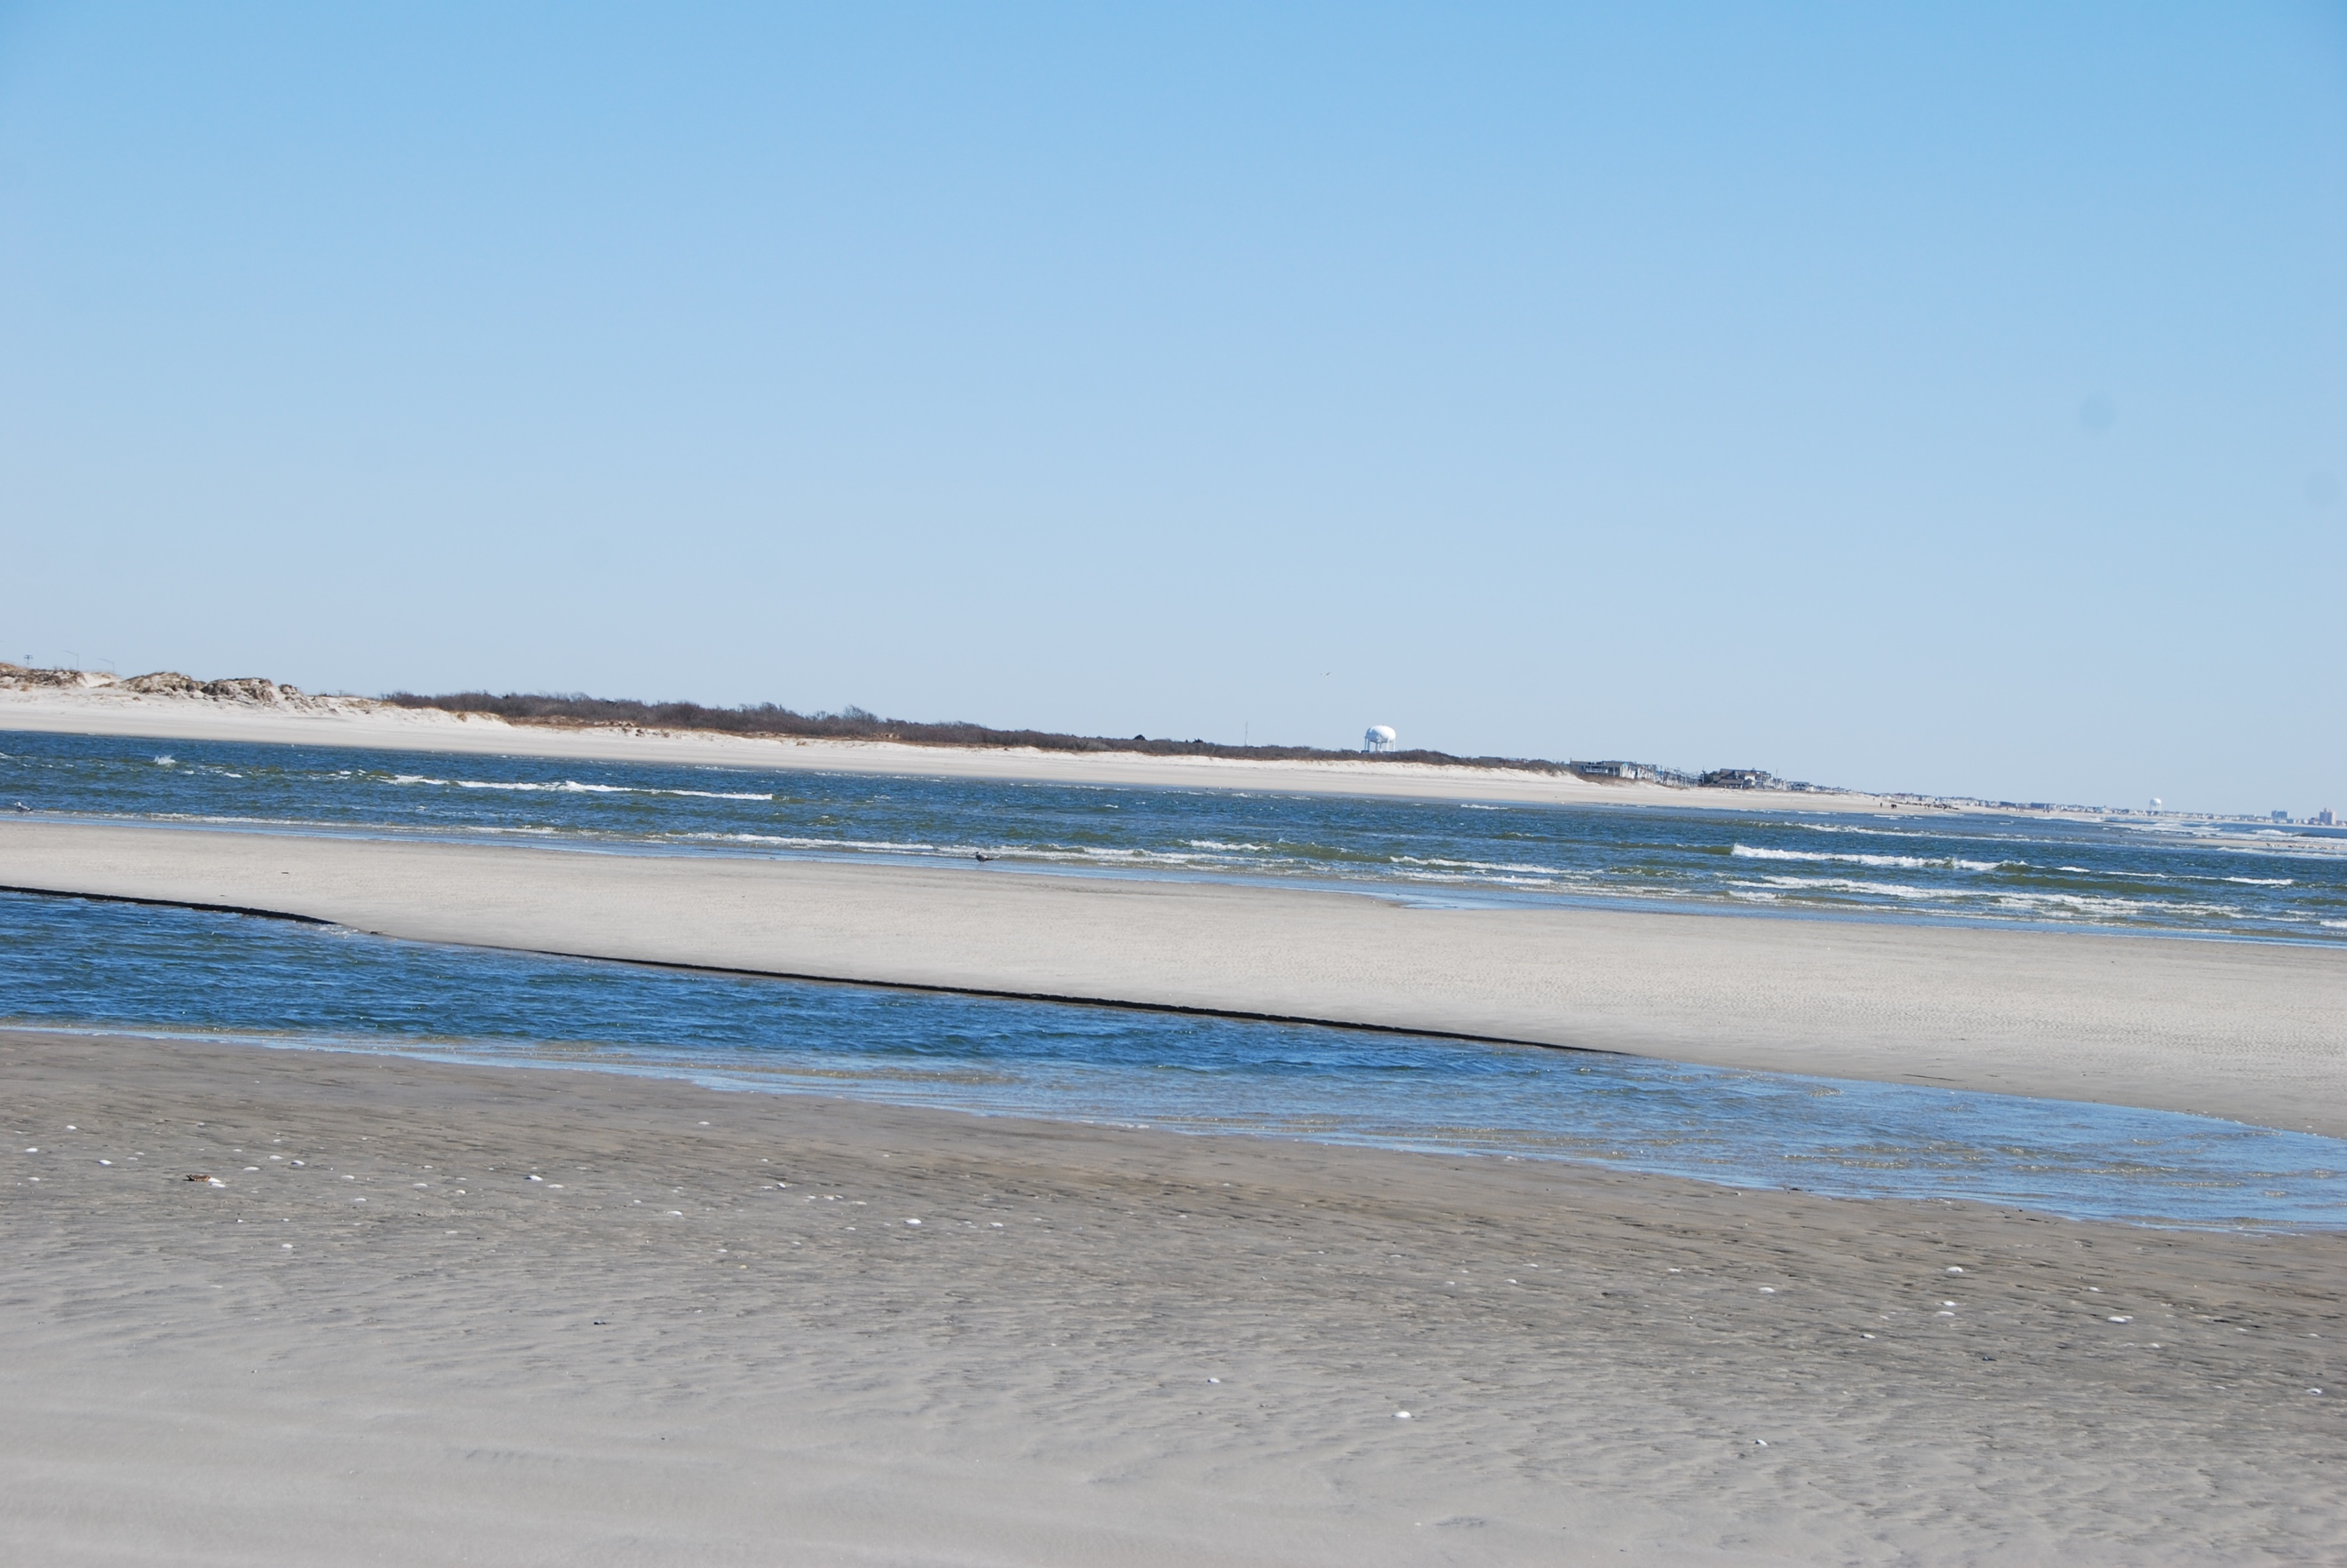

Pretty view of the Point and the bridge.

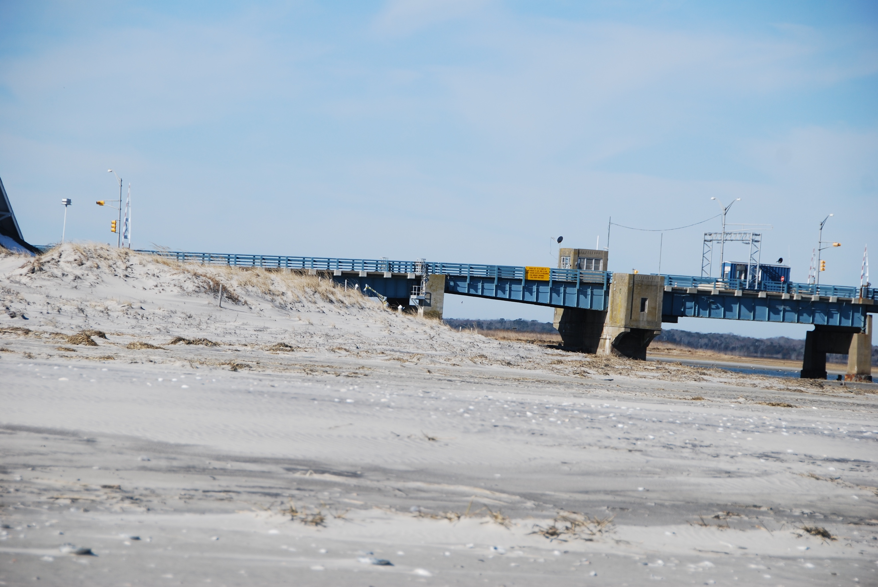

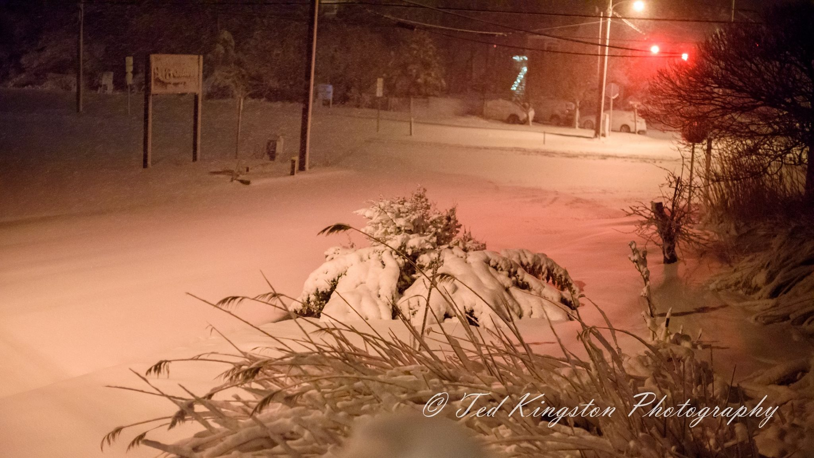

This is Ted’s “I thought it wasn’t supposed to be snow,” shot from Wednesday night.

And while it was very cold, at least we didn’t have this extraordinary salt freeze as Ocean City had in January 1918. Thanks, Karen Mitchell for sharing this gem.
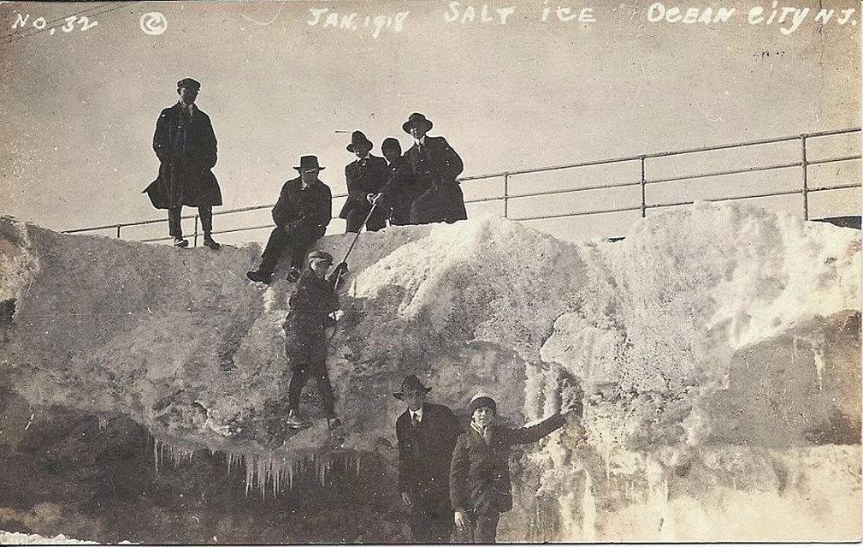

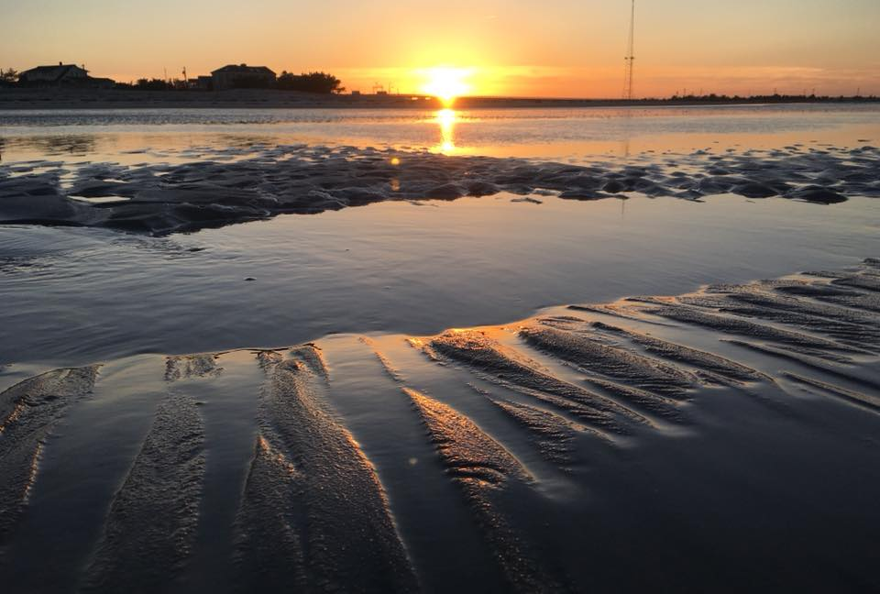
If you follow Greg Bennett on facebook, you’ve seen his enticing sunset pix, usually featuring a salute to the end of the day. Ahhh.

