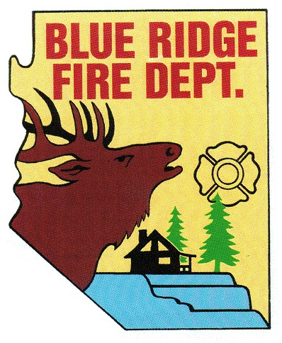
BLUE RIDGE FIRE DISTRICT

5023 Enchanted Lane
Happy Jack, AZ 86024

Notice of Public Meeting

Blue Ridge Fire District
Public Safety Personnel Retirement System
Local Board
5023 Enchanted Lane
Happy Jack, Arizona. 86024
928-477-2751
www.brfdaz.org

Pursuant to A.R.S. 38-431.02, notice is hereby given to members of the general public that members of the Public Safety Personnel Retirement System Local Board (PSPRS) will hold a meeting on FRIDAY, OCTOBER 18, 2019 at 8:30 AM at the BLUE RIDGE FIRE DISTRICT STATION in Happy Jack, Arizona.

Members of the PSPRS Local Board May attend in person or by telephone conference call.

The PSPRS Local Board reserves the right to move into Executive Session for Legal Advice under the Authority of A.R.S. 38-341.03 (A) (1) through (7) on any agenda item.

The PSPRS Local Board reserves the right to change the order of agenda items with the strict exception of the Notice of Time and Place of the Meeting.

Pursuant to the Americans With Disabilities Act, special accommodations will be made available upon a 24 hour prior request to the Secretary of the PSPRS Local Board.

DATE: Friday, October 18, 2019
TIME: 8:30 AM
PLACE: Blue Ridge Fire District Station

Meeting Called to Order: (meeting will be recorded)
Time:

Pledge of Allegiance:

Roll Call of PSPRS Local Board Members and Accepted Quorum:
Cindy Perelli
Linda Blosser
Tammy Rosenhagen
Brandon Sewell
Ryan McNeal

Adoption of the Agenda:

Approval of Previous Meeting Minutes: March 6, 2019

Chairperson Perelli’s Report: Information Only
1. New policy for the Fire Department.
2. Board Member communication.

Old Business: Discussion and Possible Approval
1. The Oath of Office for Ryan McNeal.
2. Still waiting for MOCK CLAIM for training purposes.
3. Review of PSPRS Annual Actuary.
4. Exposure Documentation Procedure (tabled from prior meeting)-Tammy Rosenhagen

New Business: Discussion and Possible Approval
1. Annual PSPRS Training scheduled for Wednesday, January 22, 2020
from 9:00 AM to 3:00 PM in Phoenix. Will need to know what members
want to attend allowing time for registration ASAP. —-Linda Blosser
2. Different types of Disability Claims—-review definitions. —-Brandon Sewell
3. Non-Routine Claims—Brandon Sewell
4. Routine Claims—Brandon Sewell
5. Board Requirements—Brandon Sewell
6. Board Responsibilities—Brandon Sewell

Call to the Public
A.R.S. 38-43.01 (H)
A public body may make an open call to the public, subject to reasonable time, place and manner restrictions, to allow individuals to address the public body on any issues within the jurisdiction of the public body. At the conclusion of any open call to the public, individual members of the public body may respond to criticism made by those members who have addressed the public body, may ask staff to review a matter to be placed on a future agenda. However, members of the public body shall not discuss or take action on matters raised during an open call to the public unless the matters are properly noticed for discussion and legal action.

Requests for Future Agenda Items:

Adjournment:
Time:

Agenda Posting: Wednesday, October 16, 2019
1. BRFD Website, 2. BRFD Bulletin Board, 3. Starlight Pines Community Building Board, Pine Canyon Bulletin Board

