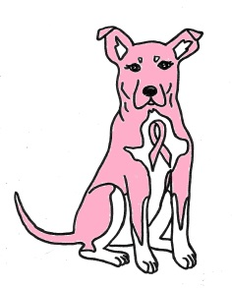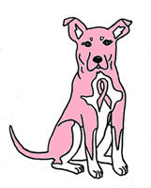
6th ANNUAL
BREAST IN SHOW WALK
Pink Paws for a Cause
Sunday: October 21, 2018
Registration at 9:00 am / Walk Begins at 10:00am
RAIN OR SHINE

ENTRY FORM & WAIVER

Name:

Address:

City/State/Zip:

Telephone: | Email:
Emergency Contact Phone:

Pet’s Name / Breed:

Pre-Registration By September 30, 2018 $25.00/person Includes: Silicone Wristband & T-Shirt (*)
Registration After September 30, 2018 $30.00/person Includes: Silicone Wristband

Desired T-Shirt Size: __________ (*) T-Shirt sizes are NOT guaranteed and are limited quantities

T-Shirts and Wristbands can be picked up at 9am the morning of the walk

WAIVER (Must Be Signed)
Notice: This entry form and release form is a contract with legal consequences. Read it carefully before signing.
I know that participating in a walk could be a potentially hazardous activity. I should not enter and walk unless I am medically able and properly trained. I also know that there will be a possibility of traffic on the course route. I assume the risk of walking in traffic. I also assume any and all other risks associated with walking this event including, but not limited to: falls, contact with other participants and/or their pet(s), the effects of the weather, and the conditions of the roads, all such risks being known and appreciated by me. Furthermore I agree to yield to all emergency vehicles.
I warrant that my pet is current with the vaccinations required by law, and that my pet is healthy enough to participate in this walk. I further agree to pick up any waste from my pet during the walk.
Knowing these facts, and in consideration of your accepting my entry, I hereby for myself, my heirs, executors, administrators, or anyone else who might claim on my behalf, covenant not to sue and unconditionally waive and release and discharge: The Soggie Doggie LTD., the Town of Norwood, the Norwood Police and Fire Departments, walk officials, volunteers, and all sponsors ( including any and all of their agents, employees, assigns or anyone acting for or on their behalf) from any and all claims or liability for death, personal injury, or property damage of any kind or nature whatsoever arising out of, or in the course of my participating in this event whether same be caused by negligence or fault. This release and waiver extends to all claims of every kind or nature whatsoever, foreseen or unforeseen, known or unknown. The undersigned further grants full permission to sponsors and or agents, authorized by them to use any photographs, videotapes, motion pictures, recordings, or any other record of this event for any purpose.

***ALL DOGS MUST BE LEASHED FOR THIS EVENT! ***
Walker’s Signature:

Parent / Guardian’s Signature (if under 18)

Date:

Please mail ENTRY FORM and PAYMENT to:
The Soggie Doggie / 1159 Washington St. / Norwood, MA 02062 / (781) 352-3509

*Please make checks payable to: The Soggie Doggie*

100% of the proceeds from this walk go directly to: The Breast Cancer Research Foundation (BCRF)

