2021
Mixed Doubles Open

A perfect 16 teams took part in the competitions 7th year. A great number with some fantastic teams with anyone of the entrants able to win it.

Only one game in round 1 failed to make it to 13 as one half of last years champions Lorna, playing with Matt Scholefield this year started off her defence of the title with a 11 – 7 win against Gary & Wendy.

Last years runners up Christine & Paul also started off with a win, 13 – 11 over Kat & Paul and 2017 & 2018 champions Dawn & Geoffroy started off well winning 13 – 3 over Alan & Ella-Jay.

Shocks as Callum & Jean lost to Karolina & Laurent and Natasha & Toby lost to Billy & Nicky.

Round 2 saw a big win for Brian & Judy 13 – 1 against Karolina & Laurent to make it two from two. Callum & Jean lost again 13 – 3 this time to Alan & Ella.

Natasha & Toby recovered to win 13 – 2 against Kevin & Margaret for the biggest win in round two. Several matches didn’t make it to the end as Christine & Paul took the win from Alice & Ross 12 – 11, Geoffroy & Dawn 10 – 7 against Brigitte & David and Lorna & Matt 12 – 6 against Billy & Nicky.

In round 3 only 14 points were scored between Callum & Jean and Gary & Wendy with the former coming out 9 – 5 winners. Dawn & Geoffroy also only got to 9 but their opponents Lorna & Matt only managed 8 in a very tight match.

Natasha & Toby found themselves 8 – 0 down against Karolina & Laurent before fighting back impressively to go 12 – 8 up before some great shots by Karolina & Laurent to keep them in the game, but Natasha & Toby won 13 – 10.

Brigitte & David failed to go the distance for the second match in a row but this time won 12 – 11 against Billy & Nicky. Brian & Judy made it three from three winning 13 – 12 against Christine & Paul.

Round 4 saw the first certificate of the day as Kevin & Margaret’s struggles continued with a 13 – 0 loss to Gary & Wendy who won their first match of the day. Alice & Ross took the win on the final end 11 – 10 over Natasha & Toby to keep their hopes of qualification alive as did Alan & Ella-Jay with a big 13 – 3 win over Karolina & Laurent.

So many close matches in this round though as Brian & Judy qualified with a round to spare beating Dawn & Geoffroy 9-7, Christine & Paul beat Brigitte & David 12 – 10, Lorna & Matt won 13 – 12 over Kat & Paul and Callum & Jean also won 13 – 12 over Keith & Vanessa.

The final round saw a big result for Dawn & Geoffroy who handed out the second certificate of the day surprisingly to Christine & Paul. This meant Dawn & Geoffroy finished 2nd in the rankings but despite this loss and ending with -9 points difference Christine & Paul’s 17 BHN (opponents wins) helped them finish 3rd.

Brian & Judy topped the rankings with a close 13 – 11 win over Alice & Ross who missed out on the Semi-Finals as a result finishing 5th.

Despite Natasha & Toby’s 13 – 3 win over Lorna & Matt they could only finish 8th but the result also ended Lorna’s chances of defending her title as herself & Matt ended in 6th place.

Alan & Ella-Jay’s big win over Billy & Nicky 13 – 1 gave them the last Semi-Final spot in 4th place.

Kat & Paul gave out Kevin & Margaret’s second certificate of the day but it wasn’t enough to go through as then ended in 7th but with +19 points difference and not only that they scored more points than anyone else (62).

FINAL RANKINGS

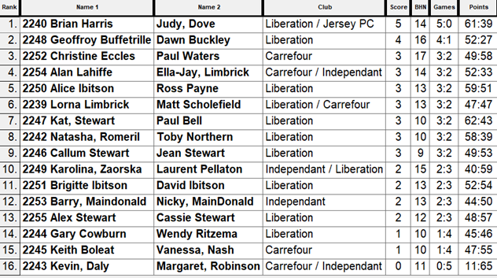

So the Semi-Finals were as follows.

Ranked Ranked

1st Brian Harris & Judy Dove v Alan Lahiffe & Ella-Jay Limbrick 4th

2nd Dawn Buckley & Geoffroy Buffetrille v Christine Eccles & Paul Waters 3rd

Well, the weather had taken a turn for the worst from the semi-finals onwards but despite this, the excellent play continued.

As expected after winning all five matches in the Swiss Rankings Brian & Judy took an early lead and looked to have the match in the bag at 10 - 3, but some great placing on a now wet and soft terrain by Ella-Jay put the pressure on Brian’s shooting which is always difficult in the wet weather and this showed as time after time Brian couldn’t take Ella-Jay’s boules out and with Alan also placing well they fought back to win 13 – 11 and go through to the final at the expense of Brian & Judy.

In the second semi-final Christine & Paul had the opportunity to get quck revenge for their 13 – 0 loss in the final round of the swiss system. They got off to a much better start and mid-way through the match were leading 6 – 2 but Geoffroy shooting was excellent throughout and with Dawn placing well the turned it around to take a timed out match 10 – 7.

Third place went to Brian & Judy as the ran out 13 – 6 winners against Christine & Paul in a very fast paced match.

Well experience of playing in finals can make all the difference and with Dawn playing in 4 (now 5) of the 7 finals and winning it twice with Geoffroy already they surely had the advantage despite Alan’s experience it was Ella-Jay first ever final in only her second competition. In fact this was the second successive open final to have Geoffroy and Alan in it with Geoffroy taking the Island Singles

Ella-Jay didn’t seem faced and continued to place really well, but when you are playing the best shooter in the Island and he is on top form there is little anyone can do about it and despite some close ends Dawn & Geoffroy ran out 13 – 8 winners for their third Mixed Doubles Open title, some record as they have only played together in four of them.

Great seeing new players taking part, enjoying the sport and of course doing really well.

Special thanks to Laurent and Geoffroy for help in setting up and packing up much appreciated.

2021 - CHAMPIONS

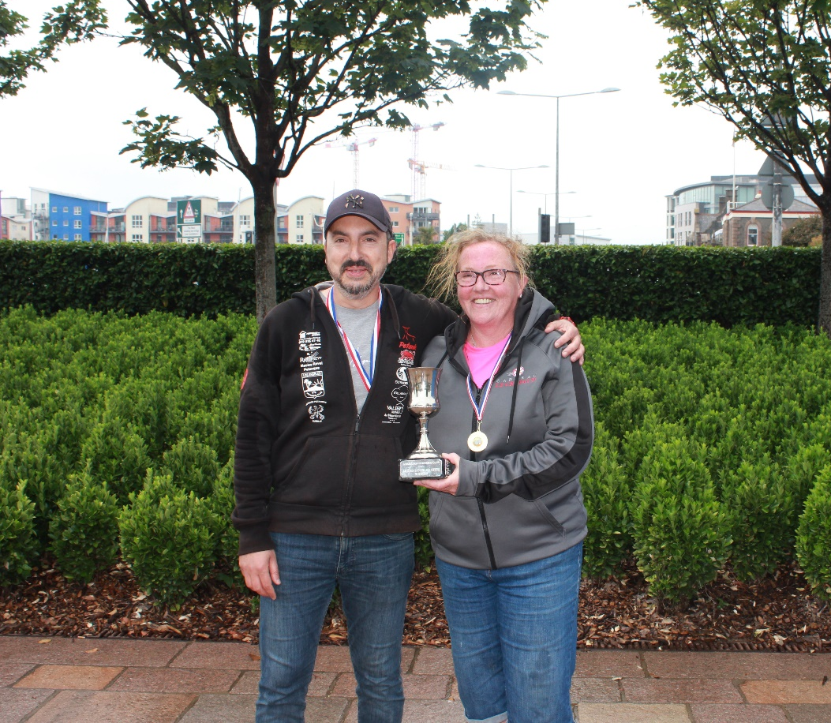

Geoffroy Buffetrille & Dawn Buckley

NEXT WEEK - Singles League

Club email address - liberationpc@gmail.com

Club Website - www.liberationpetanque.co.uk

Kind Regards

Toby Northern

Chairman

Liberation Petanque Club

